

**CSC 621/351: Database Management Systems**

**Professors: Mary Krueger & Alan Nochenson**

**DBM Project**

**SJU Scheduling System**

**Group Members:**

**Fatemah Alkhalaf Julie Osborne Jumanah Alshehri**

**December 6, 2016**

Table of Contents

Table of Contents 1

Acknowledgment 2

Introduction 3

About the Purpose 3

Project Timeline 4

Project Ranking 4

Use-case Diagram 6

Entity Relationship Diagram 7

Relational Model 8

Functional Dependency 9

Table and View Creation 9

Index Selection 11

Constraints 12

Insertion Queries 13

System Interfaces 16

1. Homepage: 16

1.1. Homepage validations: 16

2. Employee Interfaces 17

2.1. Add: 18

2.2. Search: 27

2.3. Edit: 39

2.4. Edit profile: 45

3. Faculty and Student Interfaces 46

4. Guest Interfaces 53

References 56

Acknowledgment

We would like to thank Professor Mary Krueger and Professor Alan Nochenson for giving us the opportunity to work on this project and for helping us through the project steps. Also, we would like to thank our colleague Mohammed Alamoudi for helping us with the programming part.

Introduction

As a requirement for the Database Management System course, we built a Database and interface for a certain system. Our idea was to build a Database for Saint Joseph’s University, which will help the University Departments to schedule classes and search for students, faculty and classes. This report will summarize the project.

About the Purpose

The purpose of this application is to allow employees, faculty members, students, and guests of Saint Joseph’s University to be able to access a scheduling system which contains information pertaining to various programs and courses. We would like this to be primarily be used for access to the information that focuses on the Computer Science department. We anticipate this application to be used among all four types of users to gain information regarding the department and its courses. Since this was the primary goal, our design was focused on making it accessible to each type of user. Each type of users has access and control to different information, so it was important in our design to have each user have a different type of portal that pertained specifically to that information. We designed our application with the purpose of being purposeful, yet simple, so it could be attainable to all different users. We hope that over time this application can contain information about all the colleges, programs, departments, and courses offered here at Saint Joe’s.

For this project we analyzed our system using the Rational Unified Process (RUP), which has four different phases that are shown in the following figure.

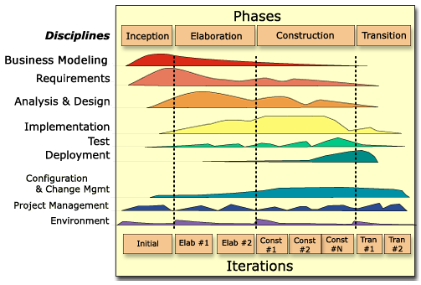

Project Timeline

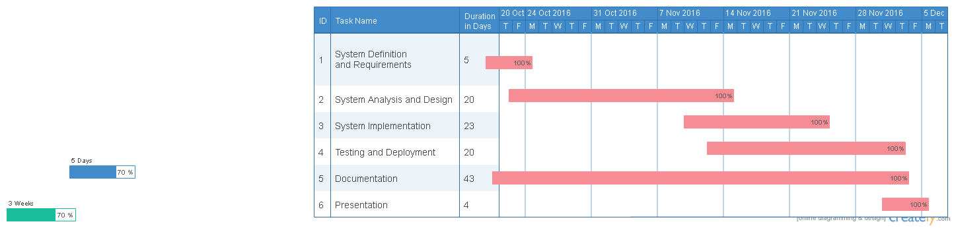

Project Ranking

* Member 1 : Fatemah Alkhalaf

My teammates and I agrees I did 33.33 % of the overall project.  My specific tasks include

   Task 1 : I helped define the idea

Task 2 : I helped create the ERD after discussing the system with teammates

     Task 3 : I helped create the relational model and made modifications after peer review

Task 4 : I helped create the Use Case Diagram and made mods after peer review

Task 5 : I helped create the database after discussing the system with teammates

     Task 6 : I helped code the form for the inserting, editing, deleting from the database

Task 7 : I tested the 2 of my teammates’ forms offering suggestions on improvement

Task 8 : I helped specify constraints and indexing

Task 9: I helped write reports

Task 10 : I helped create the PowerPoint presentation.

Signature: …………………………………………………………………………………..

* Member 2 : Julie Osborne

My teammates and I agrees I did 33.33 % of the overall project.  My specific tasks include

   Task 1 : I helped define the idea

Task 2 : I helped create the ERD after discussing the system with teammates

     Task 3 : I helped create the relational model and made mods after peer review

Task 4 : I helped create the Use Case Diagram and made mods after peer review

Task 5 : I helped create the database after discussing the system with teammates

     Task 6 : I helped code the form for the inserting, editing, deleting from the database

Task 7 : I tested the 2 of my teammates’ forms offering suggestions on improvement

Task 8 : I helped specify constraints and indexing

Task 9: I helped write reports

Task 10 : I helped create the PowerPoint presentation.

Signature: …………………………………………………………………………………..

* Member 3 : Juamanh Alshehri

My teammates and I agrees I did 33.33 % of the overall project.  My specific tasks include

   Task 1 : I helped define the idea

Task 2 : I helped create the ERD after discussing the system with teammates

     Task 3 : I helped create the relational model and made mods after peer review

Task 4 : I helped create the Use Case Diagram and made mods after peer review

Task 5 : I helped create the database after discussing the system with teammates

     Task 6 : I helped code the form for the inserting, editing, deleting from the database

Task 7 : I tested the 2 of my teammates’ forms offering suggestions on improvement

Task 8 : I helped specify constraints and indexing

Task 9: I helped write reports

Task 10 : I helped create the PowerPoint presentation.

Signature: …………………………………………………………………………………..

Use-case Diagram

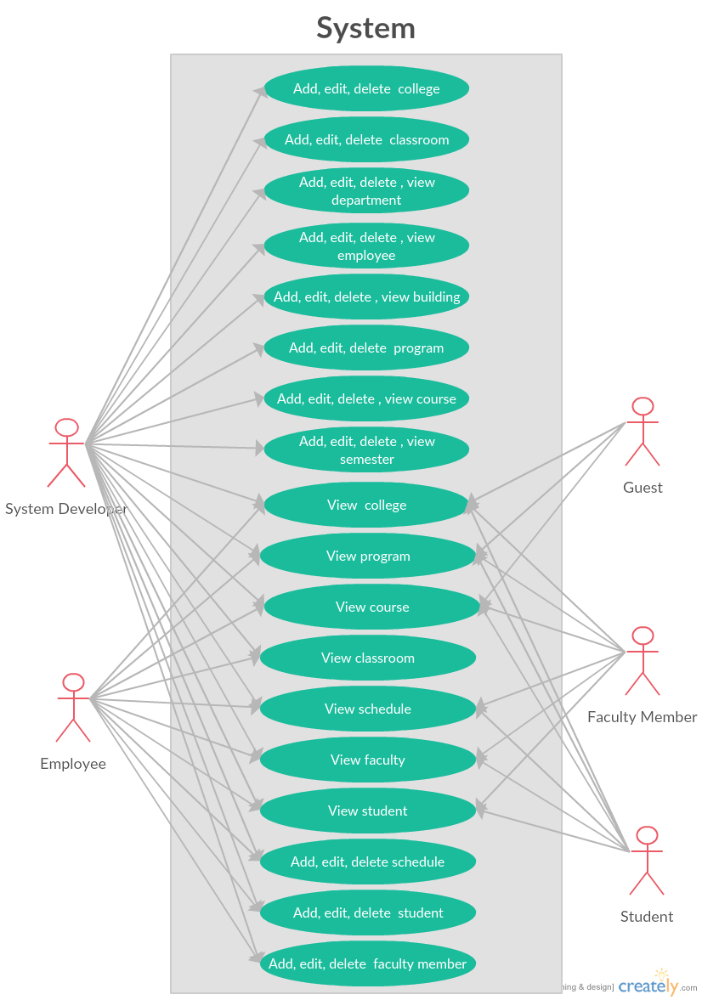

Entity Relationship Diagram

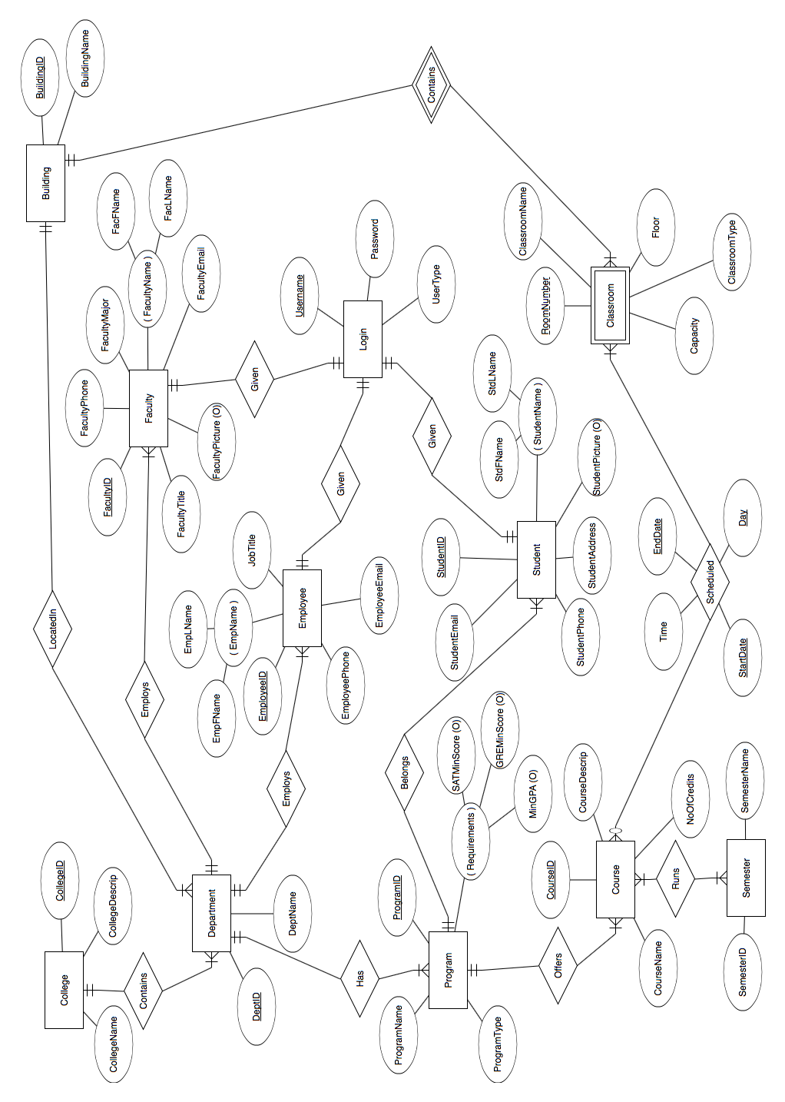

Relational Model

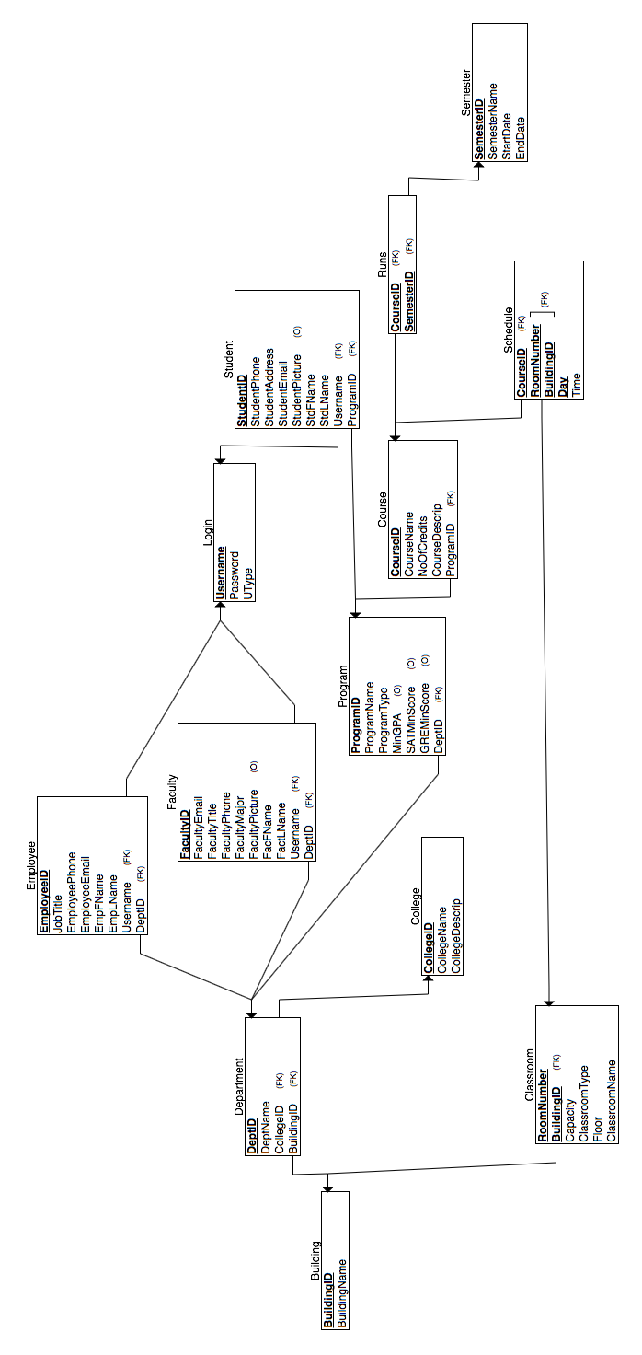

Functional Dependency

According to our analysis, we can say that our database is in 3rd Normalized Form. Therefore, we did avoid all types of functional dependency which they are:

1. Full functional dependency.
2. Partial functional dependency.
3. Transitive functional dependency.

Table and View Creation

|  |  |  |
| --- | --- | --- |
| **No.** | **Table Name** | **SQL Query** |
| **1** | building | CREATE TABLE `building` (  `BID` varchar(5) NOT NULL,  `BName` varchar(30) NOT NULL) |
| **2** | classroom | CREATE TABLE `classroom` (  `BID` varchar(5) NOT NULL,  `CRNum` int(3) NOT NULL,  `CRName` varchar(10) NOT NULL,  `Floor` int(2) NOT NULL,  `CRType` enum('Lecture','ComputerLab','ScienceLab','') NOT NULL,  `Capacity` int(4) NOT NULL) |
| **3** | college | CREATE TABLE `college` (  `ColgID` int(2) NOT NULL,  `ColgName` varchar(50) NOT NULL,  `ColgDesc` text NOT NULL) |
| **4** | course | CREATE TABLE `course` (  `CID` varchar(6) NOT NULL,  `CName` varchar(70) NOT NULL,  `NoOfCredits` int(1) NOT NULL,  `CDesc` text NOT NULL,  `ProgID` int(2) NOT NULL) |
| **5** | department | CREATE TABLE `department` (  `DeptID` int(3) NOT NULL,  `DeptName` varchar(50) NOT NULL,  `ColgID` int(2) NOT NULL,  `BID` varchar(5) NOT NULL) |
| **6** | employee | CREATE TABLE `employee` (  `EmpID` varchar(6) NOT NULL,  `EmpFName` varchar(30) NOT NULL,  `EmpLName` varchar(30) NOT NULL,  `JobTitle` varchar(30) NOT NULL,  `EmpPhone` varchar(10) NOT NULL DEFAULT '6106601000',  `EmpEmail` varchar(30) NOT NULL,  `DeptID` int(3) NOT NULL,  `UName` varchar(10) NOT NULL) |
| **7** | faculty | CREATE TABLE `faculty` (  `FID` varchar(6) NOT NULL,  `FFName` varchar(30) NOT NULL,  `FLName` varchar(30) NOT NULL,  `FTitle` varchar(30) NOT NULL,  `FMajor` varchar(30) NOT NULL,  `FPhone` varchar(15) NOT NULL DEFAULT '6106601000',  `FEmail` varchar(30) NOT NULL,  `FPicture` blob,  `DeptID` int(3) NOT NULL,  `UName` varchar(10) NOT NULL) |
|  | student | CREATE TABLE `student` (  `StdID` varchar(10) NOT NULL,  `StdFName` varchar(30) NOT NULL,  `StdLName` varchar(30) NOT NULL,  `StdPhone` varchar(10) NOT NULL,  `StdEmail` varchar(30) NOT NULL,  `StdAddress` varchar(100) NOT NULL,  `StdPicture` blob,  `ProgID` int(2) NOT NULL,  `UName` varchar(10) NOT NULL) |
| **8** | login | CREATE TABLE `login` (  `UName` varchar(10) NOT NULL,  `Pass` varchar(100) NOT NULL,  `UType` varchar(10) NOT NULL) |
| **9** | program | CREATE TABLE `program` (  `ProgID` int(2) NOT NULL,  `ProgName` varchar(50) NOT NULL,  `ProgType` varchar(4) NOT NULL,  `SATMinScore` int(4) DEFAULT NULL,  `GREMinScore` int(3) DEFAULT NULL,  `MinGPA` decimal(4,2) DEFAULT NULL,  `DeptID` int(3) NOT NULL) |
| **10** | runs | CREATE TABLE `runs` (  `CID` varchar(6) NOT NULL,  `SID` int(5) NOT NULL) |
| **11** | schedule | CREATE TABLE `schedule` (  `BID` varchar(5) NOT NULL,  `CRNum` int(3) NOT NULL,  `CID` varchar(6) NOT NULL,  `Time` time NOT NULL,  `Day` enum('Monday','Tuesday','Wednesday','Thursday','Friday') NOT NULL) |
| **12** | semester | CREATE TABLE `semester` (  `SID` int(5) NOT NULL,  `SName` varchar(10) NOT NULL,  `Start_Date` date NOT NULL,  `End_Date` date NOT NULL) |
| **13** | course_view | CREATE VIEW course_view AS (  SELECT *  FROM course; |

Index Selection

Beside primary key index here is a list of the other indexes:

|  |  |  |
| --- | --- | --- |
| **No.** | **Table** | **Indexes** |
| **1** | classroom | ADD KEY `CRNum` (`CRNum`); |
| **2** | course | ADD KEY `ProgID` (`ProgID`); |
| **3** | department | ADD KEY `ColgID` (`ColgID`),  ADD KEY `BID` (`BID`); |
| **4** | employee | ADD KEY `UName` (`UName`); |
| **5** | faculty | ADD KEY `DeptID` (`DeptID`),  ADD KEY `UName` (`UName`); |
| **6** | student | ADD KEY `ProgID` (`ProgID`),  ADD KEY `UName` (`UName`); |
| **7** | program | ADD KEY `DeptID` (`DeptID`); |
| **8** | runs | ADD KEY `SID` (`SID`); |
| **9** | schedule | ADD KEY `CID` (`CID`),  ADD KEY `CRNum` (`CRNum`); |

Constraints

We implemented the following constraints to ensure all types of integrity.

|  |  |  |
| --- | --- | --- |
| **No.** | **Table** | **Constraints** |
| 1 | Classroom | * ADD CONSTRAINT `classroom_ibfk_1` FOREIGN KEY (`BID`) REFERENCES `building` (`BID`) ON DELETE CASCADE ON UPDATE CASCADE; * ADD CONSTRAINT chk_capacity CHECK (Capacity>0); |
| **2** | Course | * ADD CONSTRAINT `course_ibfk_1` FOREIGN KEY (`ProgID`) REFERENCES `program` (`ProgID`) ON DELETE CASCADE ON UPDATE CASCADE; |
| **3** | Department | * ADD CONSTRAINT `department_ibfk_1` FOREIGN KEY (`ColgID`) REFERENCES `college` (`ColgID`) ON UPDATE CASCADE, * ADD CONSTRAINT `department_ibfk_2` FOREIGN KEY (`BID`) REFERENCES `building` (`BID`) ON UPDATE CASCADE; |
| **4** | Employee | * ADD CONSTRAINT `employee_ibfk_1` FOREIGN KEY (`DeptID`) REFERENCES `department` (`DeptID`) ON UPDATE CASCADE, * ADD CONSTRAINT `employee_ibfk_2` FOREIGN KEY (`UName`) REFERENCES `login` (`UName`) ON DELETE CASCADE ON UPDATE CASCADE; |
| **5** | Faculty | * ADD CONSTRAINT `faculty_ibfk_1` FOREIGN KEY (`DeptID`) REFERENCES `department` (`DeptID`) ON UPDATE CASCADE, * ADD CONSTRAINT `faculty_ibfk_2` FOREIGN KEY (`UName`) REFERENCES `login` (`UName`) ON DELETE CASCADE ON UPDATE CASCADE; |
| **6** | Student | * ADD CONSTRAINT `student_ibfk_1` FOREIGN KEY (`ProgID`) REFERENCES `program` (`ProgID`) ON UPDATE CASCADE, * ADD CONSTRAINT `student_ibfk_2` FOREIGN KEY (`UName`) REFERENCES `login` (`UName`) ON DELETE CASCADE ON UPDATE CASCADE; |
| **7** | Program | * ADD CONSTRAINT `program_ibfk_1` FOREIGN KEY (`DeptID`) REFERENCES `department` (`DeptID`) ON UPDATE CASCADE; |
| **8** | Runs | * ADD CONSTRAINT `runs_ibfk_1` FOREIGN KEY (`CID`) REFERENCES `course` (`CID`) ON UPDATE CASCADE, * ADD CONSTRAINT `runs_ibfk_2` FOREIGN KEY (`SID`) REFERENCES `semester` (`SID`) ON UPDATE CASCADE; |
| **9** | Schedule | * ADD CONSTRAINT `building` FOREIGN KEY (`BID`) REFERENCES `building` (`BID`) ON UPDATE CASCADE, * ADD CONSTRAINT `classroom` FOREIGN KEY (`CRNum`) REFERENCES `classroom` (`CRNum`) ON UPDATE CASCADE, * ADD CONSTRAINT `course` FOREIGN KEY (`CID`) REFERENCES `course` (`CID`) ON UPDATE CASCADE; |
| **10** | Semester | * ADD CONSTRAINT chk_date CHECK (Start_Date<End_Date); |

Insertion Queries

Here are some insertion queries:

|  |  |  |
| --- | --- | --- |
| **No.** | **Table** | **Constraints** |
| 1 | Classroom | INSERT INTO `classroom` (`BID`, `CRNum`, `CRName`, `Floor`, `CRType`, `Capacity`) VALUES  ('BN', 110, 'Lab 110', 1, 'ComputerLab', 30),  ('BN', 111, 'Lab 111', 1, 'ScienceLab', 20),  ('BN', 221, 'Class 221', 2, 'Lecture', 40),  ('BN', 222, 'Class 222', 2, 'Lecture', 30),  ('BN', 223, 'Class 223', 2, 'Lecture', 50),  ('BN', 224, 'Lab 224', 2, 'ComputerLab', 25),  ('BN', 225, 'Lab 225', 2, 'ComputerLab', 30),  ('MV', 110, 'Class 110', 1, 'Lecture', 50),  ('MV', 120, 'Class 120', 1, 'Lecture', 50),  ('MV', 300, 'Class 300', 3, 'Lecture', 60),  ('MV', 310, 'Class 310', 3, 'Lecture', 100),  ('MV', 320, 'Lab 320', 3, 'ComputerLab', 25),  ('MV', 330, 'Lab 330', 3, 'ComputerLab', 25),  ('SC', 111, 'Lab 111', 1, 'ComputerLab', 20),  ('SC', 112, 'Lab 112', 1, 'ScienceLab', 20),  ('SC', 221, 'Class 221', 2, 'Lecture', 30),  ('SC', 222, 'Class 222', 2, 'Lecture', 50),  ('SC', 223, 'Lab 110', 2, 'ScienceLab', 20),  ('SC', 224, 'Class 224', 2, 'Lecture', 40),  ('SC', 225, 'Lab 225', 2, 'ScienceLab', 20); |
| **2** | Department | INSERT INTO `department` (`DeptID`, `DeptName`, `ColgID`, `BID`) VALUES  (11, 'Computer Science', 1, 'BN'),  (23, 'Decision Support Science', 2, 'MV'),  (24, 'Marketing', 2, 'MV'),  (25, 'Accounting', 2, 'MV'),  (26, 'Mathematics ', 1, 'SC'),  (27, 'Physics', 1, 'SC'),  (28, 'Finance', 2, 'MV'),  (29, 'Food Marketing', 2, 'MV'); |
| **3** | Program | INSERT INTO `program` (`ProgID`, `ProgName`, `ProgType`, `SATMinScore`, `GREMinScore`, `MinGPA`, `DeptID`) VALUES  (1, 'BS.Computer Science', 'BS', 1080, NULL, '3.27', 11),  (2, 'MS.Computer Science', 'MS', NULL, NULL, '3.00', 11),  (3, 'MS. in Business Intelligence and Analytics', 'MS', NULL, NULL, '3.00', 23),  (4, 'BS. in Business Intelligence and Analytics', 'BS', 1100, NULL, '3.00', 23),  (5, 'MS. in Marketing', 'MS', NULL, 160, '3.00', 24),  (6, 'BS. in Marketing', 'BS', 1080, NULL, '3.00', 24); |
| **4** | Semester | INSERT INTO `semester` (`SID`, `SName`, `Start_Date`, `End_Date`) VALUES  (4, 'Spring16', '2016-01-01', '2016-05-01'),  (5, 'Summer16', '2016-06-01', '2016-08-01'),  (7, 'Fall16', '2016-09-01', '2016-12-01'),  (8, 'Spring17', '2017-01-01', '2017-05-01'); |

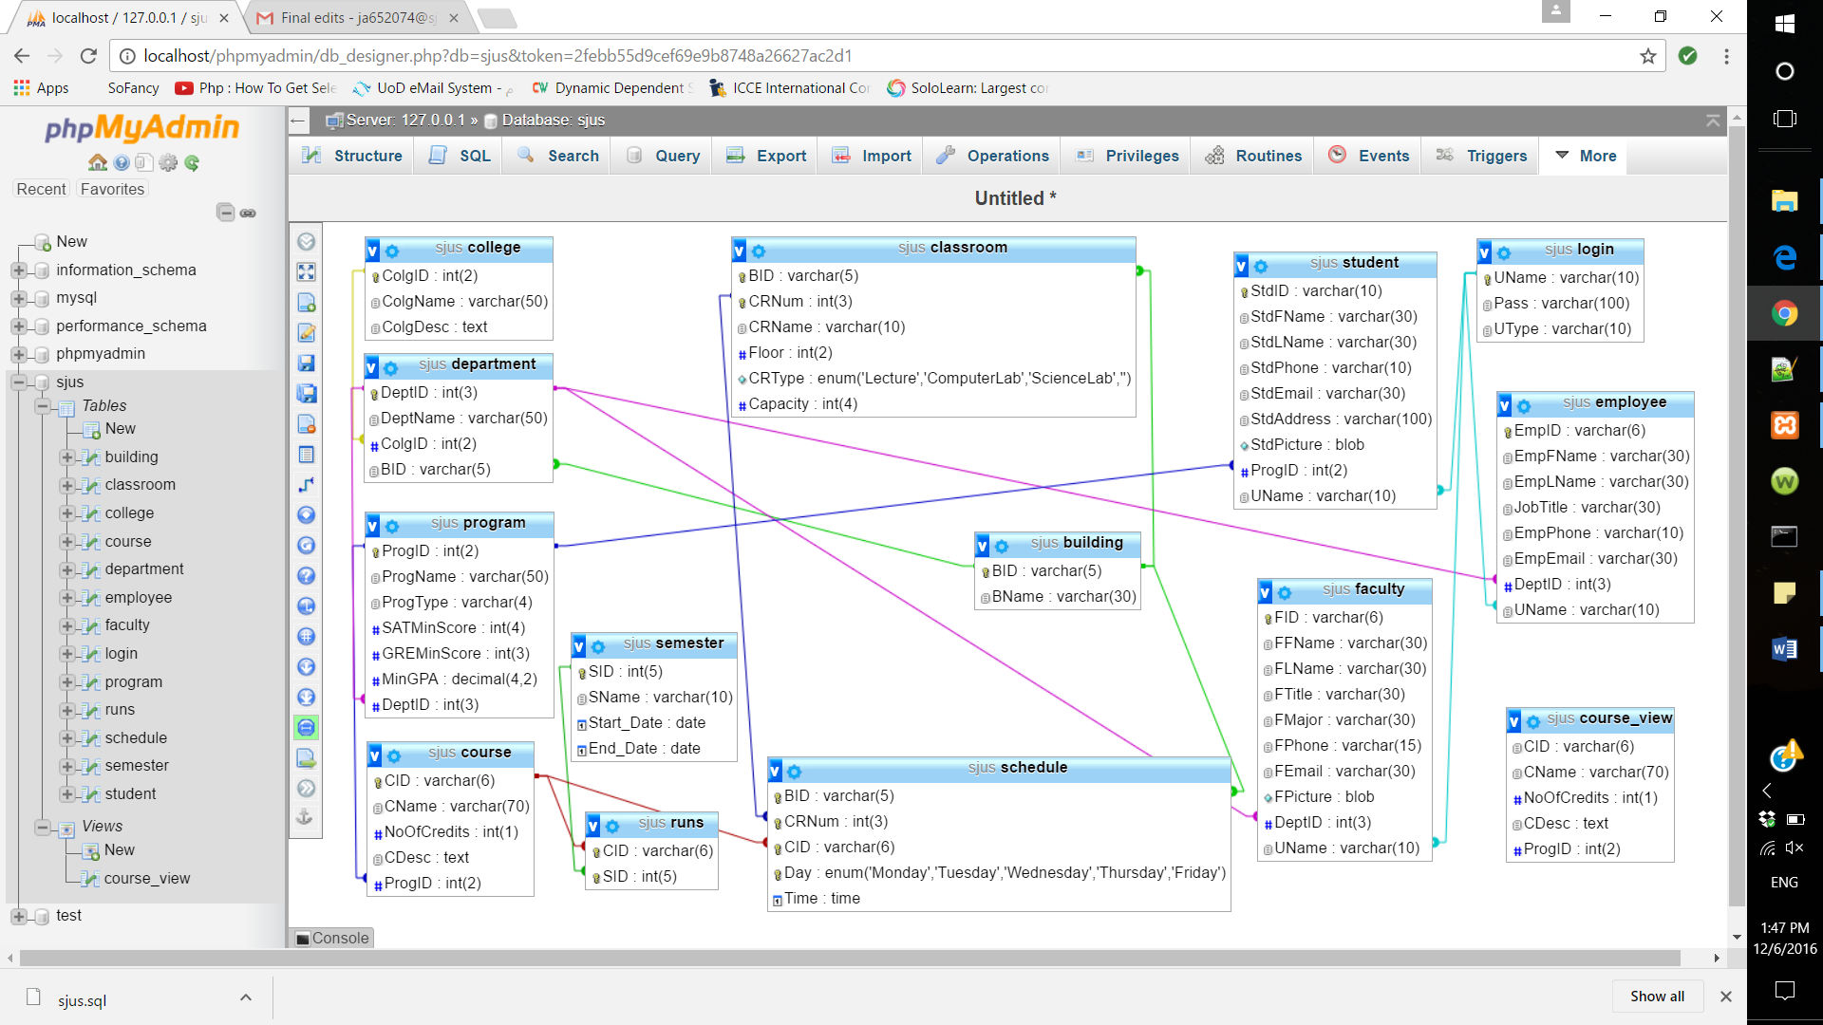

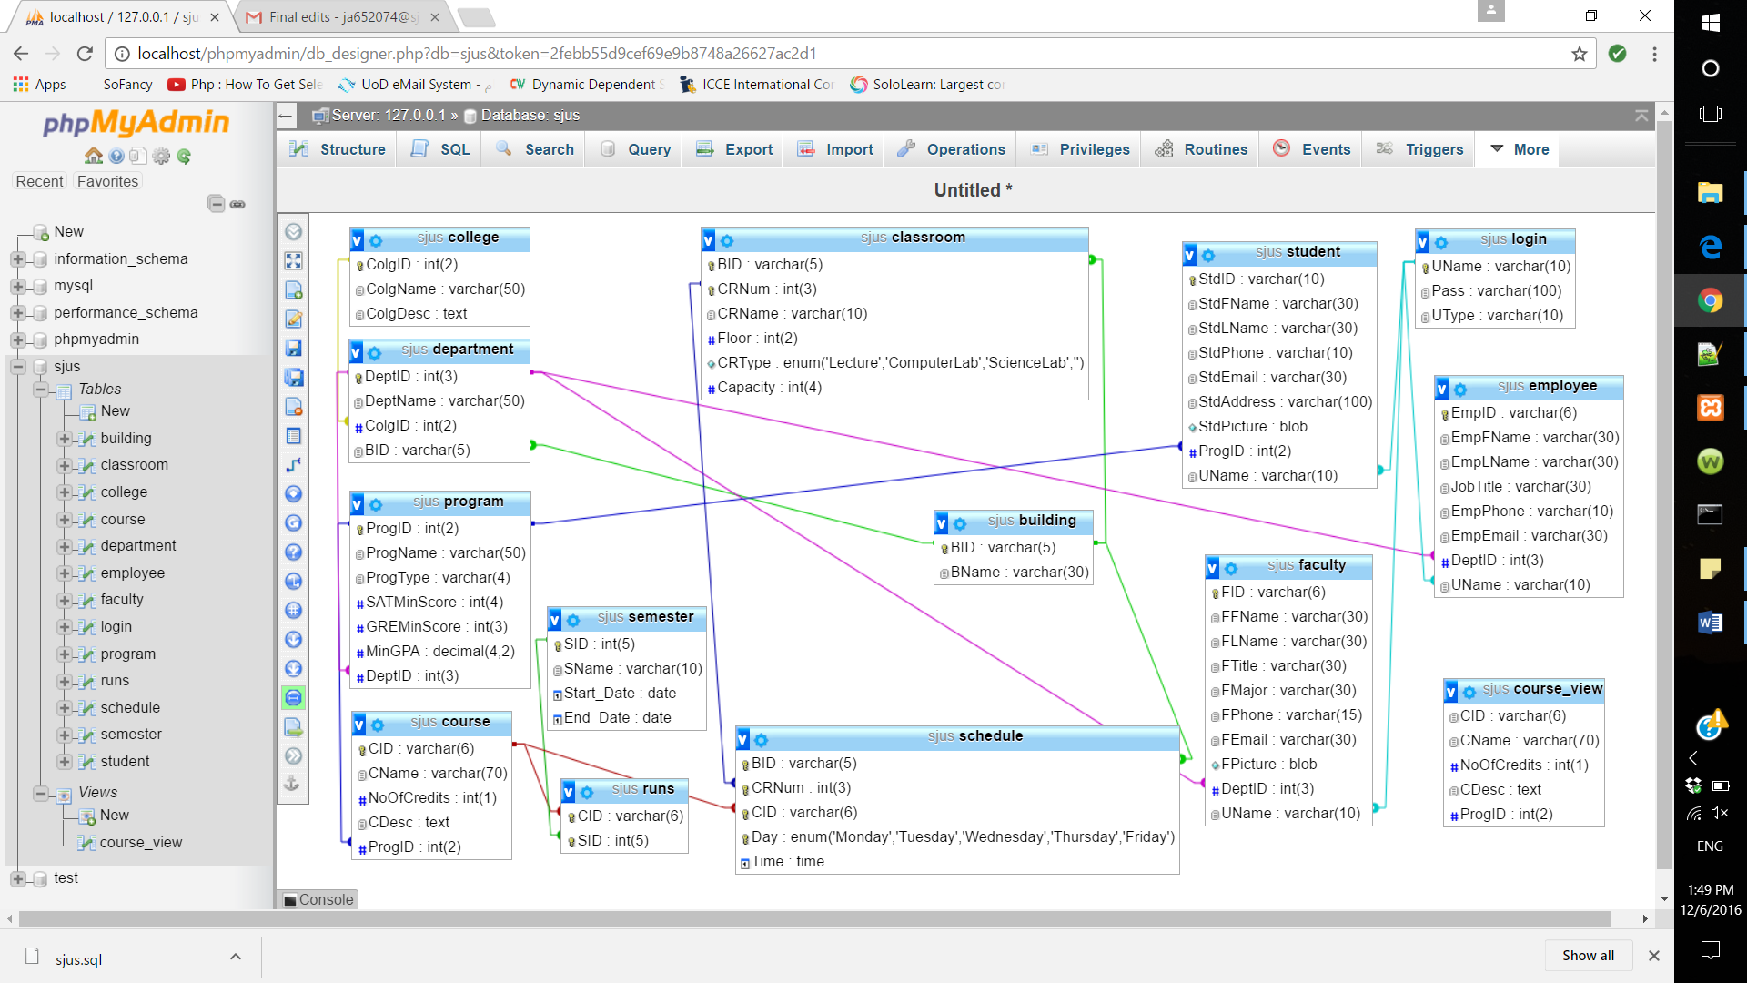

System Interfaces

* + - 1. Homepage:

All users must login through this page by typing username and password. If the user is not an SJU member, they can browse some limited function as a Guest.

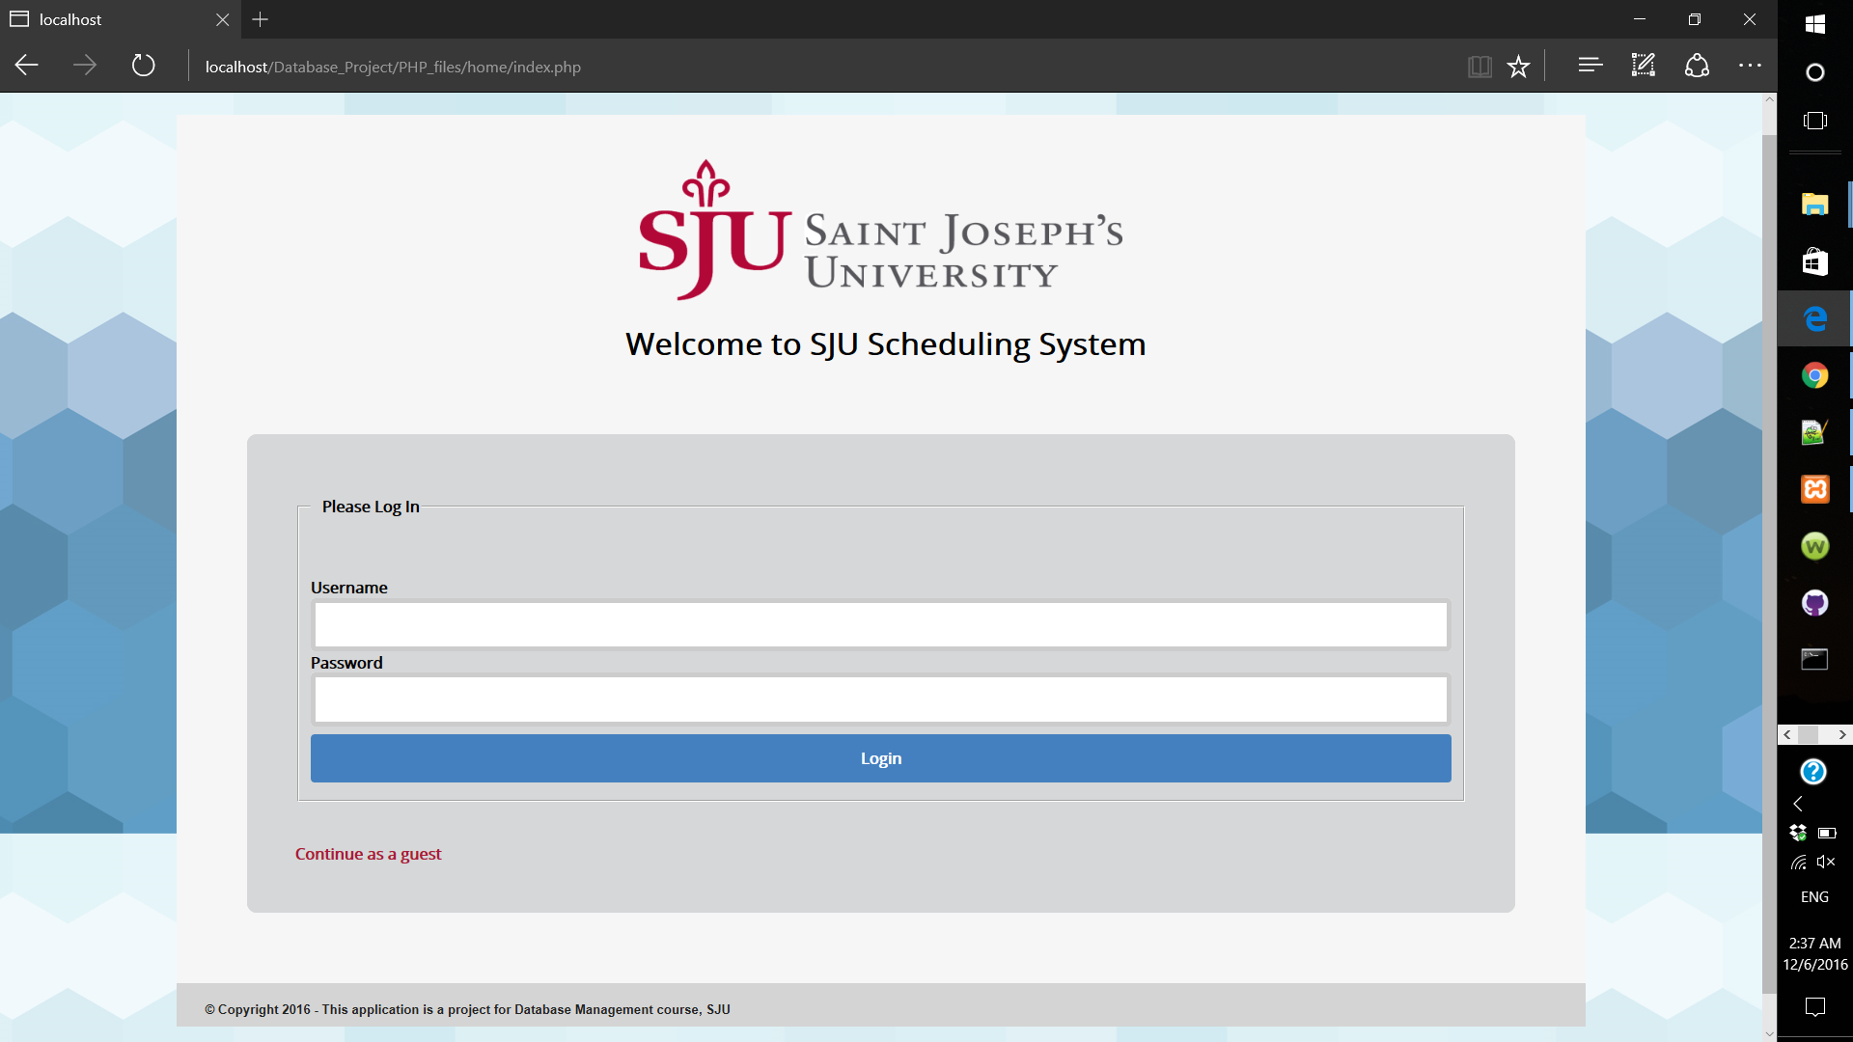

* 1. Homepage validations:
* If the user entered wrong username or password.

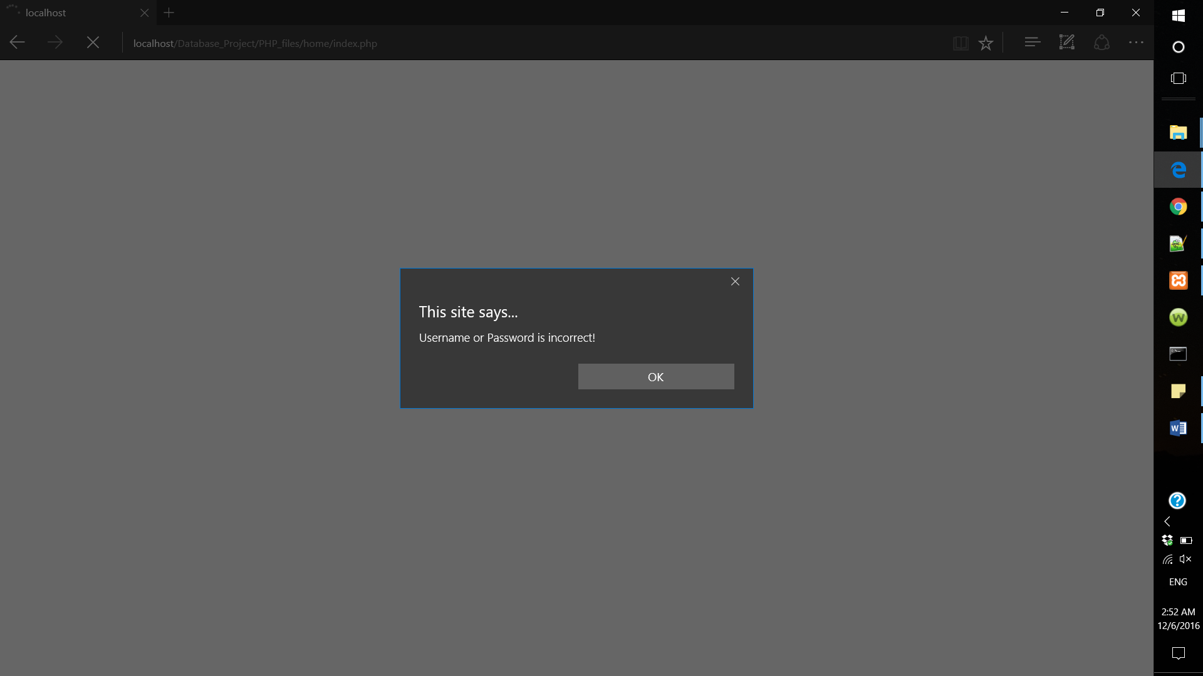

* If the user leaves the username or password field empty.

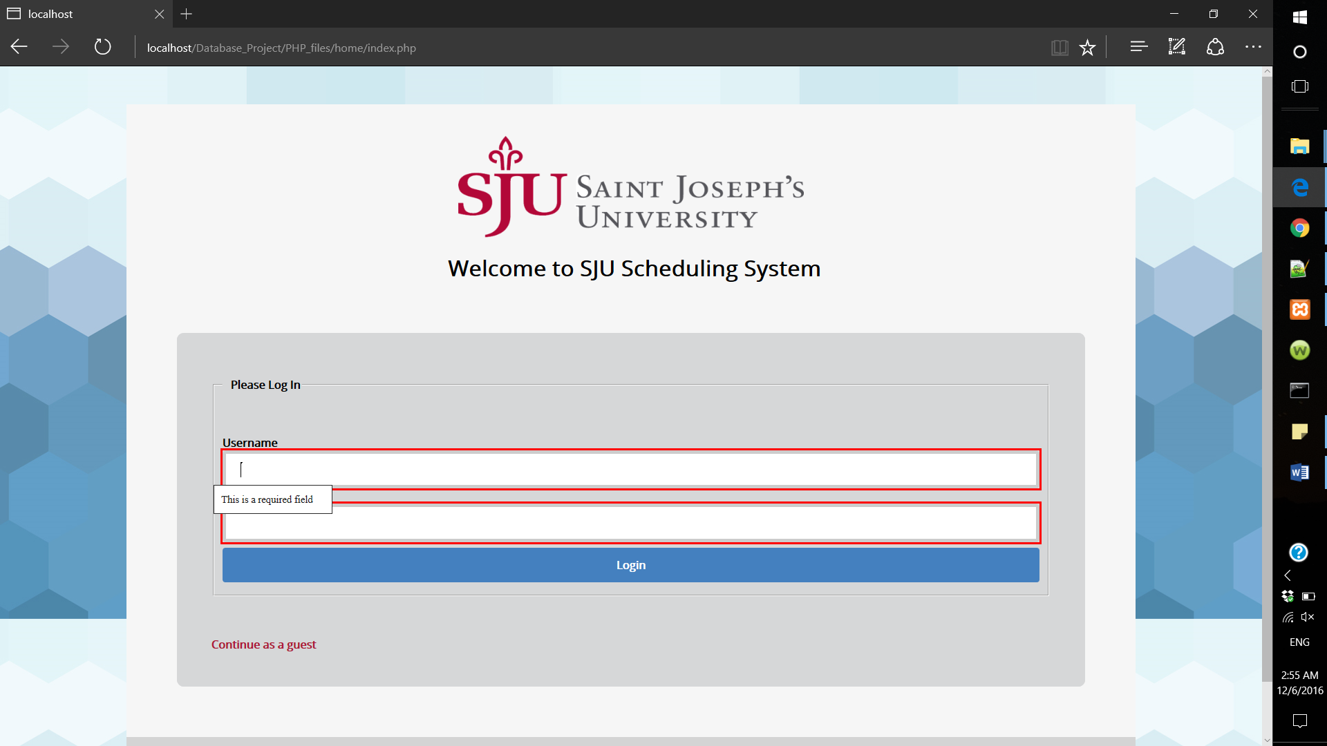

1. Employee Interfaces

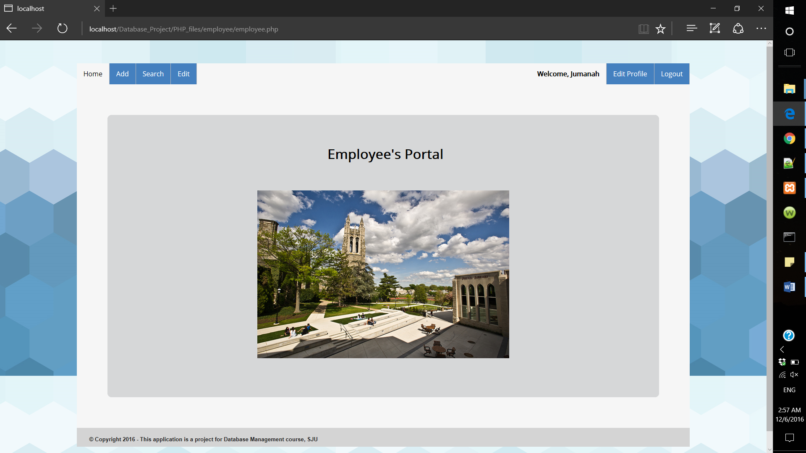

Employee’s Portal is the Employee’s main page and through this page Employees can interact with the system by adding, viewing, editing and deleting to and from the database. When the Employee logins to the system a session will start and their name will be shown next to the welcome message. The session will remain on until the user is logged out. The following code shows how the session will start.

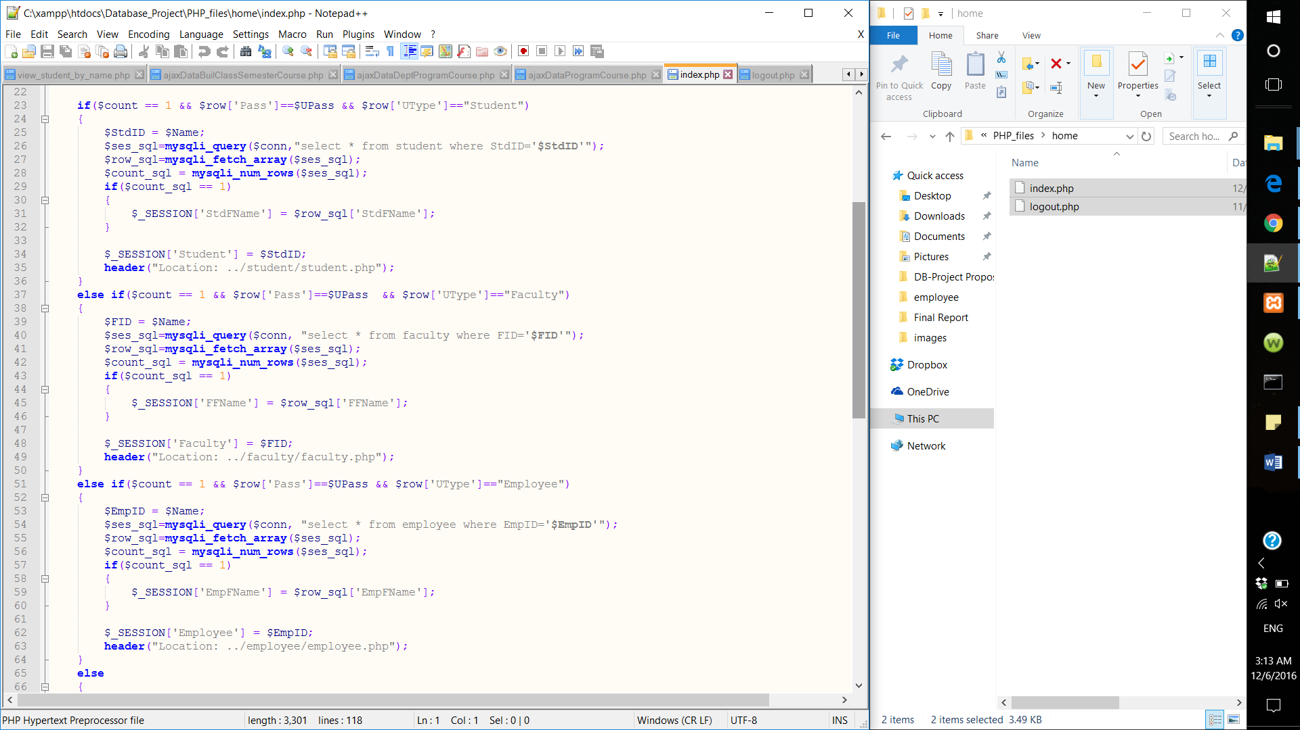

* 1. Add:

Employees can add new faculty, add new student, offer courses to a specific semester and schedule a course.

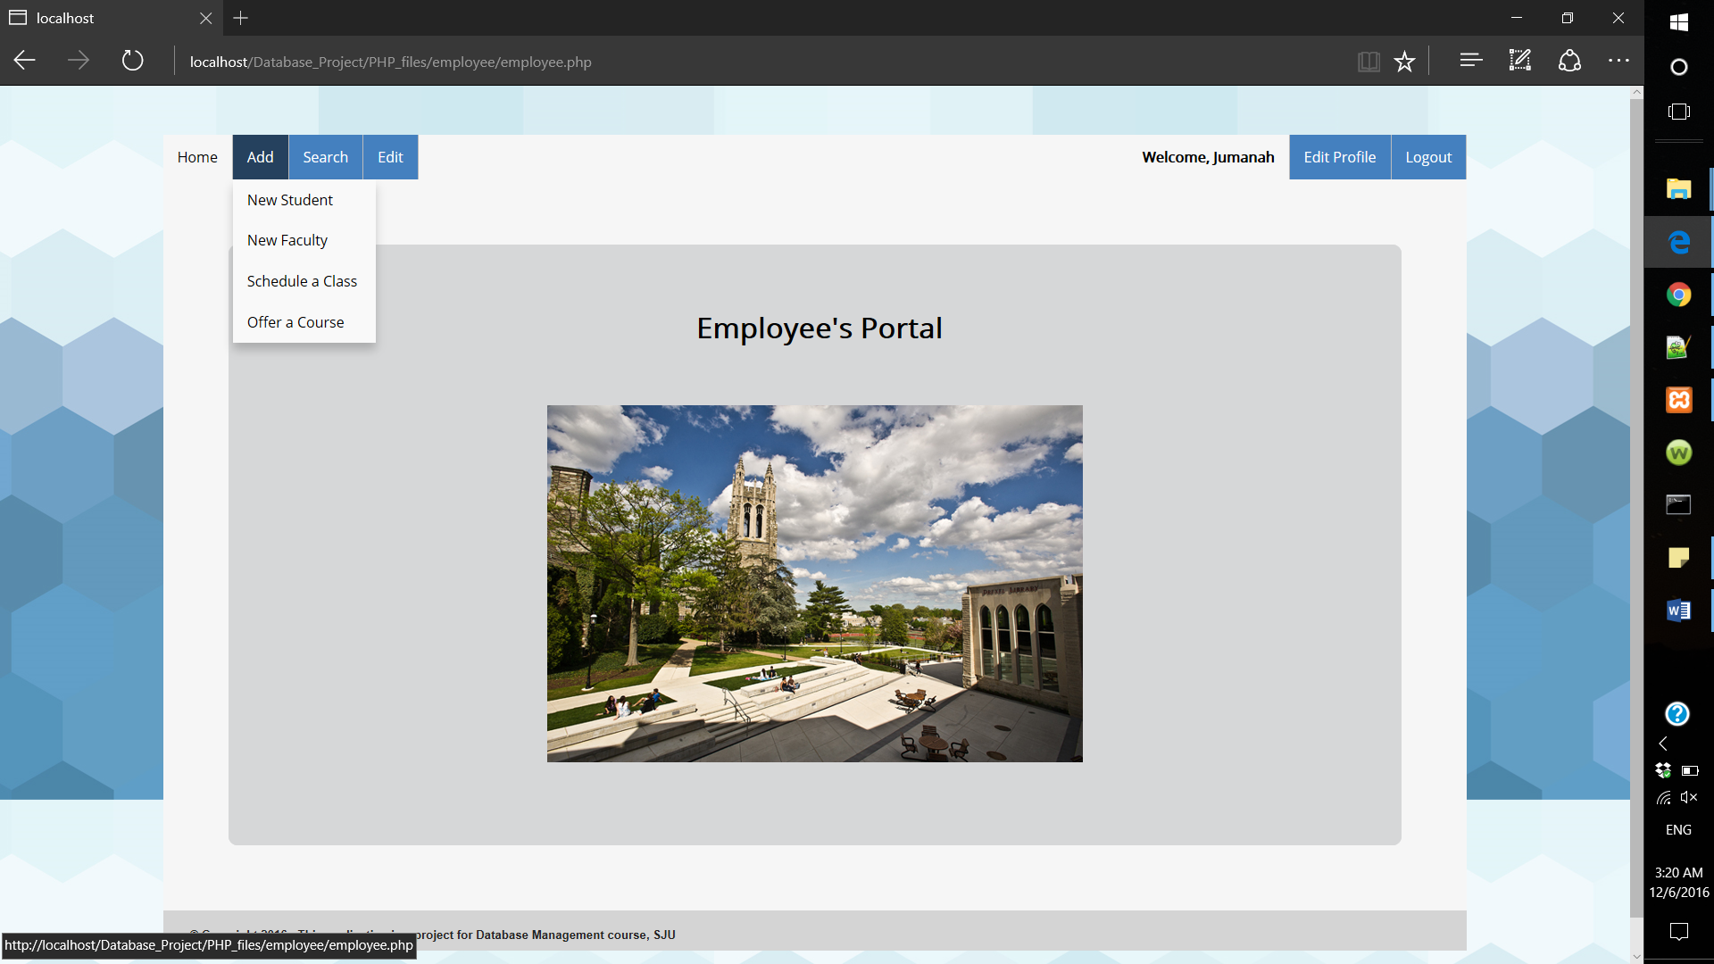

* Add new student:

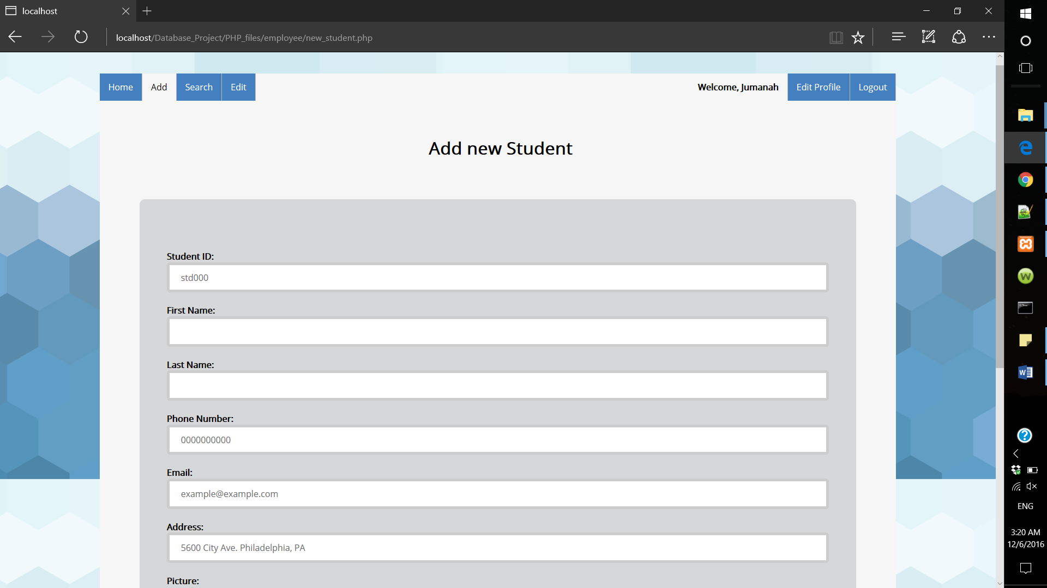

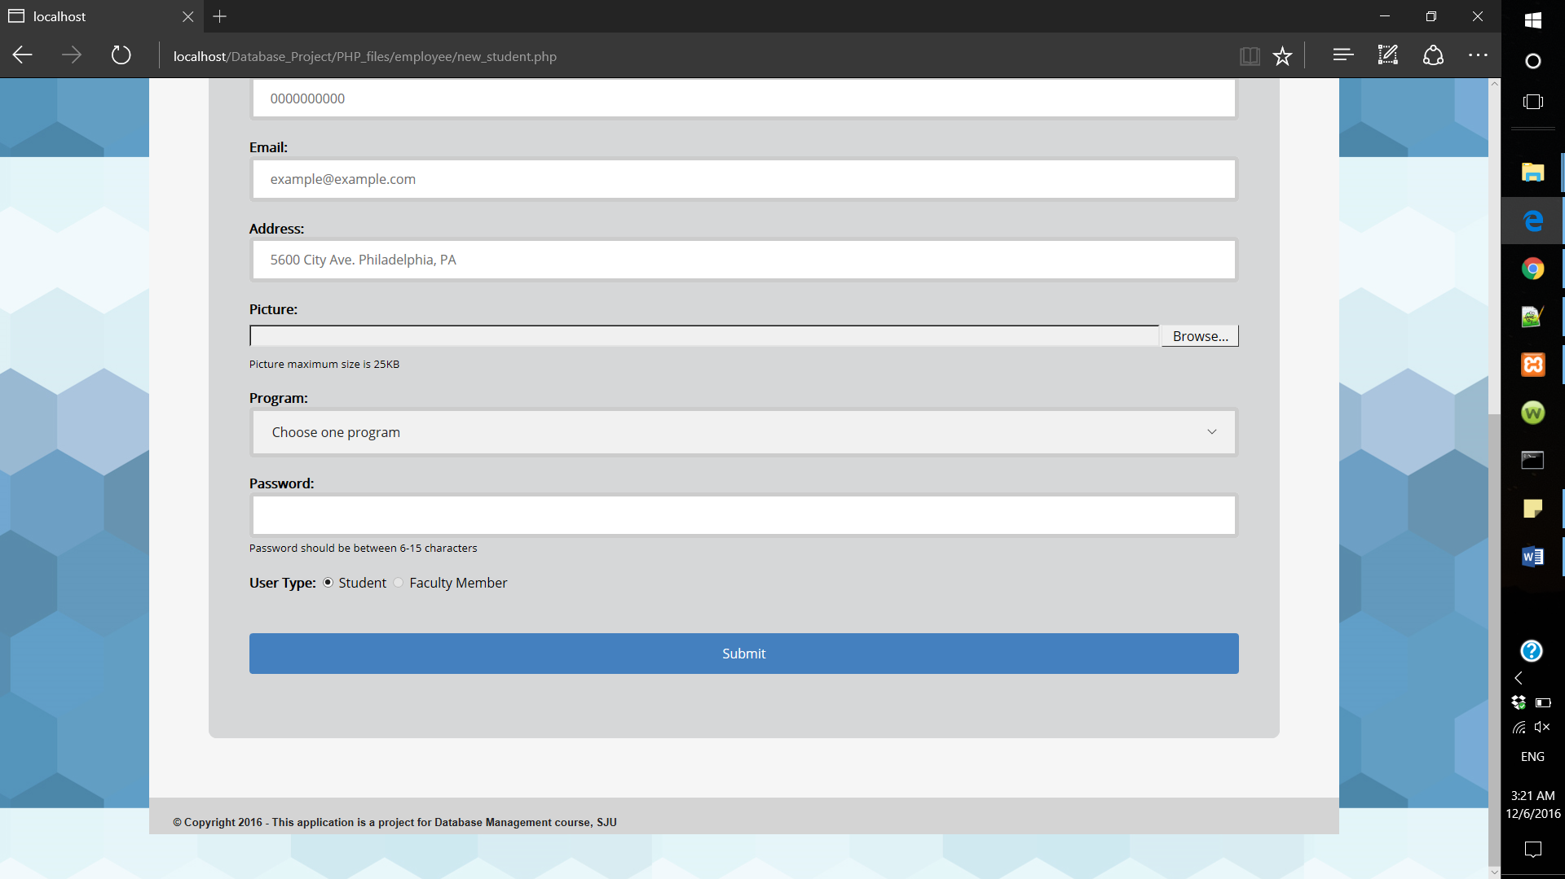

All fields are required, except for the student picture, if the employee missed any of the fields the following message will appear.

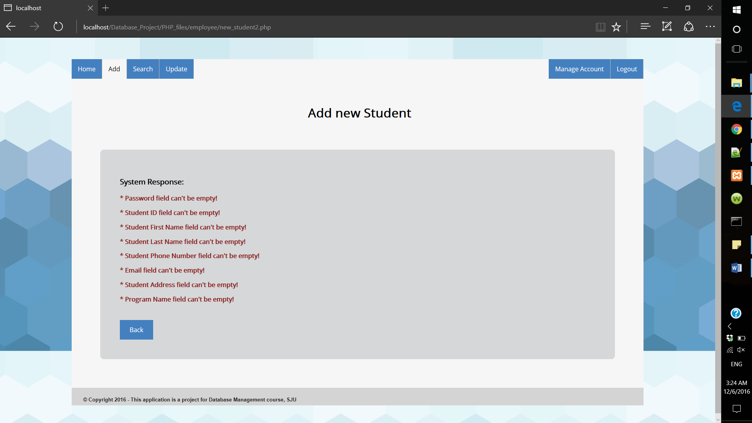

The insertion query is written as the following:

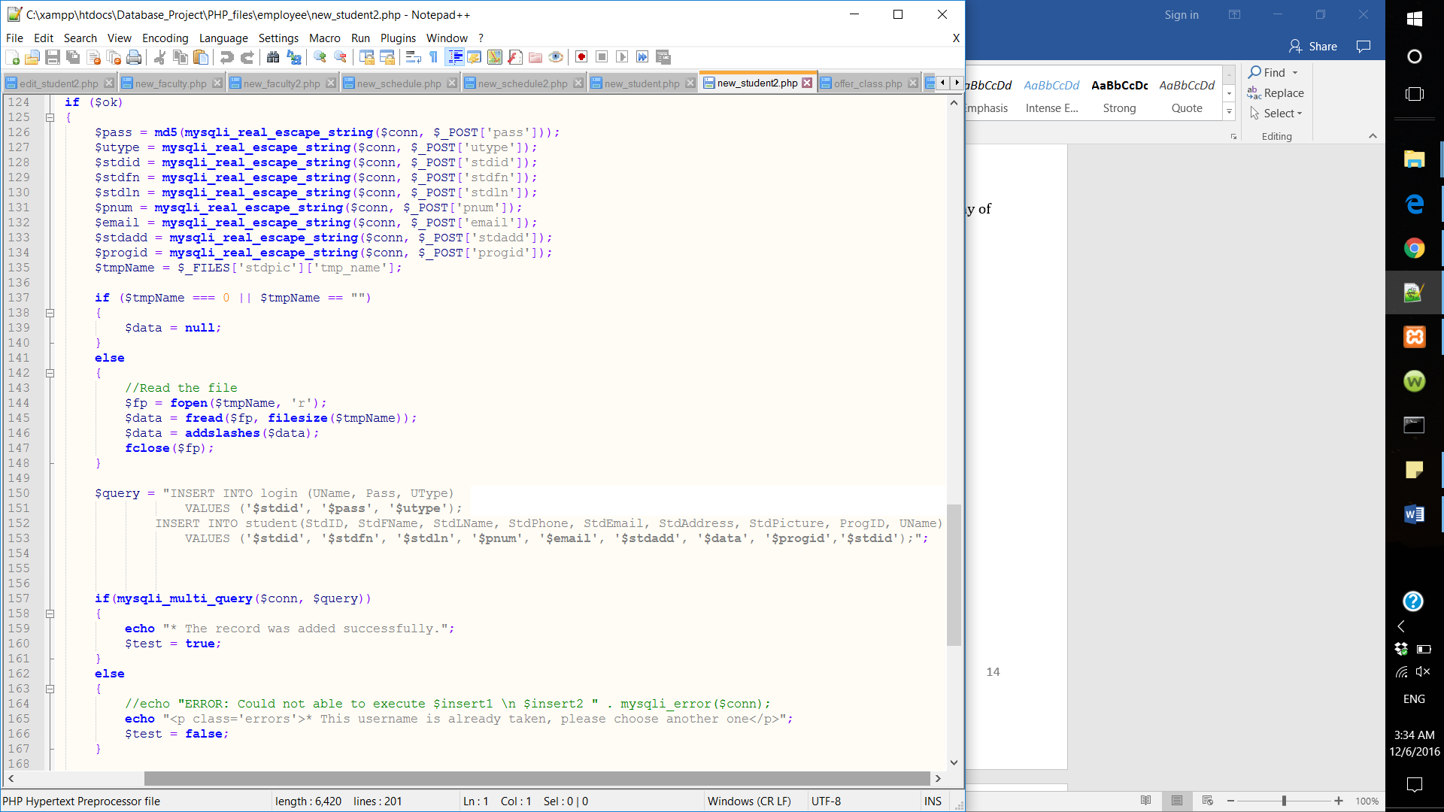

To make our database more secure we stored a hashed password in the database using the md5 algorithm.

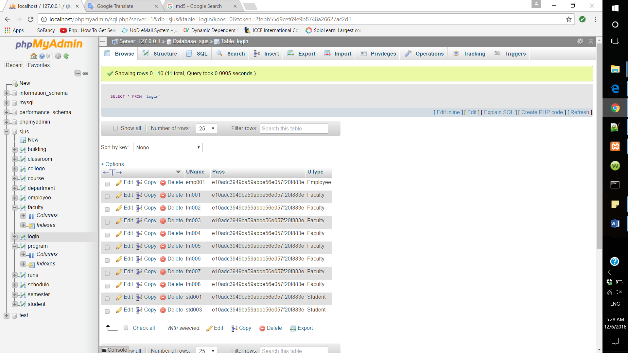

* Add new faculty:

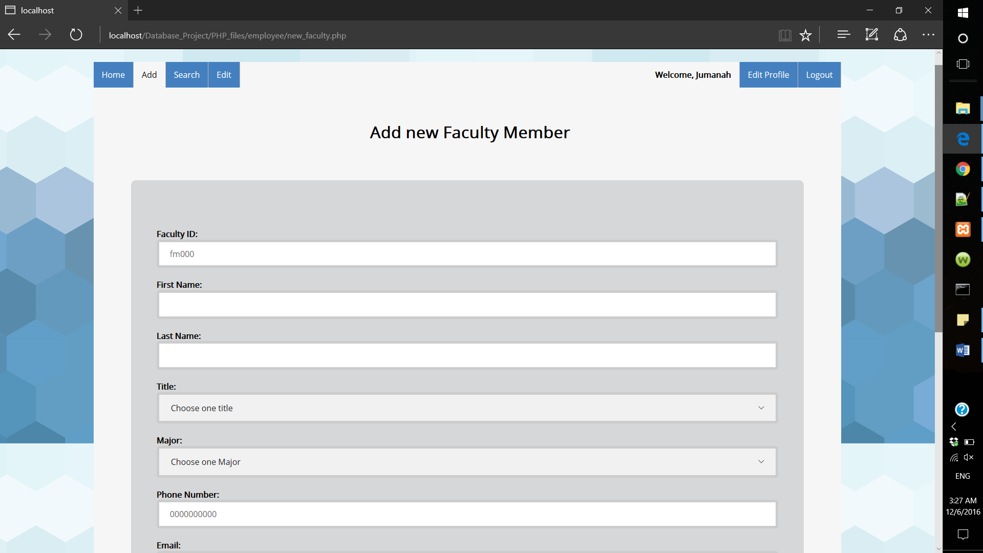

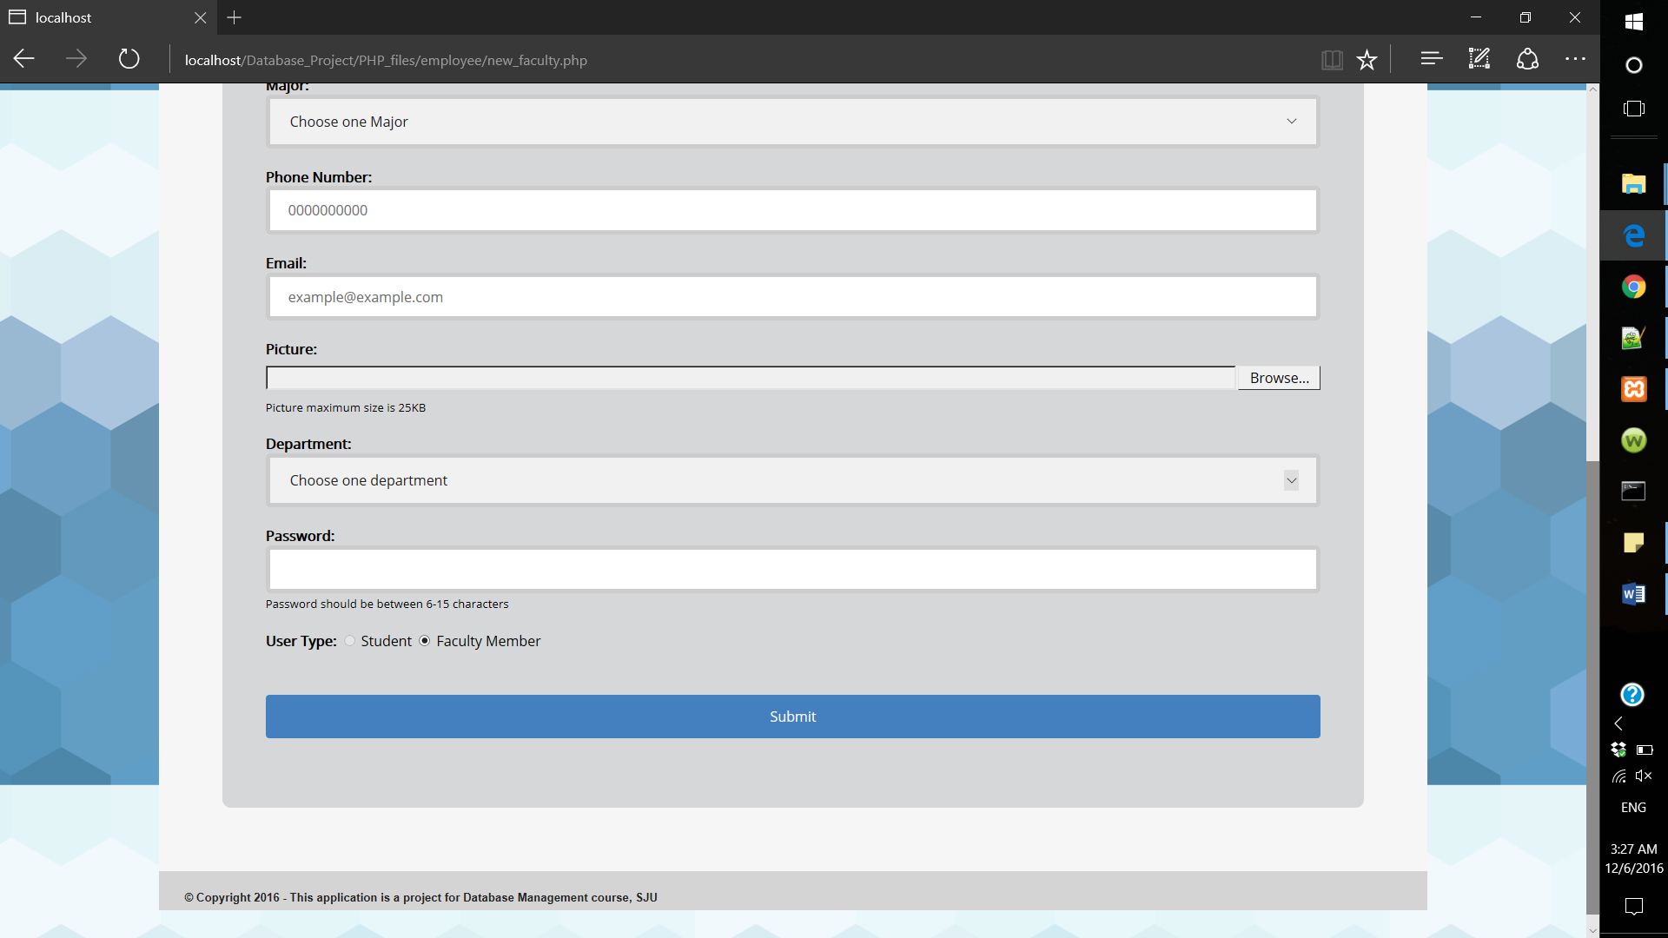

All fields are required, except for the faculty picture, if the employee missed any of the fields the following message will appear.

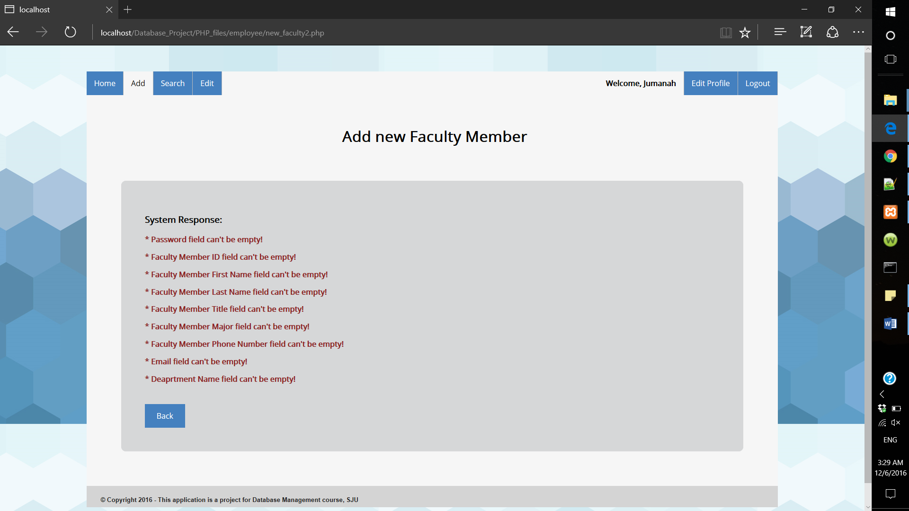

The insertion query is written as the following:

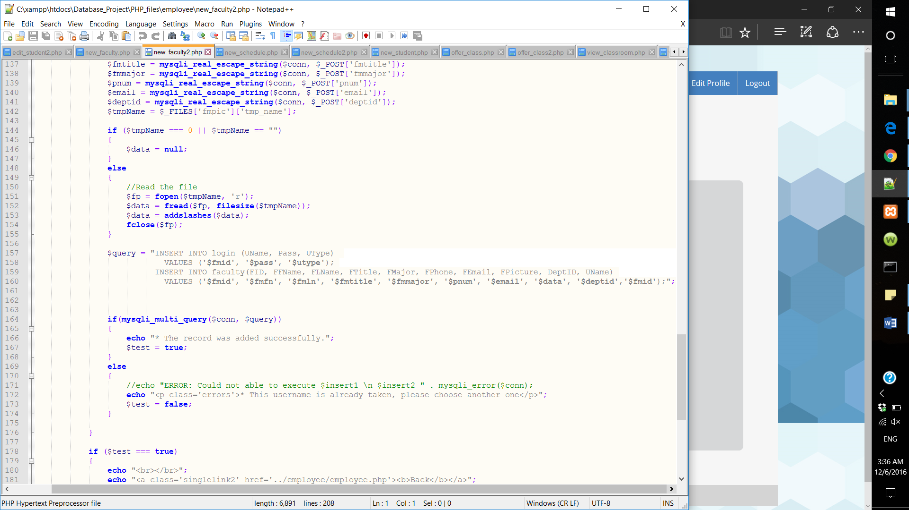

* Offer a course:

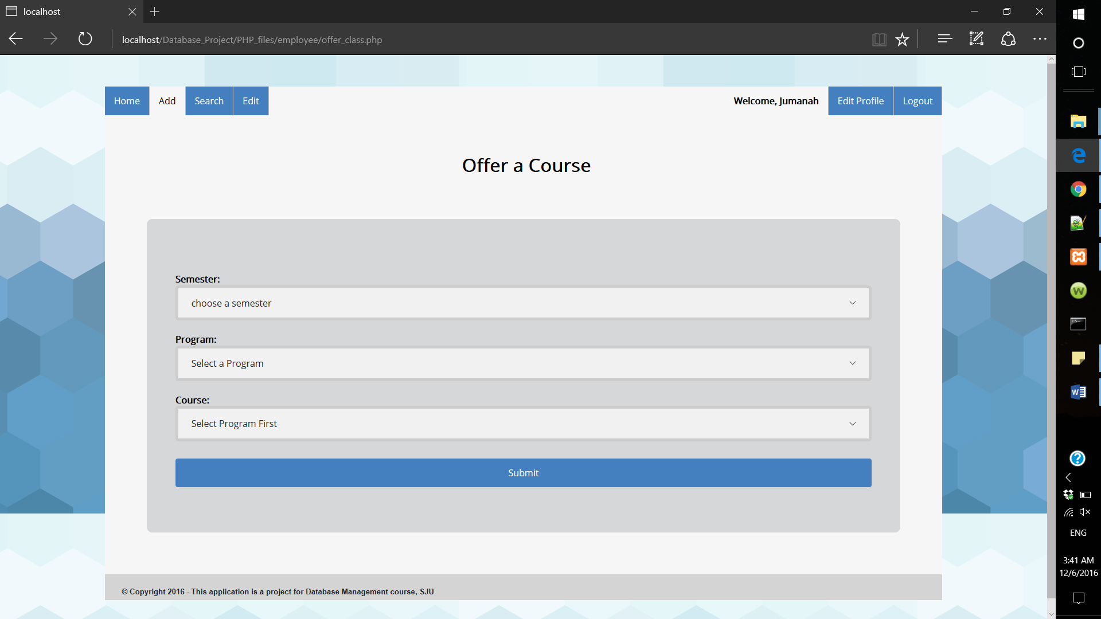

Through this page the employee can offer a course in a semester. The employee must choose the semester first then choose the program. After choosing the program the system will show a list of all courses that belongs to that program. This feature was implanted using AJAX and JQuery.

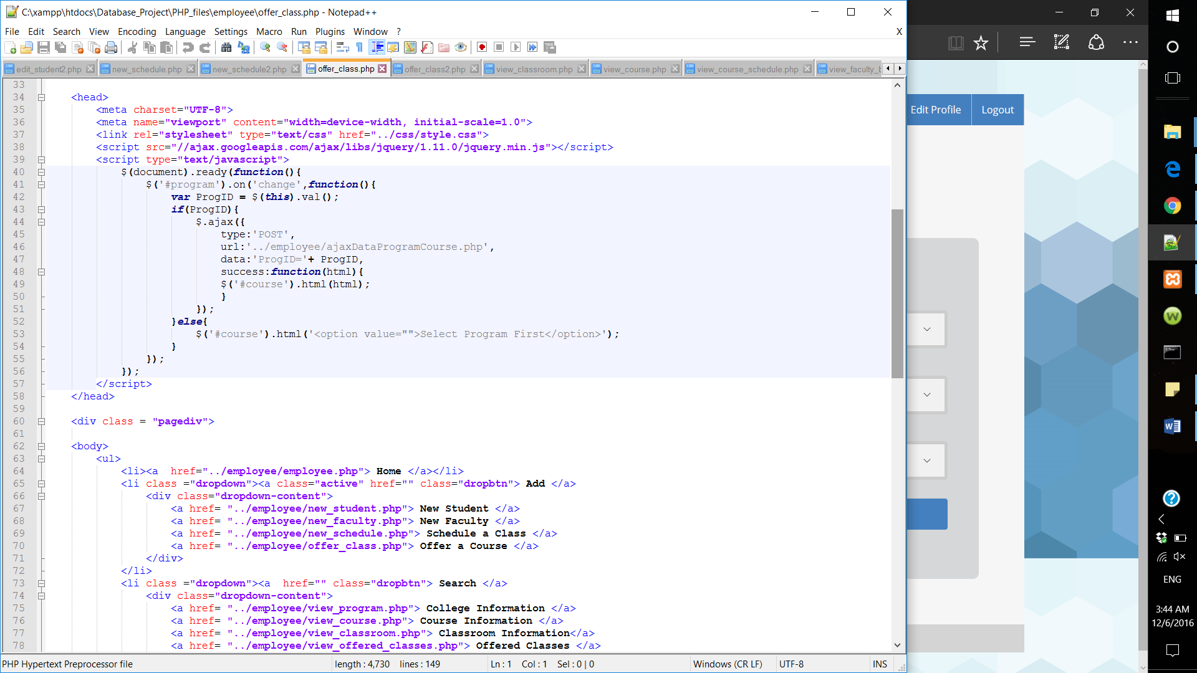

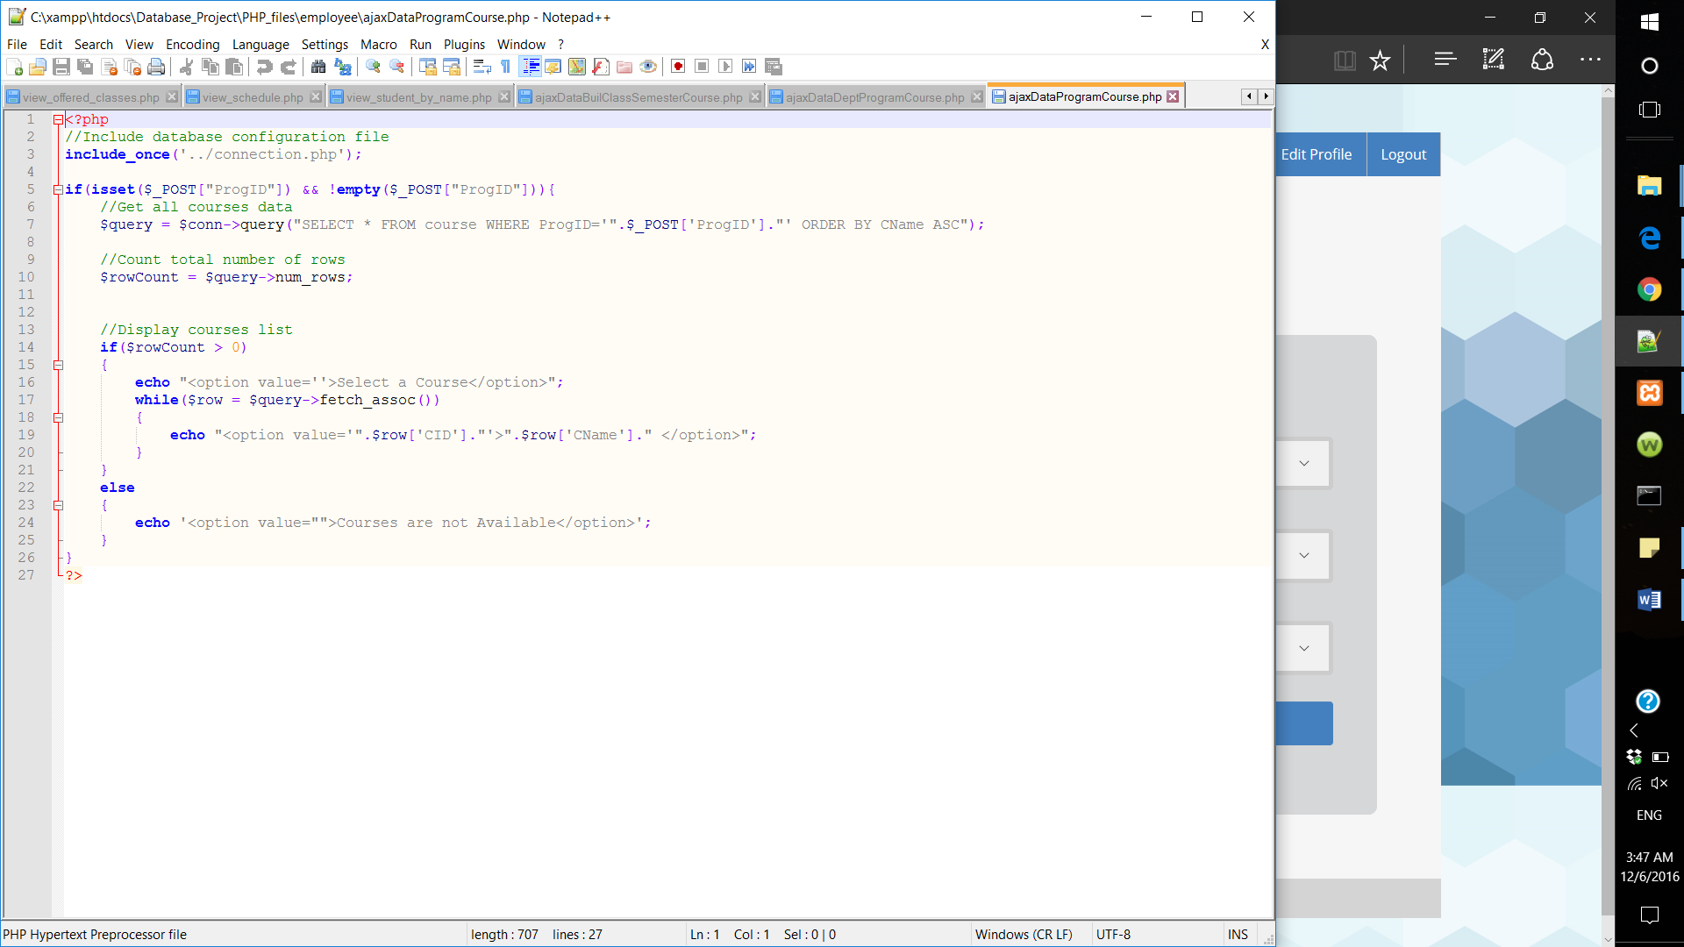

If the course was added successfully the following message will appear:

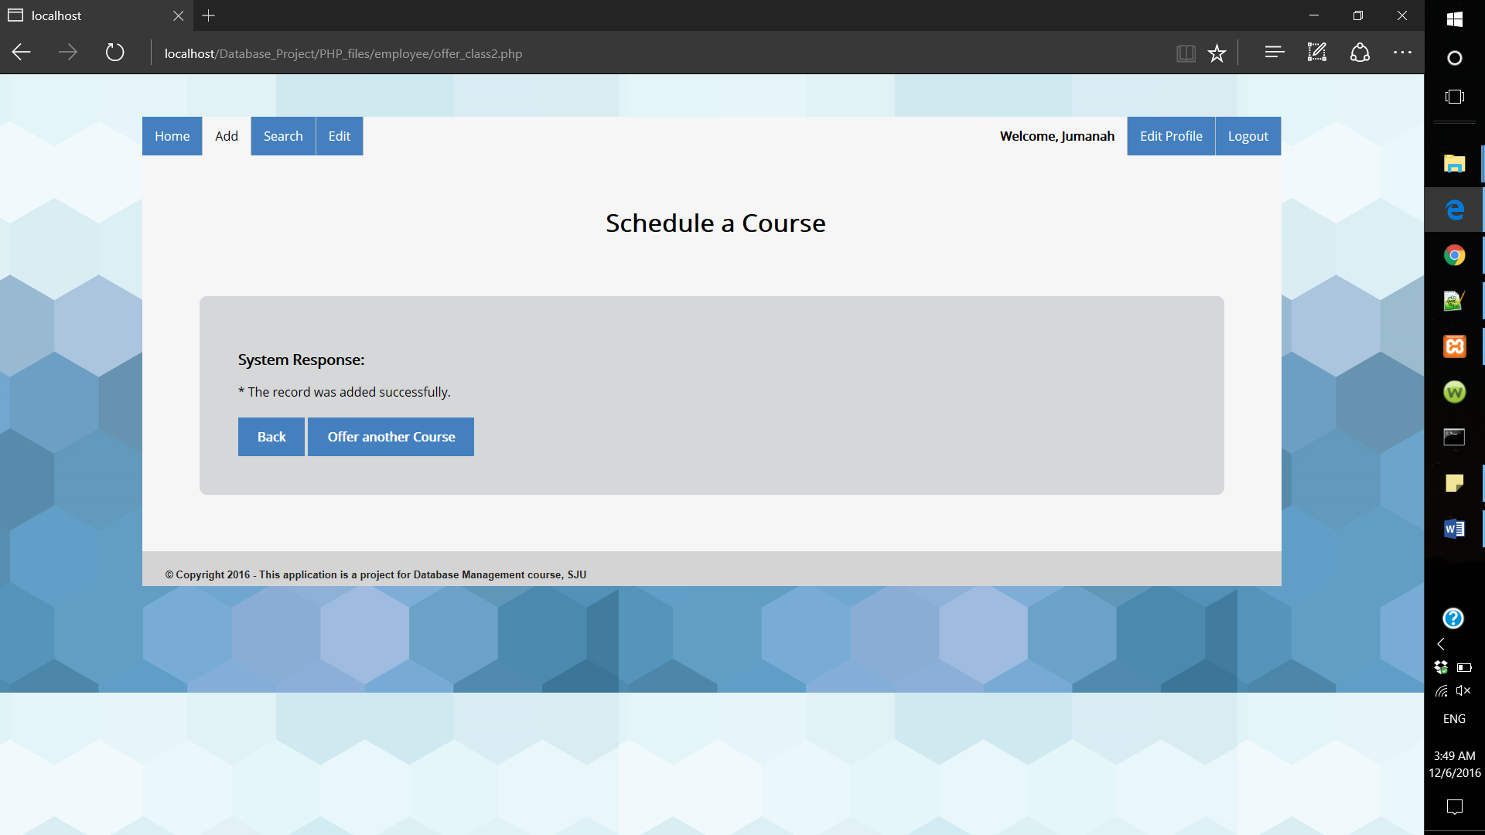

Otherwise, an error message will appear:

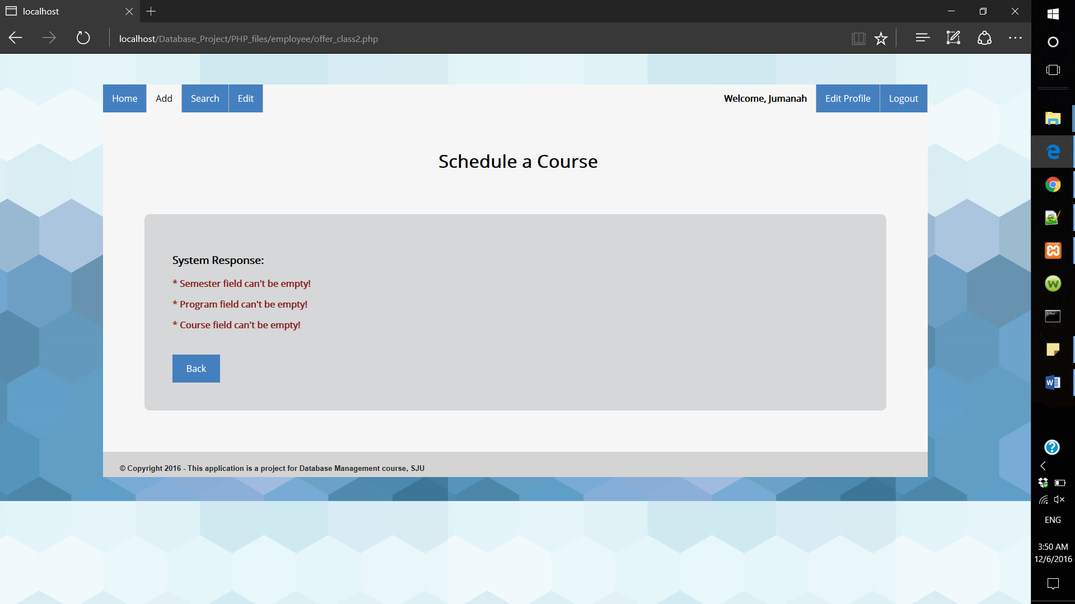

* Schedule a course

One of the main features in our system, through this page employees can schedule courses in a certain day, time and classroom.

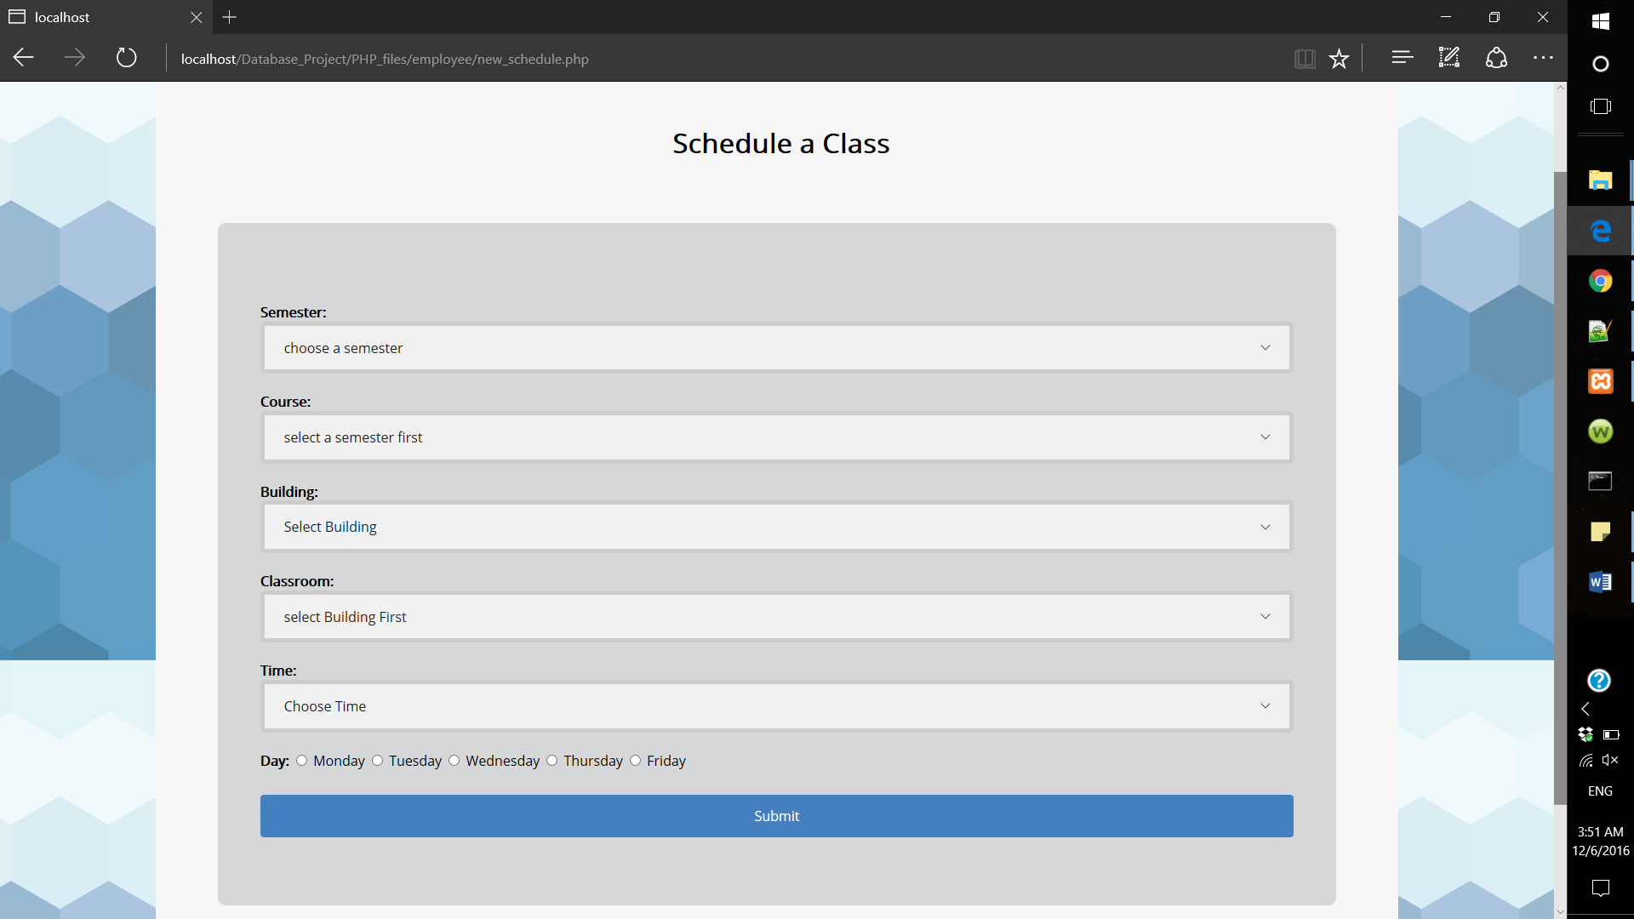

Also in this page, we used AJAX and JQuery to view all classes that in a certain building and to show offered courses in the selected semester.

If the course was scheduled successfully the following message will appear:

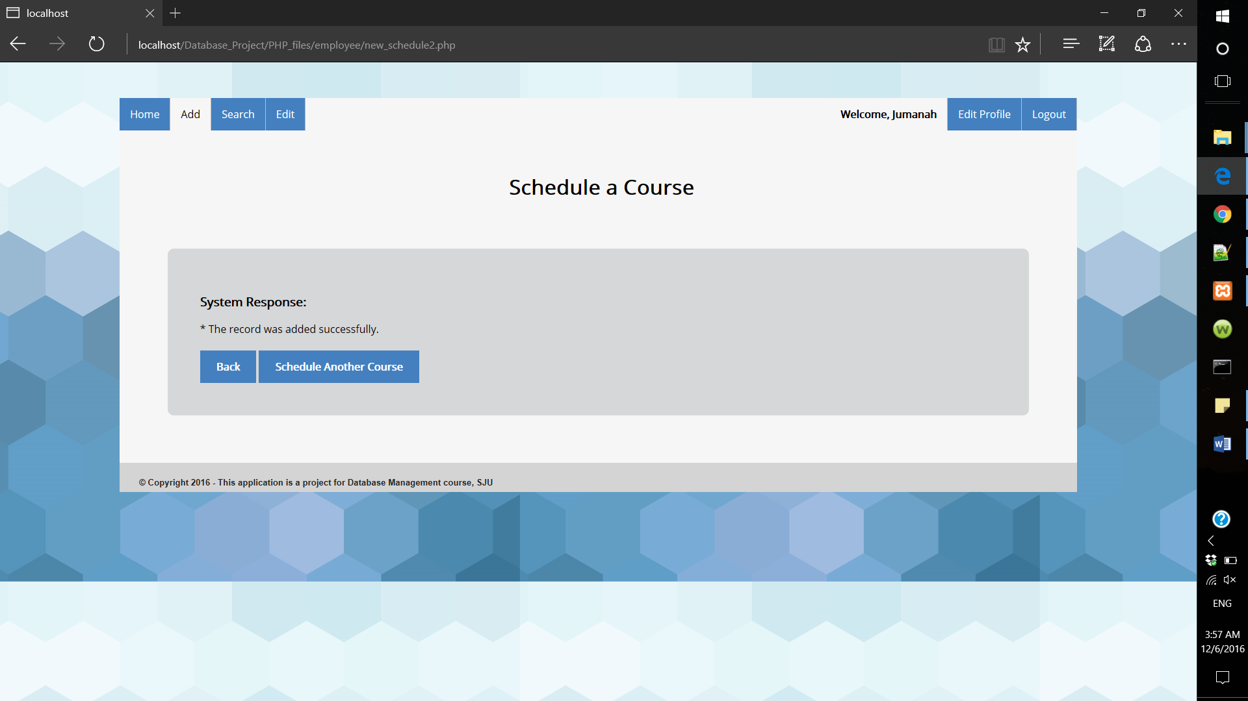

Otherwise, an error message will appear.

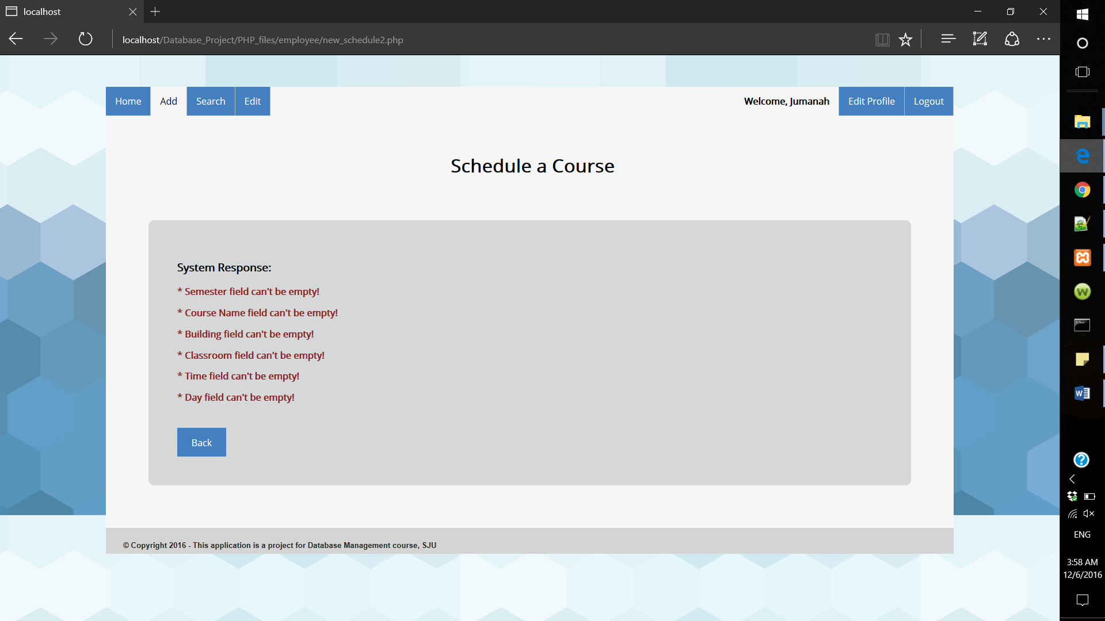

Employee cannot schedule a course in two classes at the same time and day. Also, the employee cannot schedule two courses in the same classroom at the same time and day. If so, the following error message will appear:

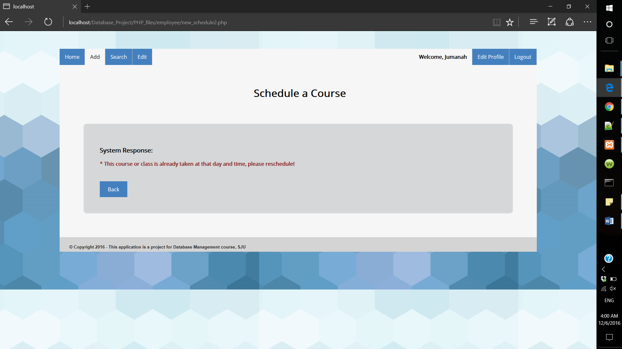

All dropdown lists are fetched from the database. For example, getting the programs and semester list.

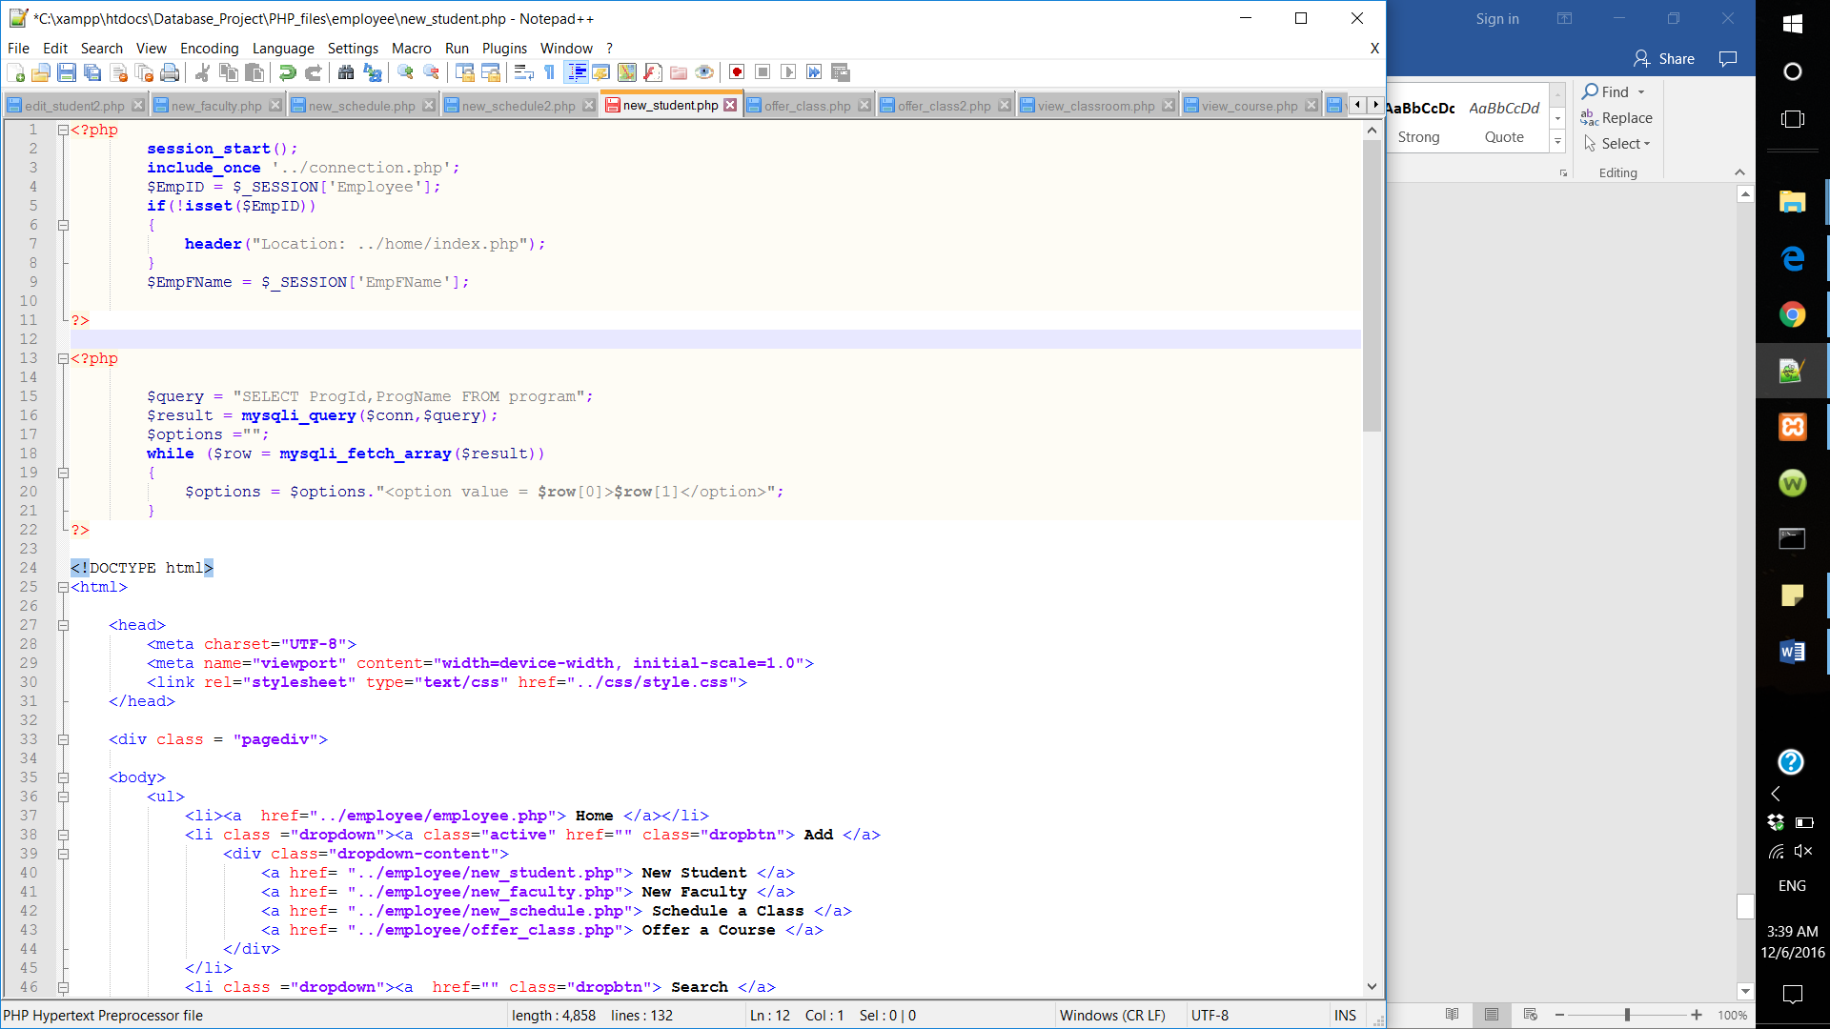

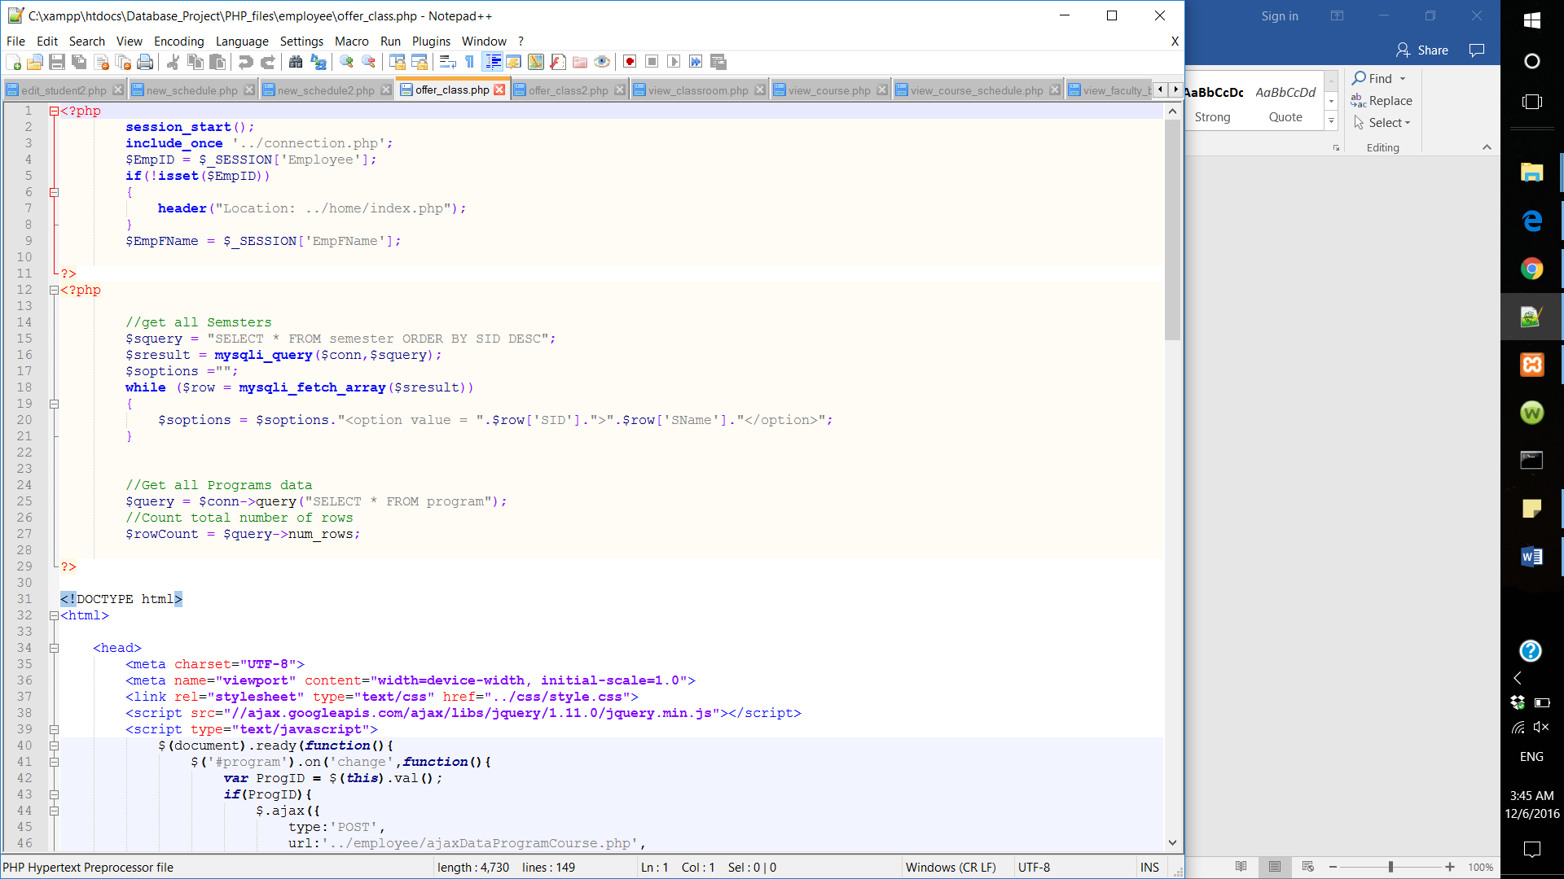

* 1. Search:

Employees can search for college information, course information, classroom information, offered courses, schedule, student information and faculty information

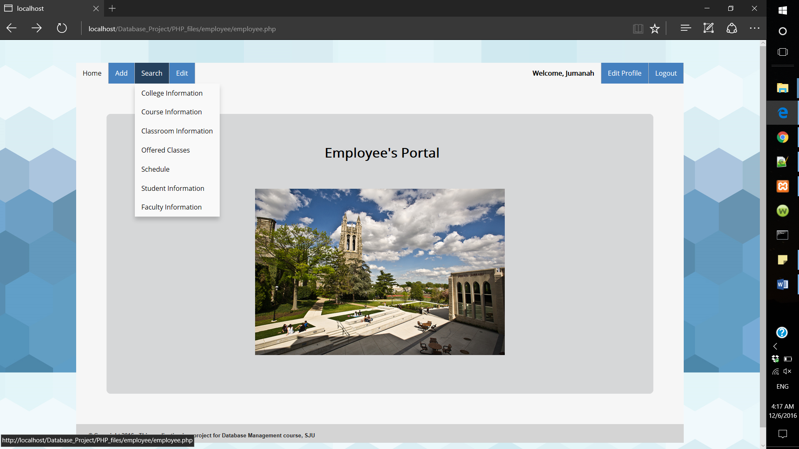

* College Information: From this page Employee can get information about a specific college.

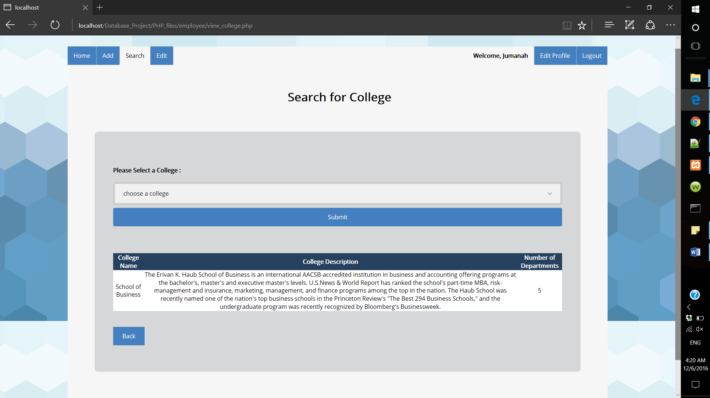

The query for this form is shown as the following:

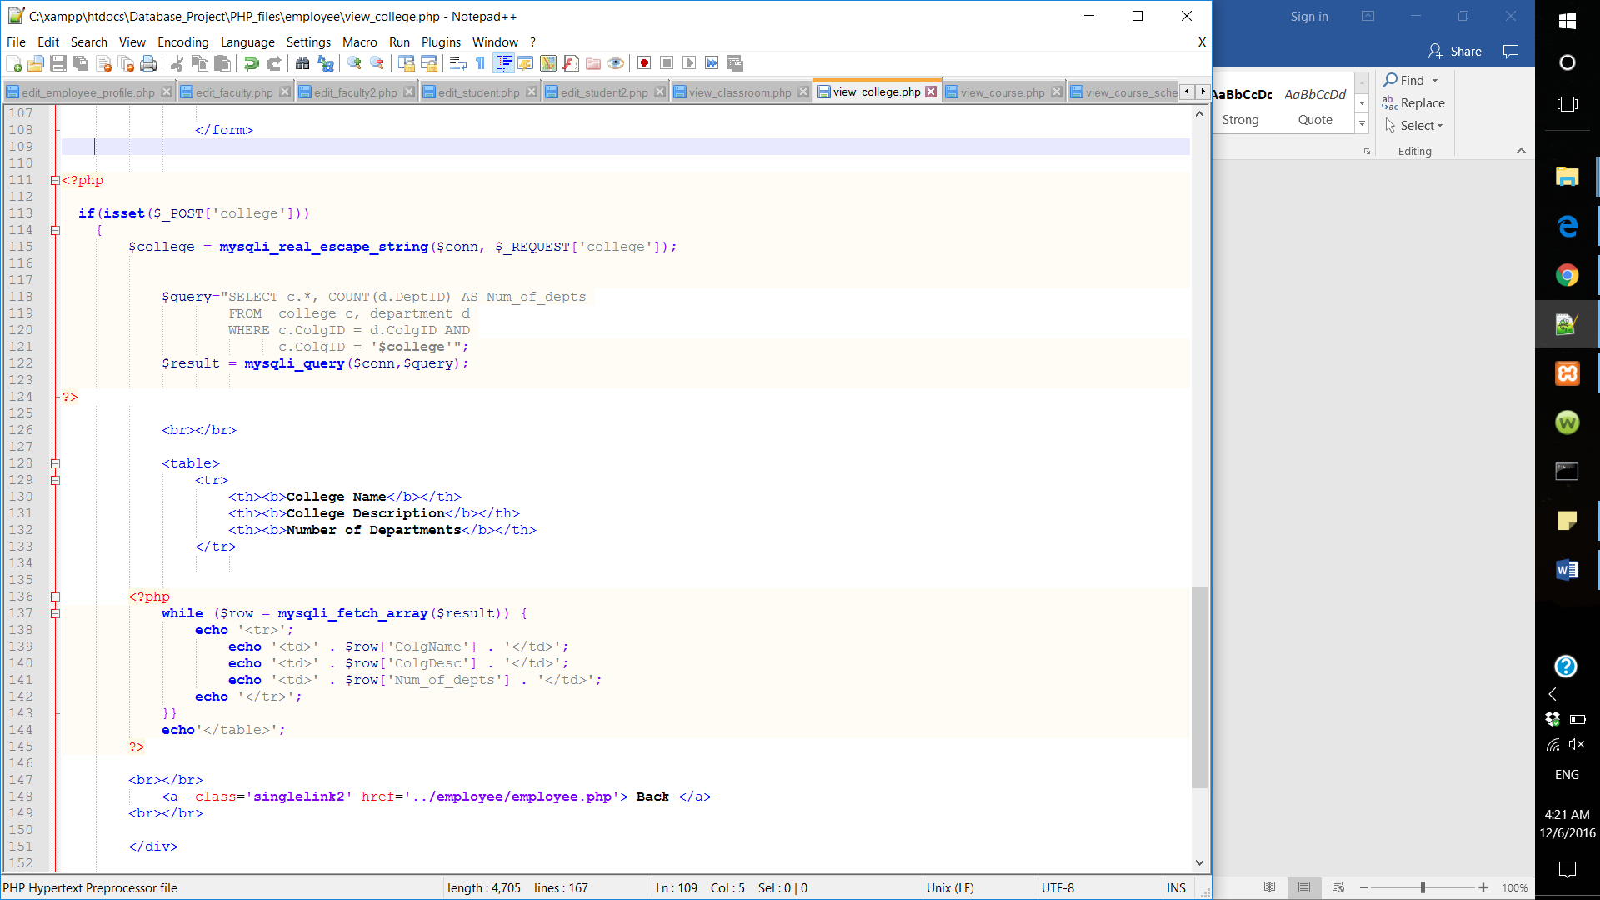

* Search for course description

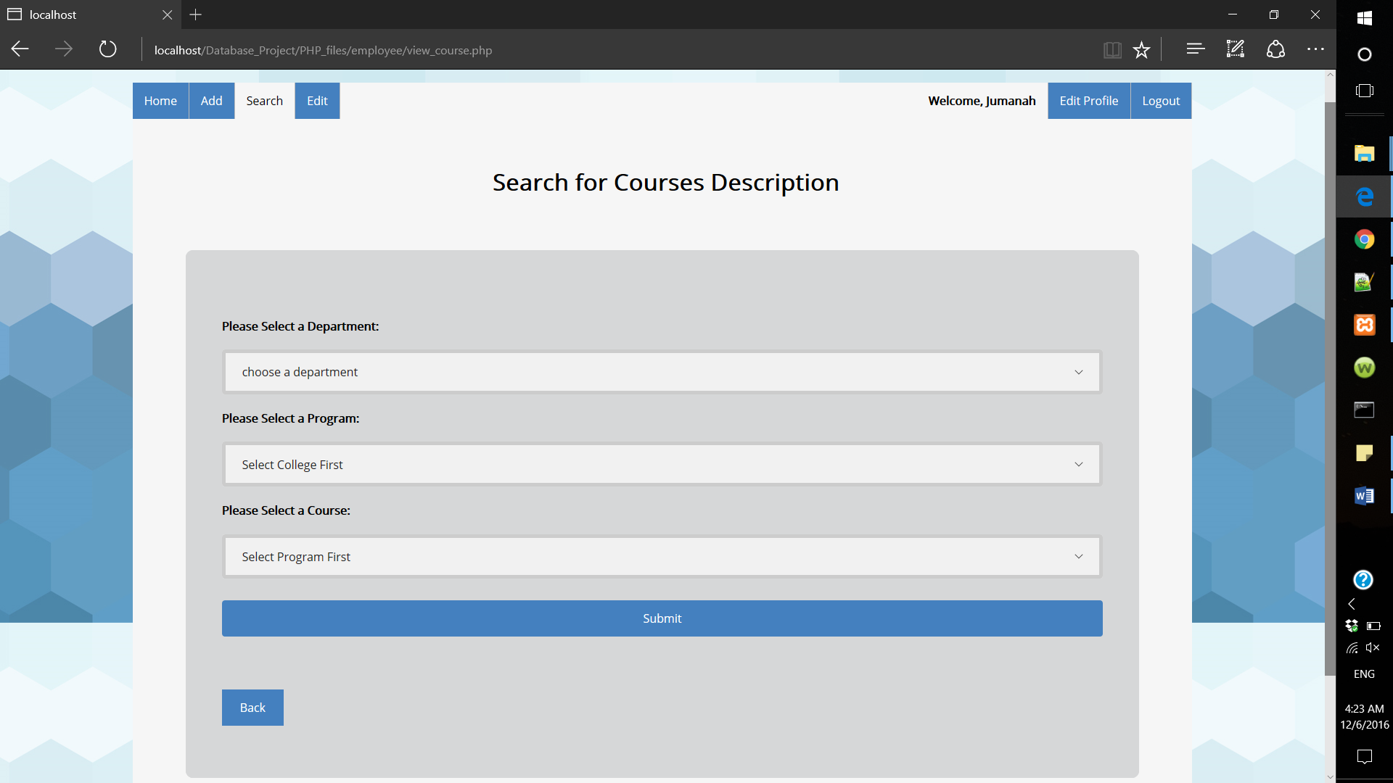

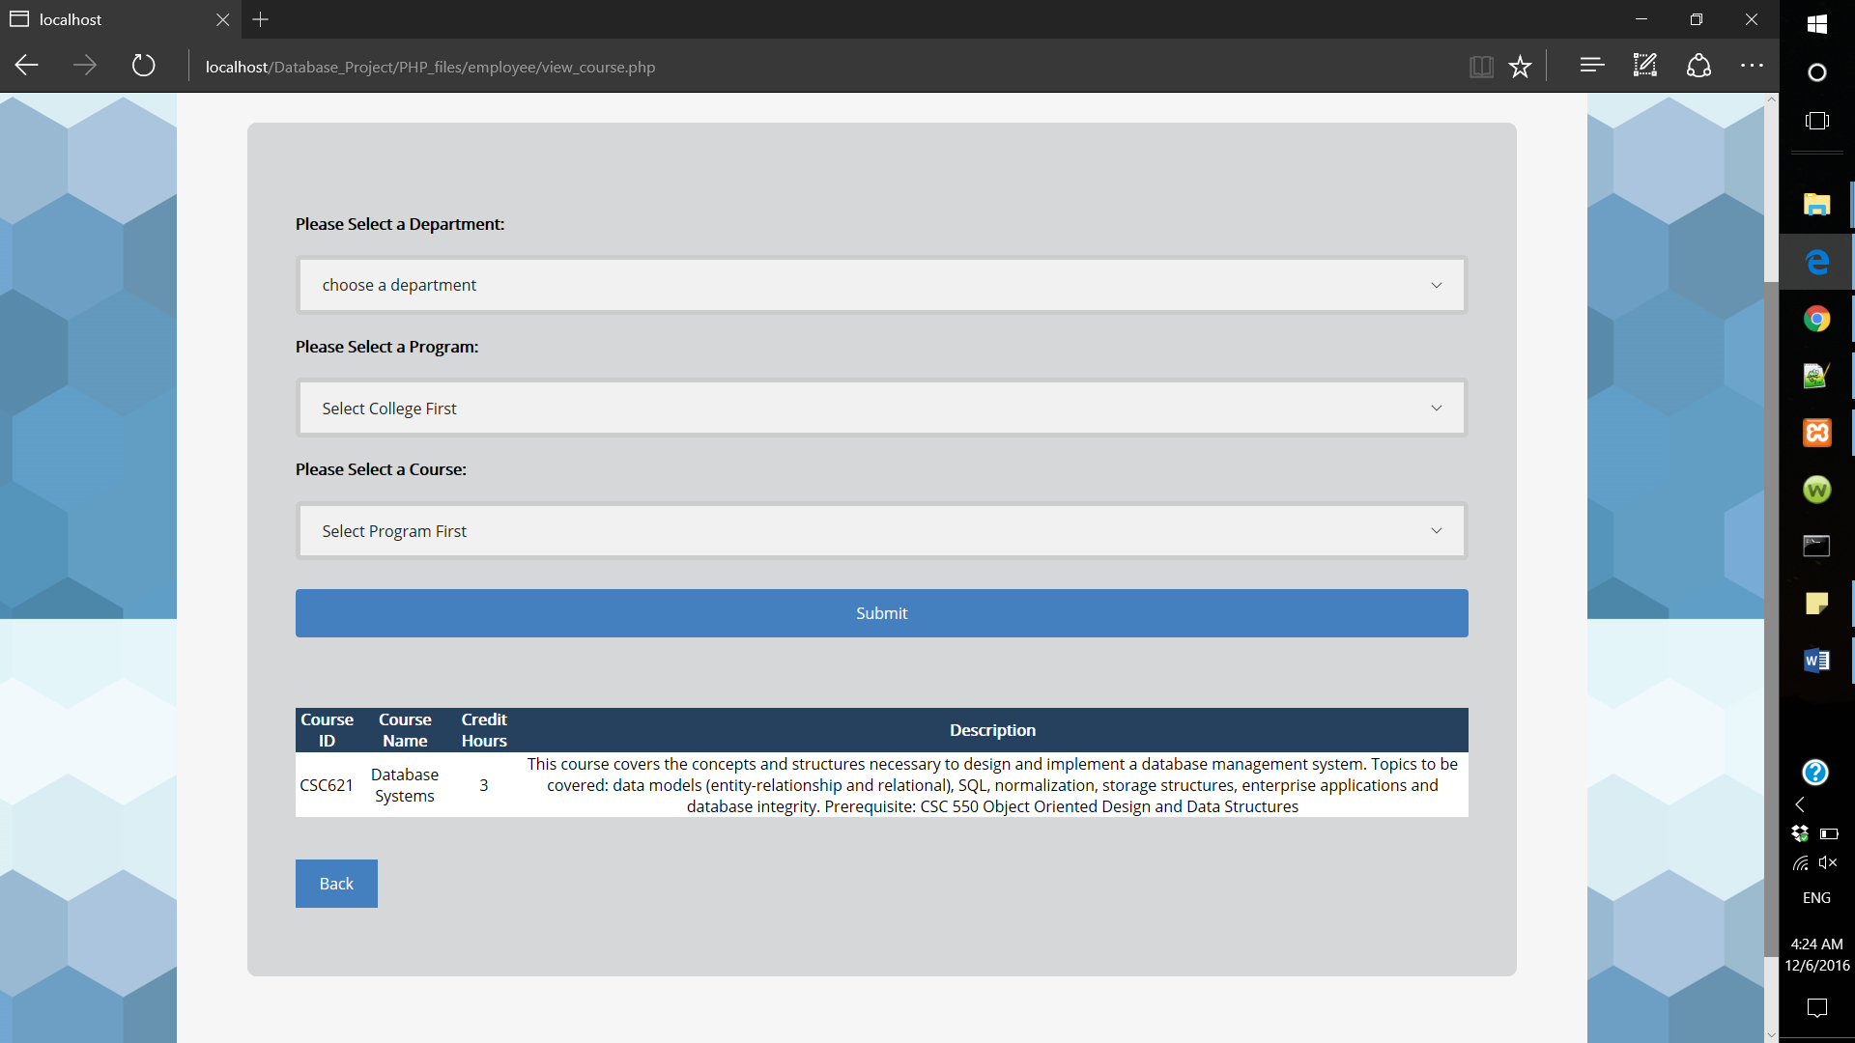

Query used in this form:

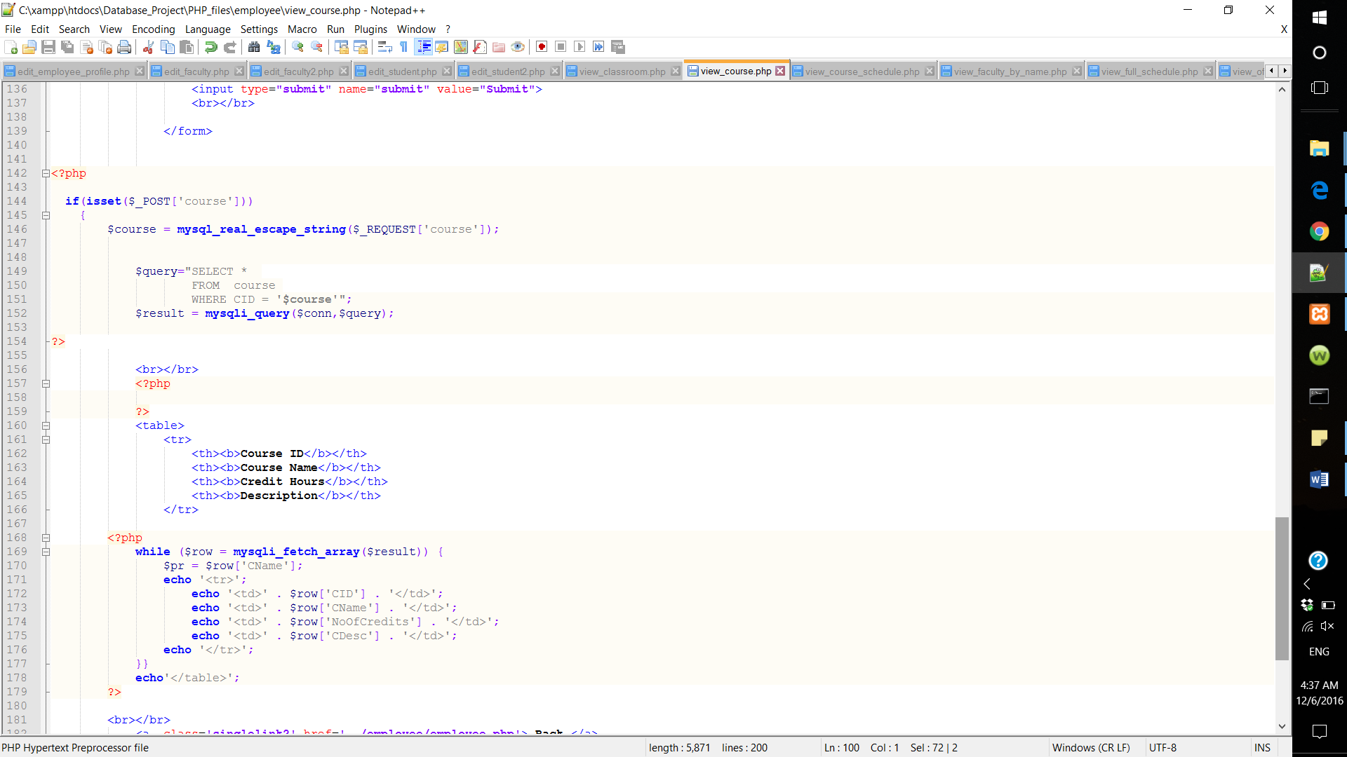

* Classroom Information: If an employee wants to schedule a course and he/she needs more information about the classrooms. Though this form he/she can get information about any classroom by selecting the building name.

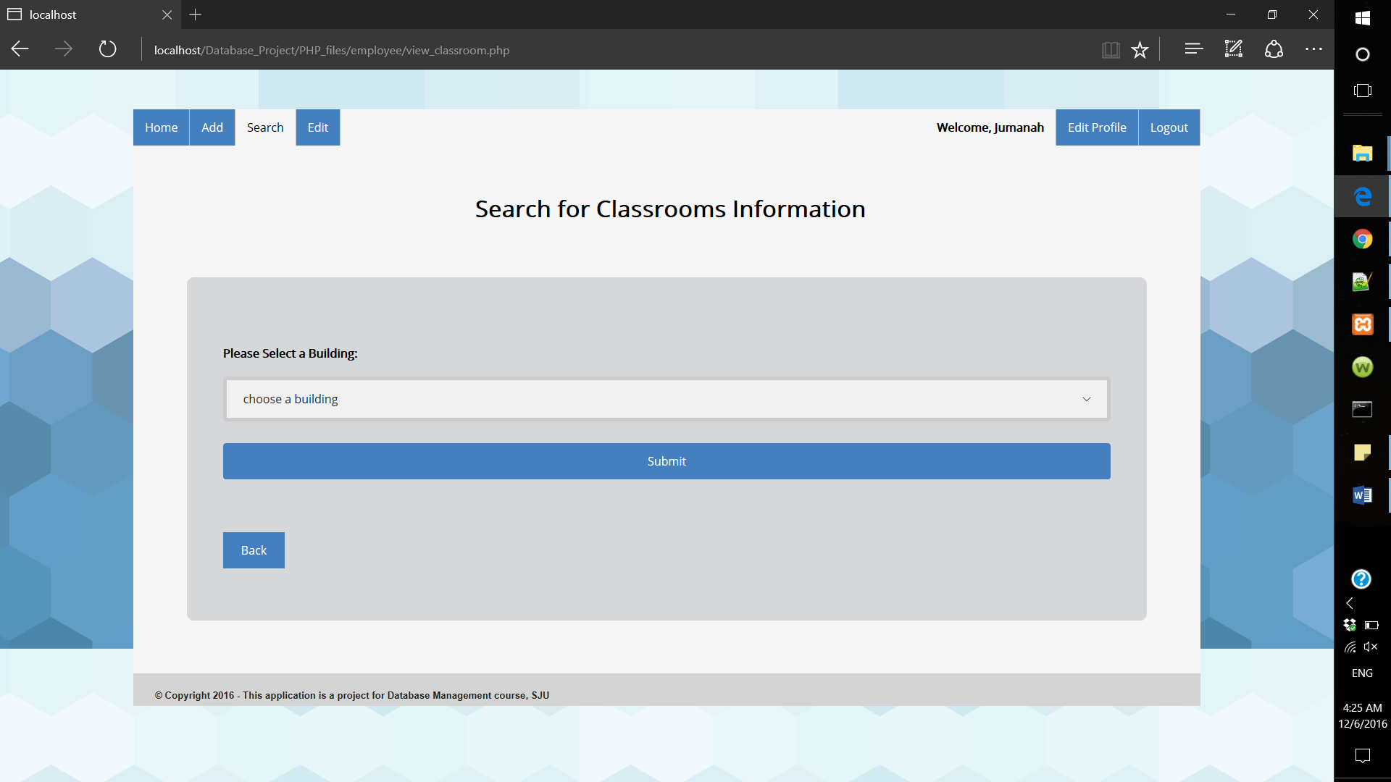

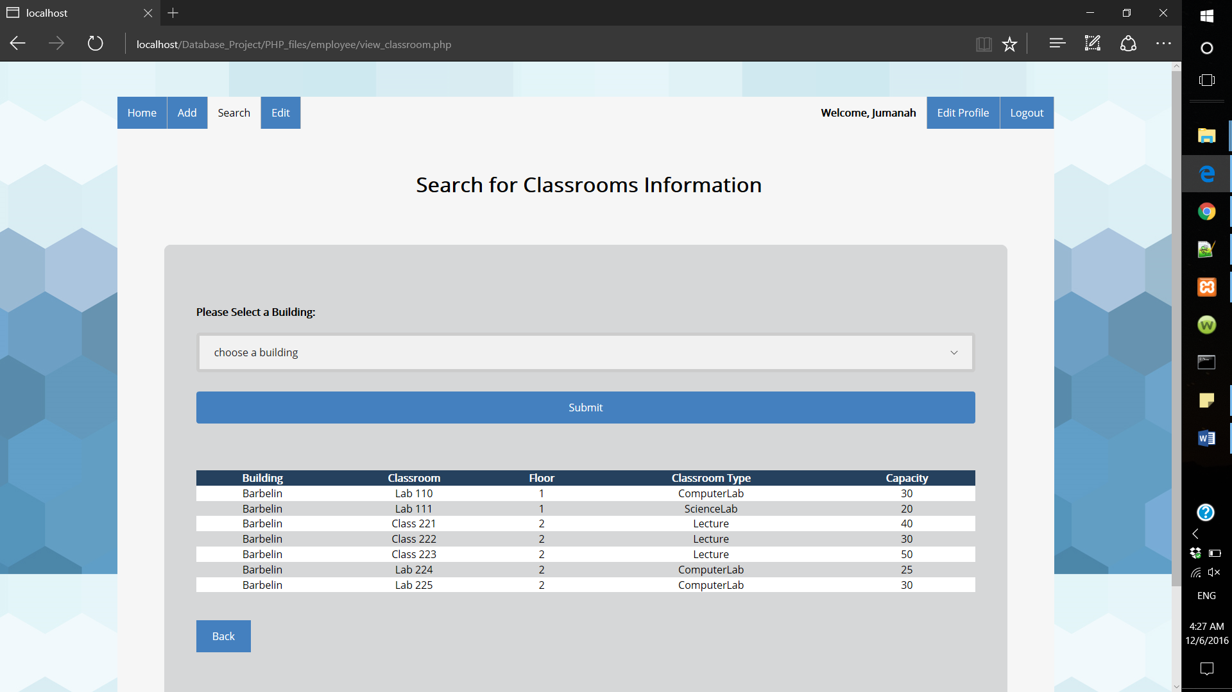

Query used in this form:

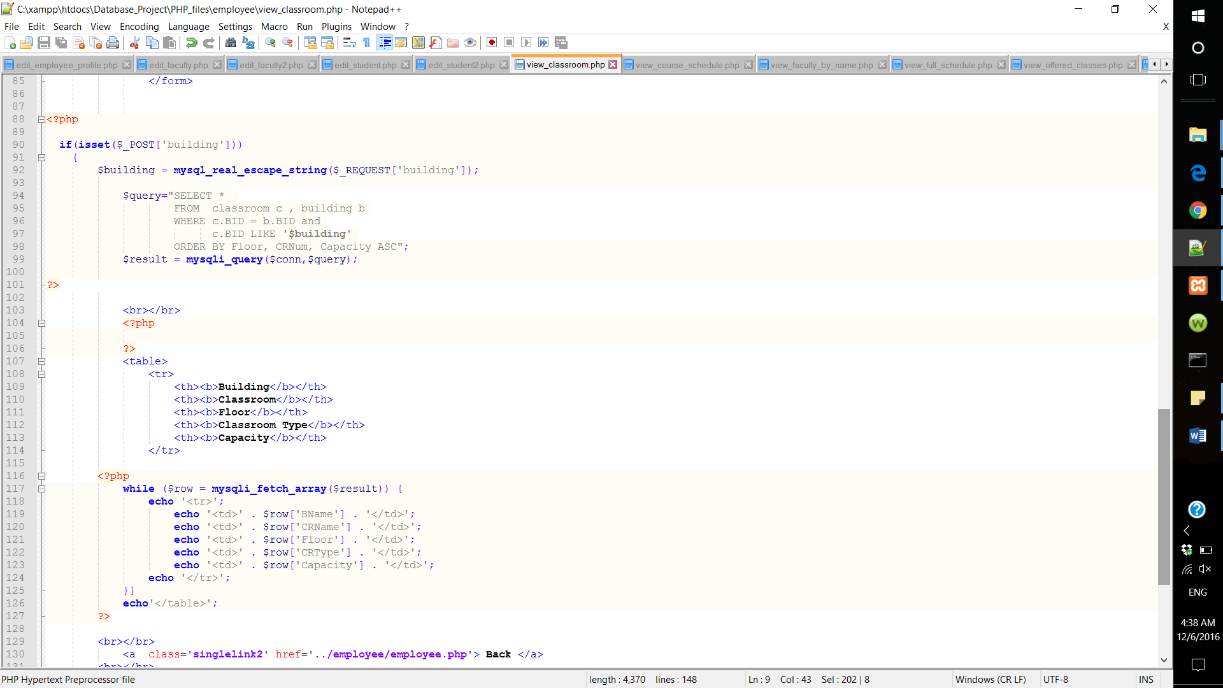

* Search for offered courses

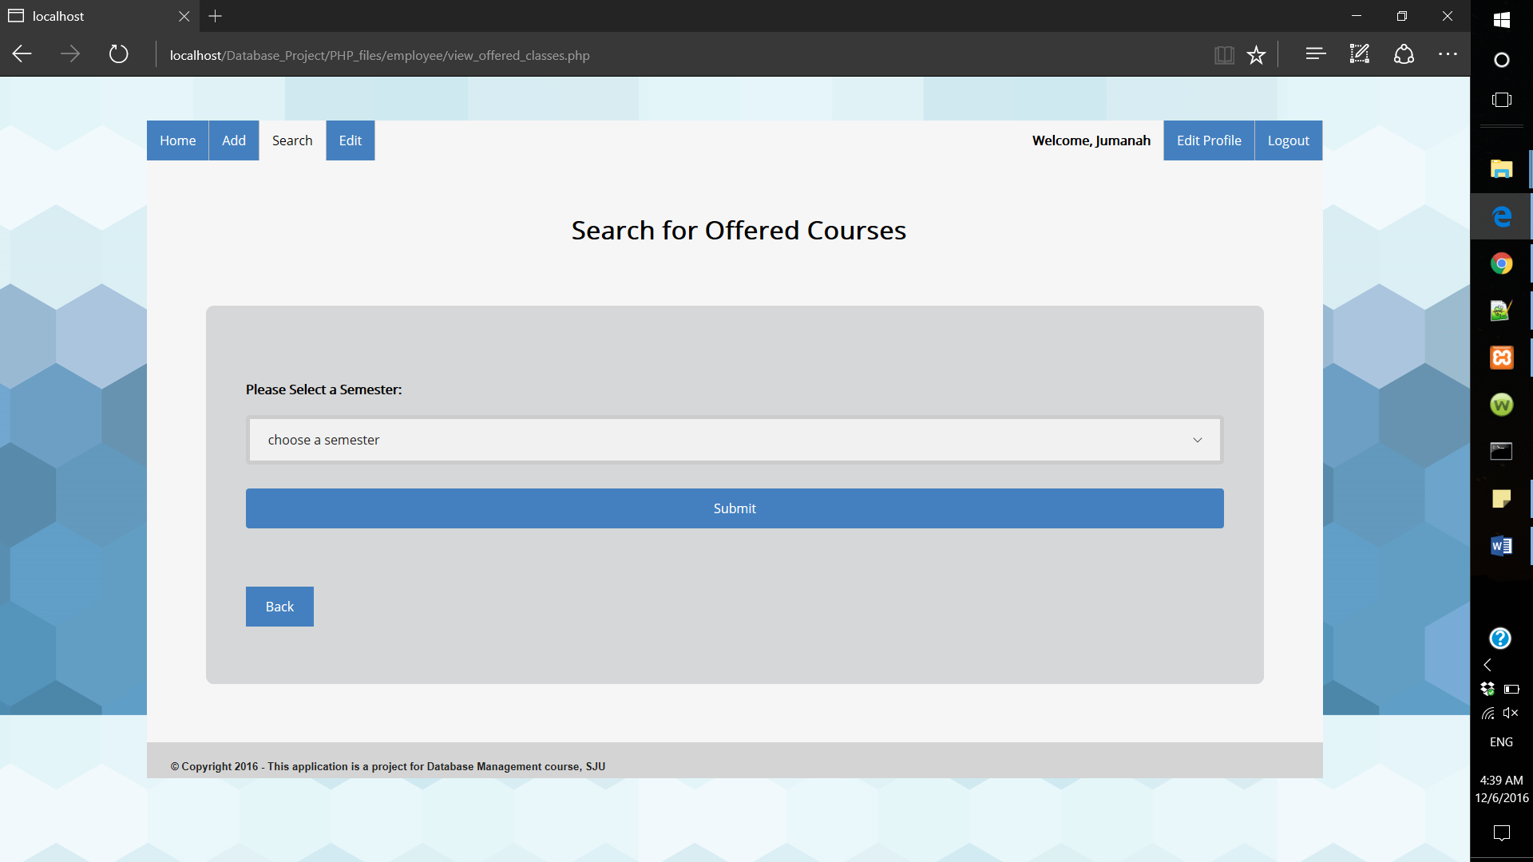

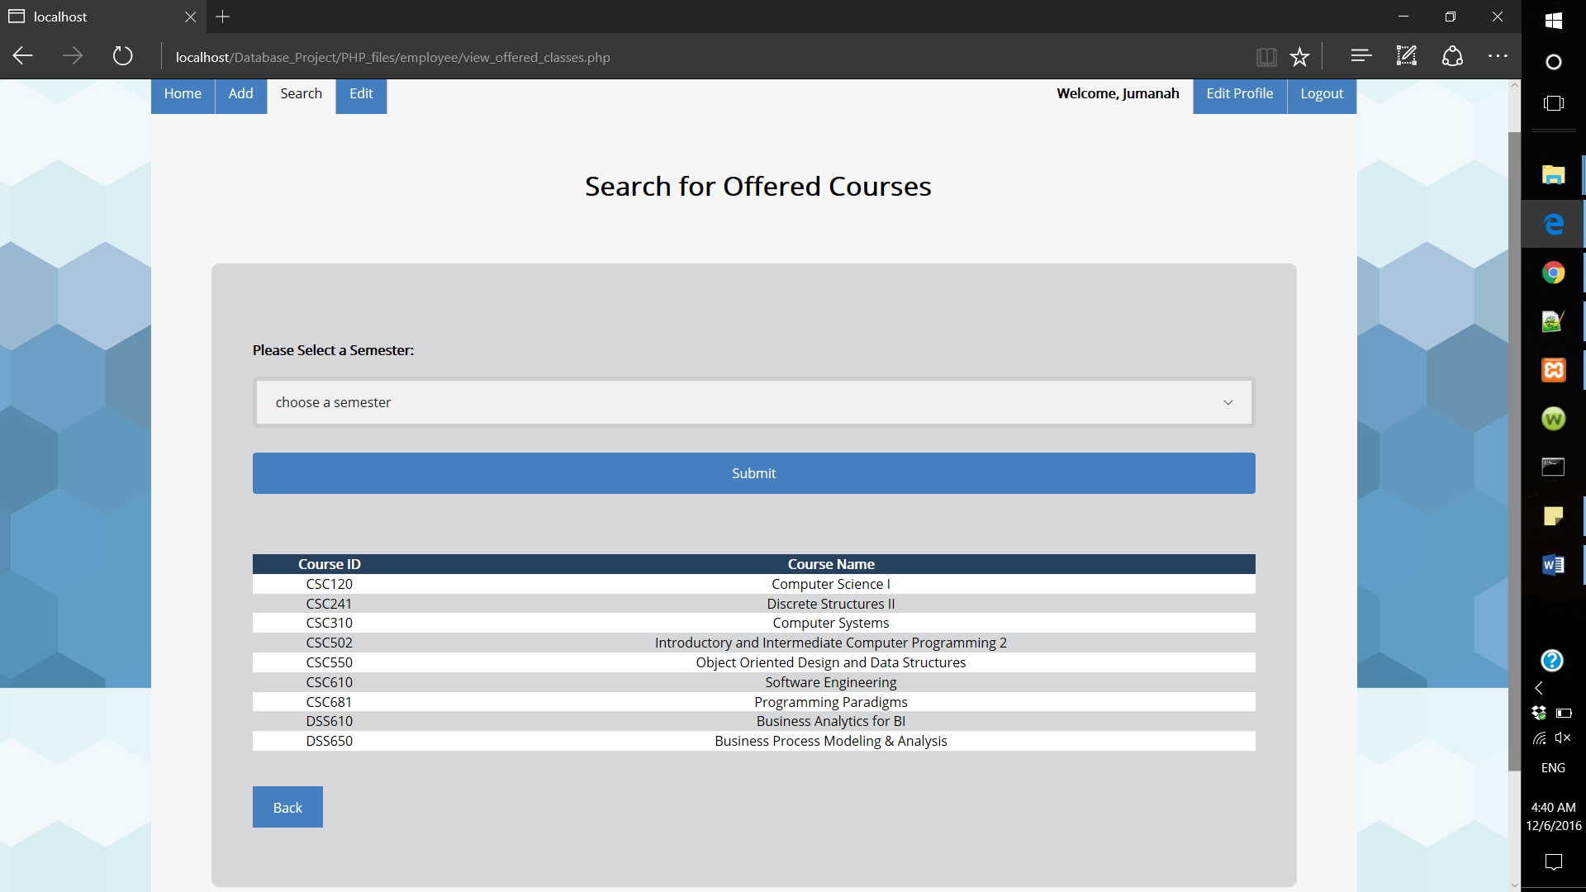

If no courses were offered in that semester the following message will appear:

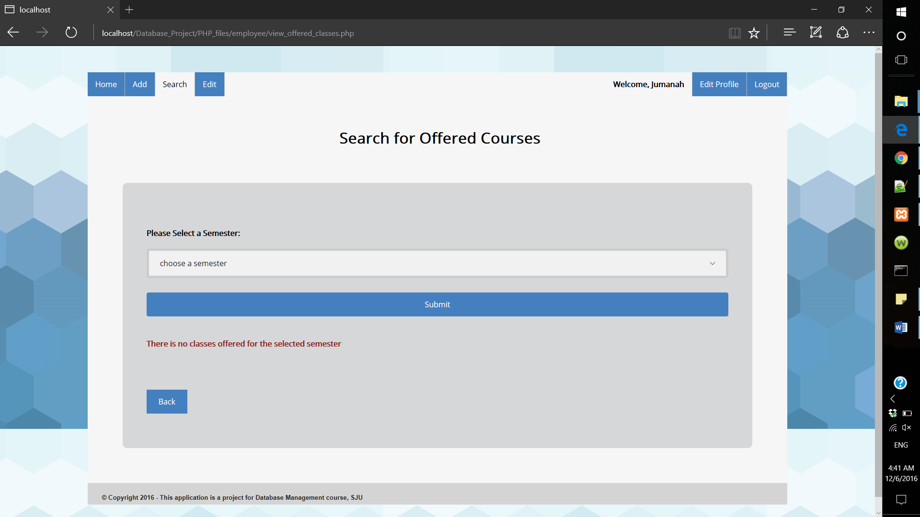

Query used in this form:

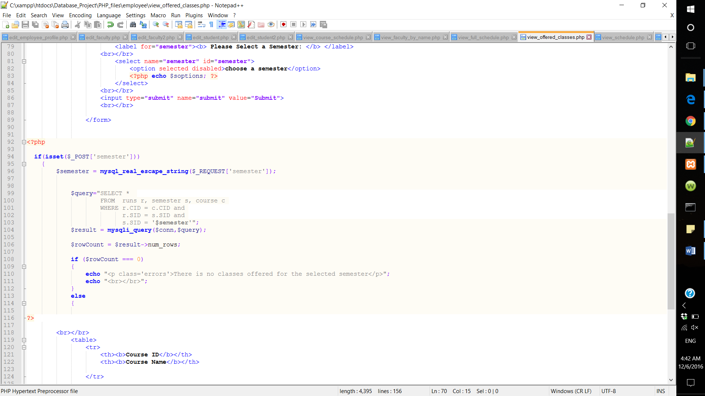

* View schedule: Employees can view full schedule by choosing the semester or they can view a course schedule by choosing a course.

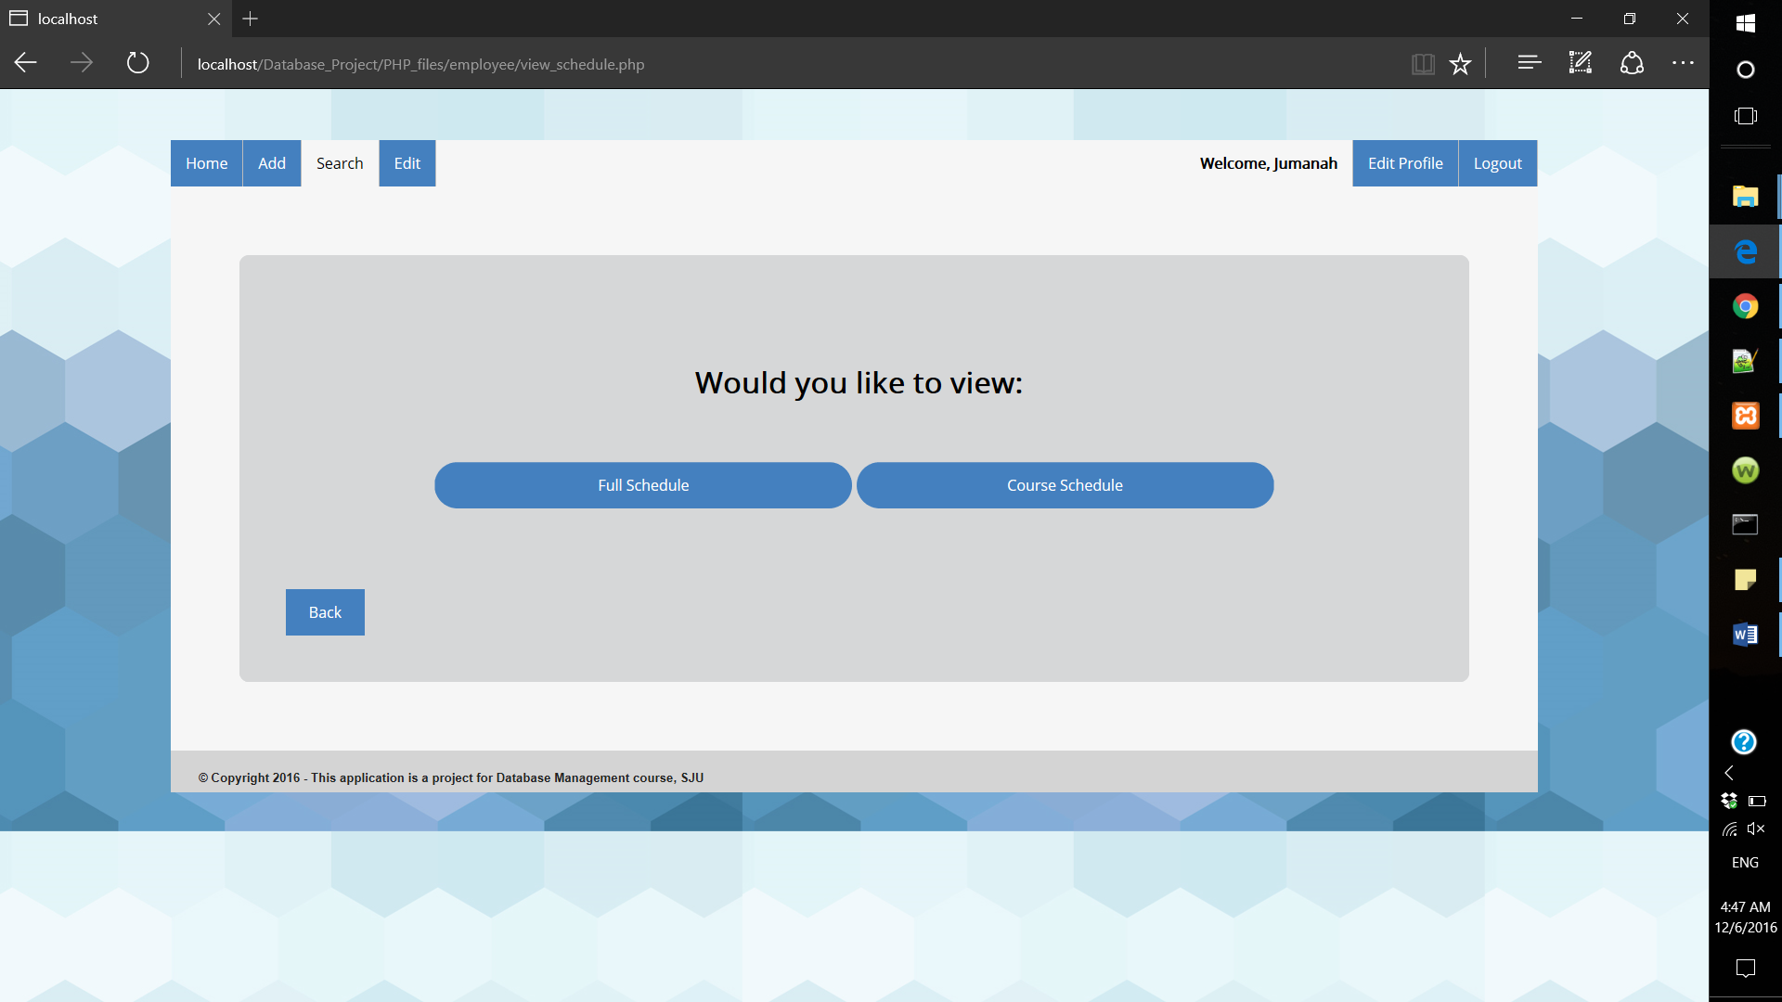

* + View full schedule:

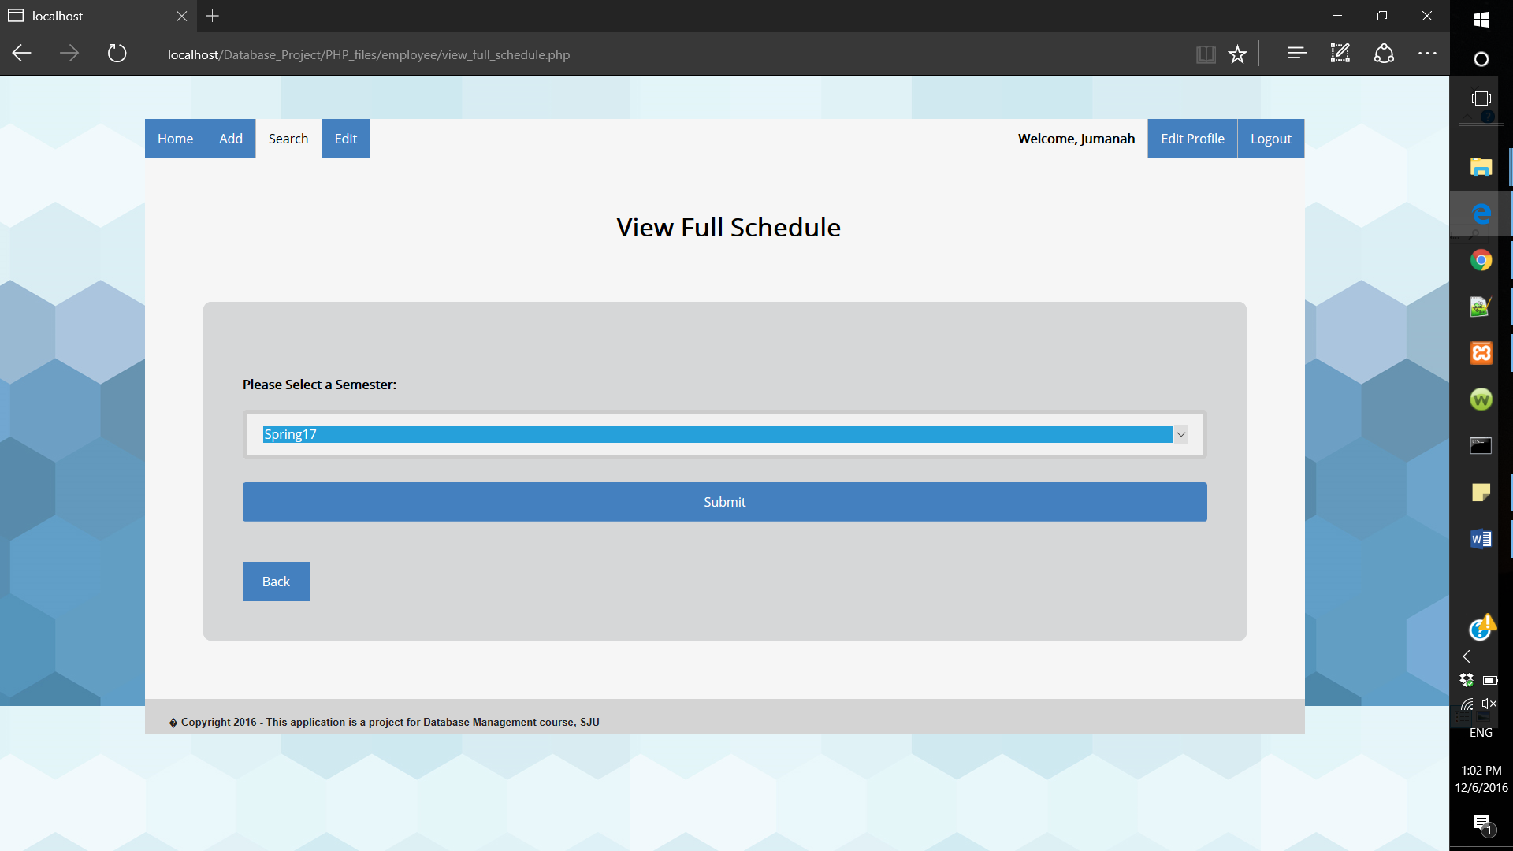

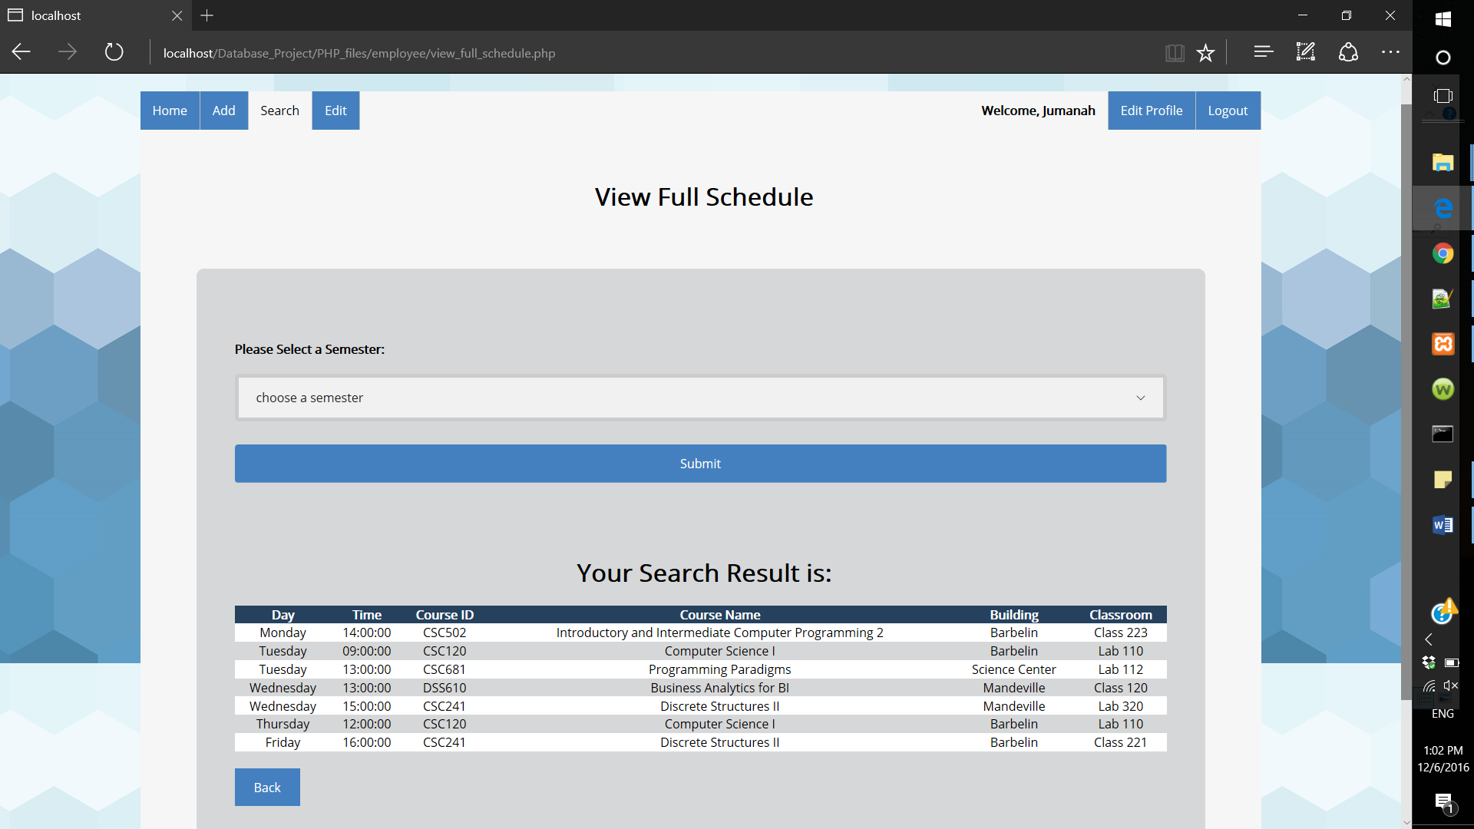

If there is no schedule classes in the chosen semester following message will be shown:

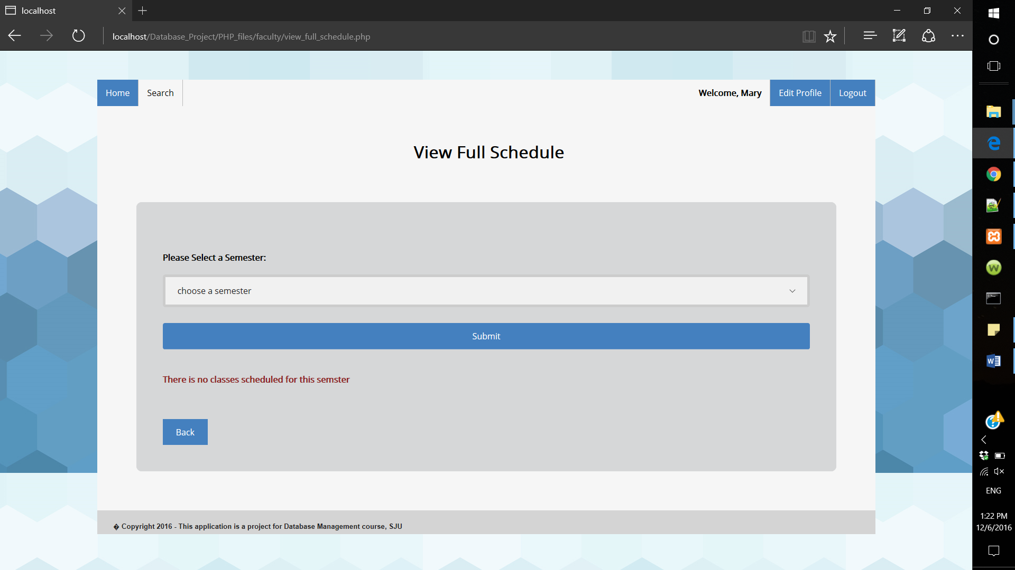

Query used in this form:

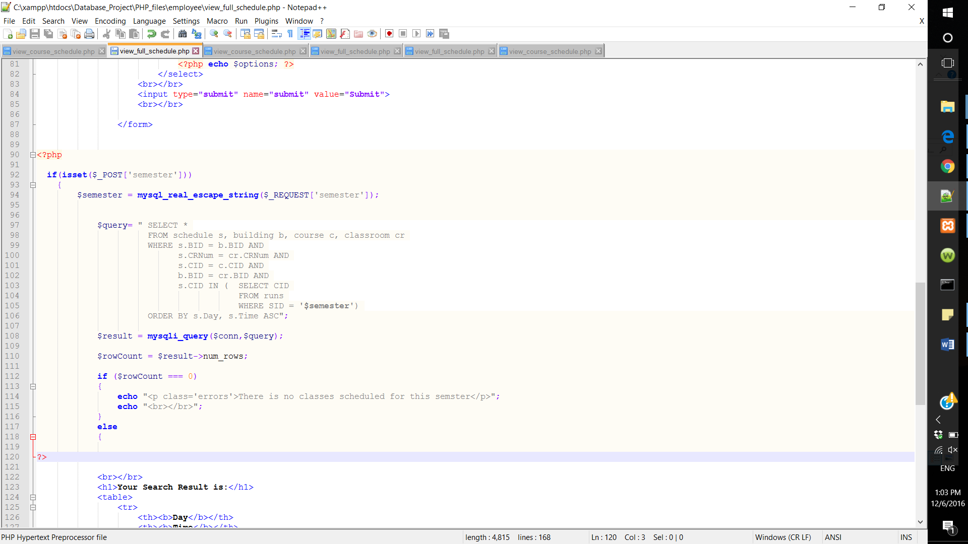

* + View course schedule:

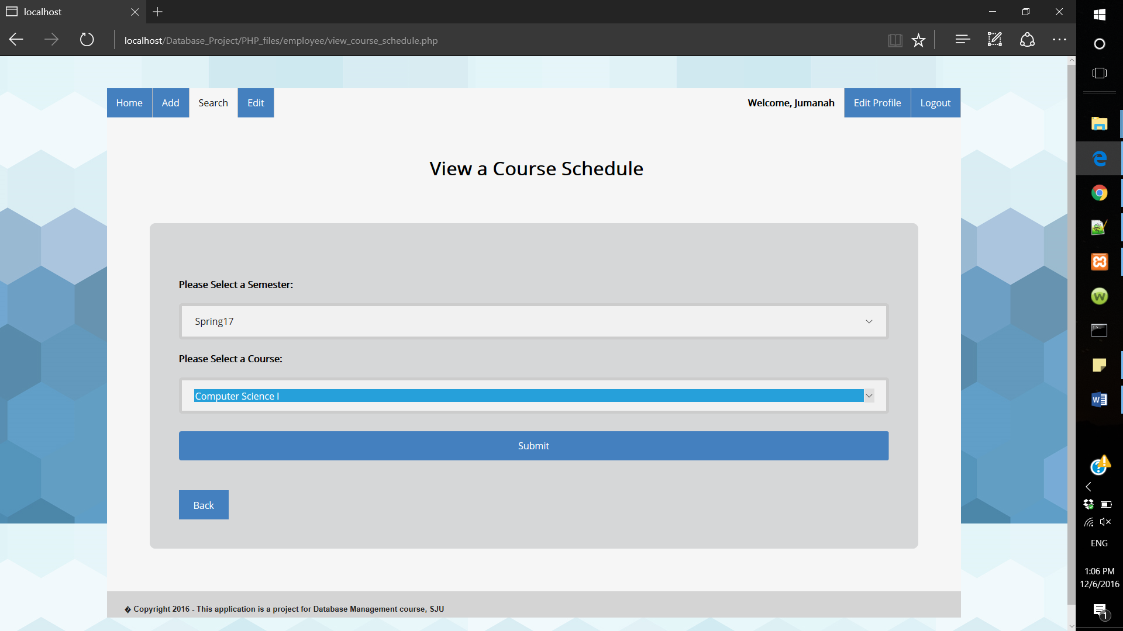

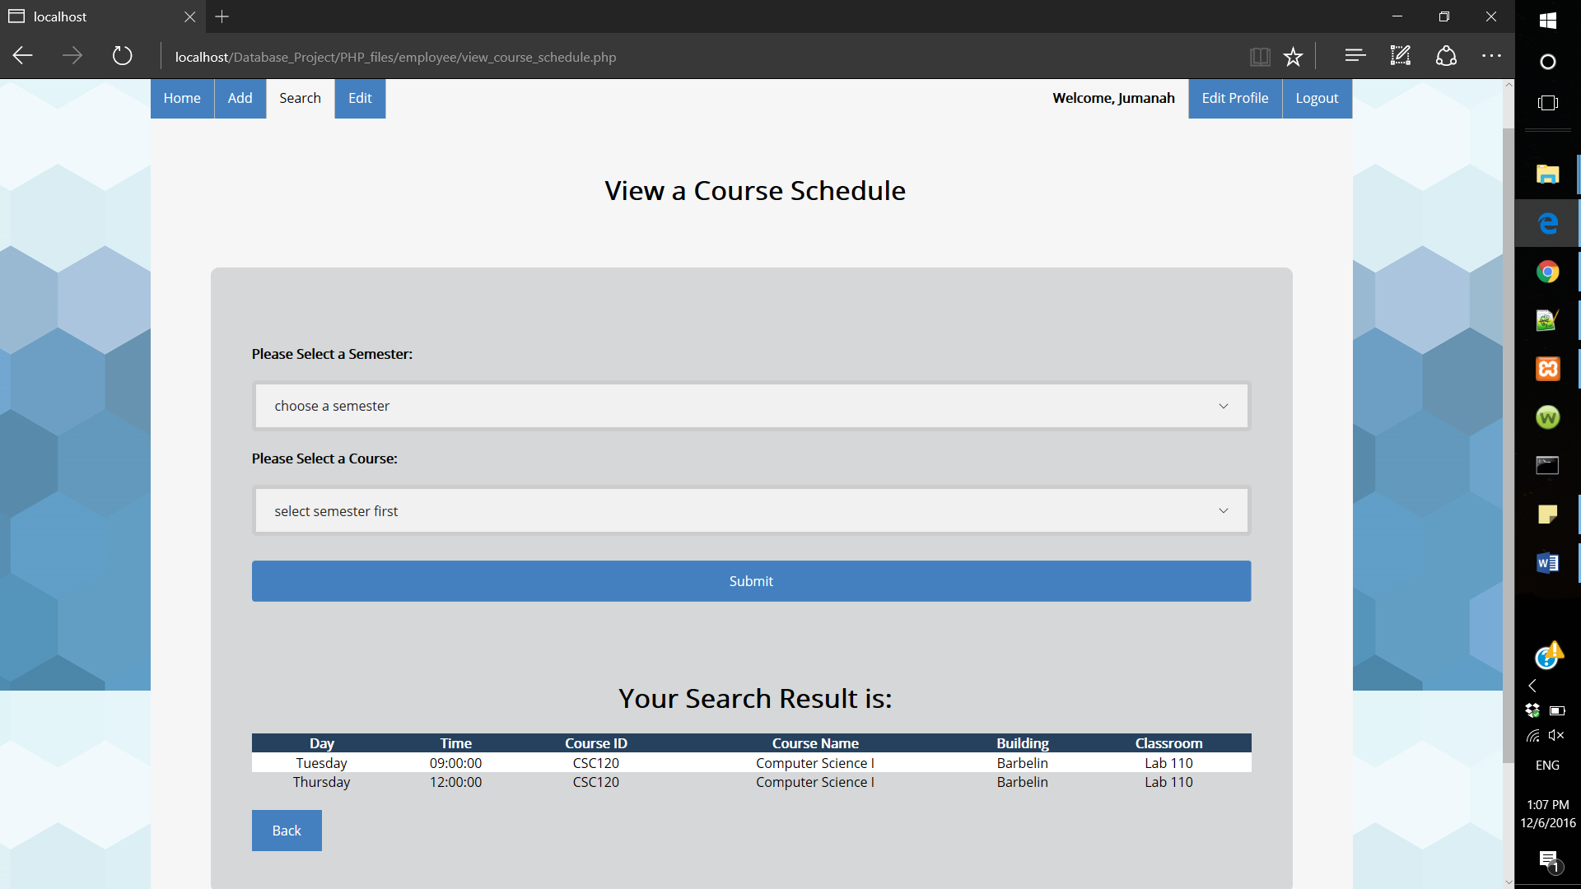

If the course is not schedule yet the following message will be shown:

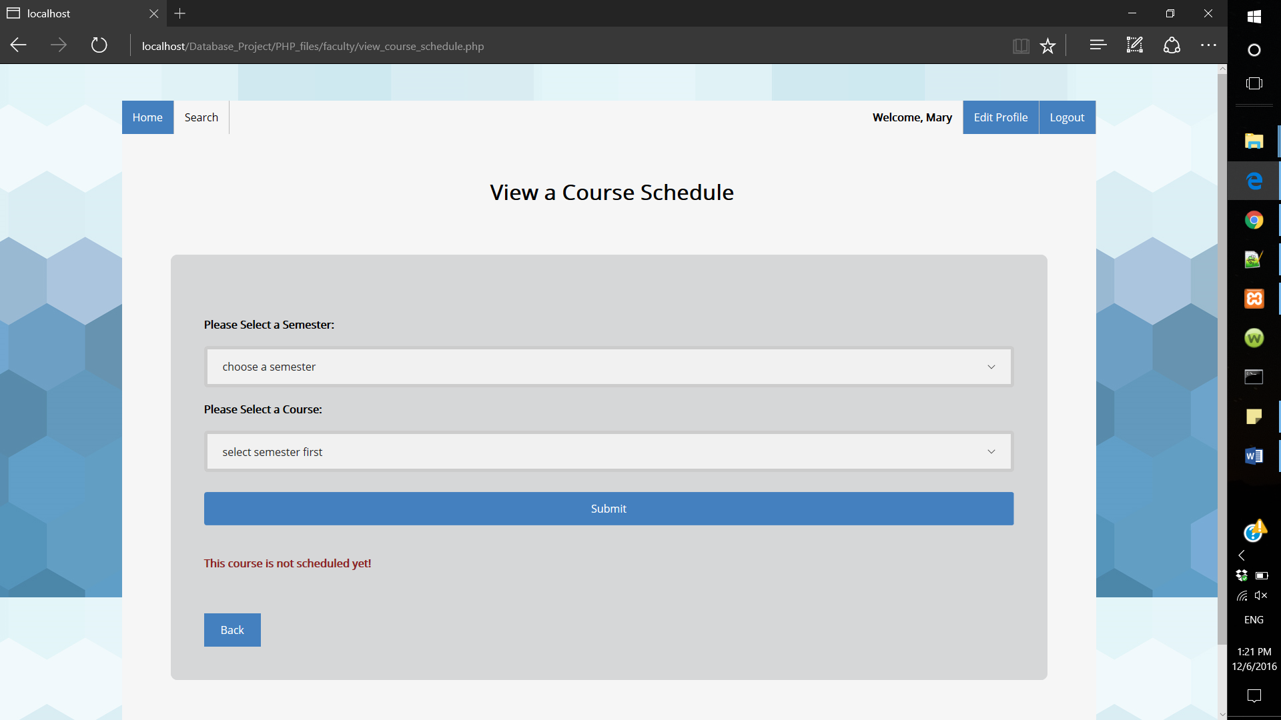

Query used in this form:

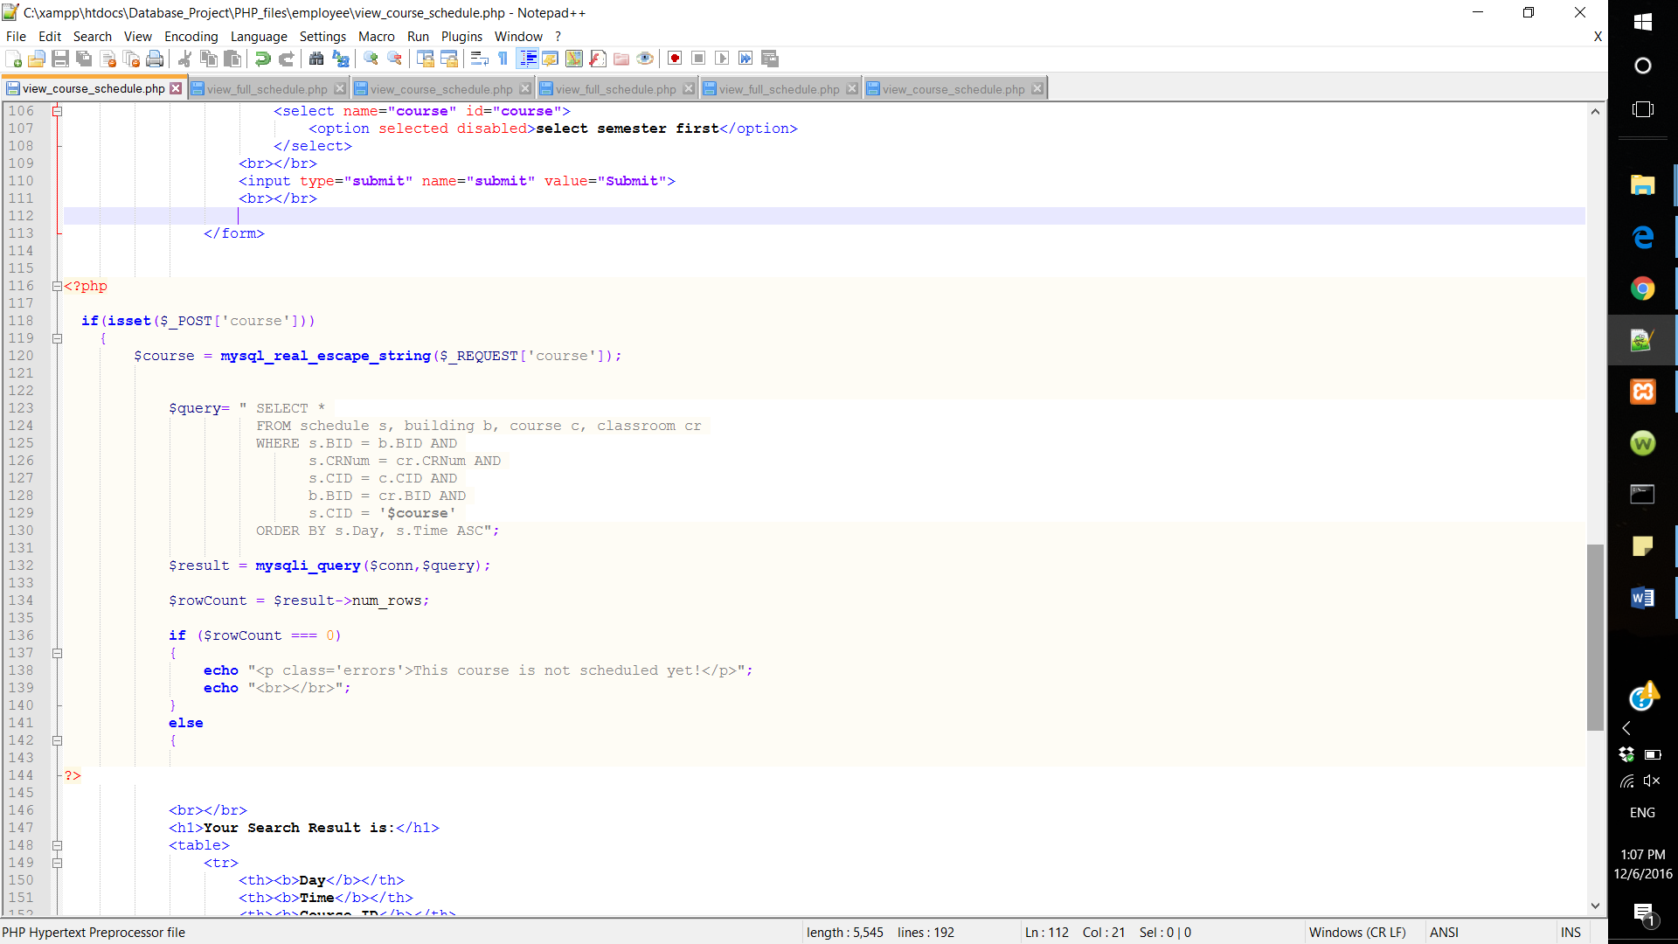

* Search for student information: Employee can view student information by searching for that student by their last name.

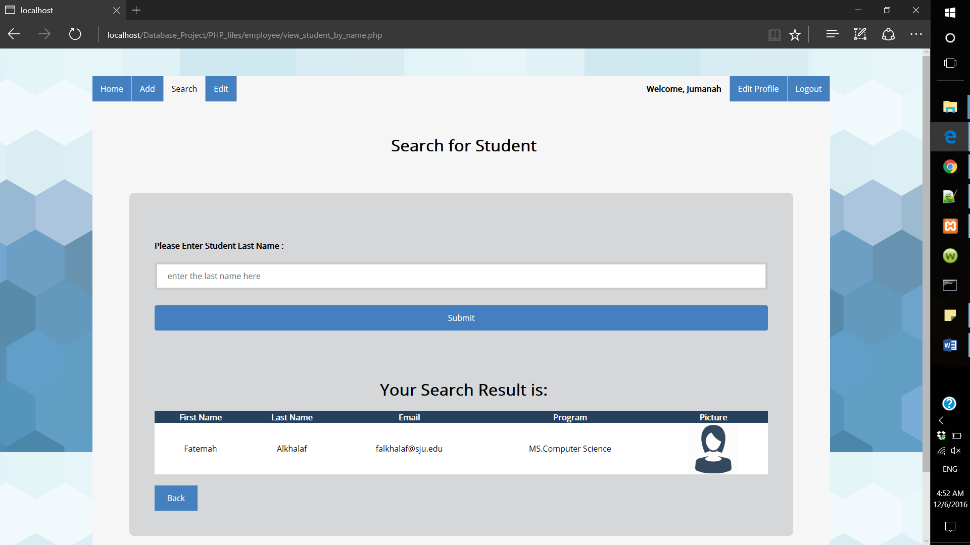

Query used in this form:

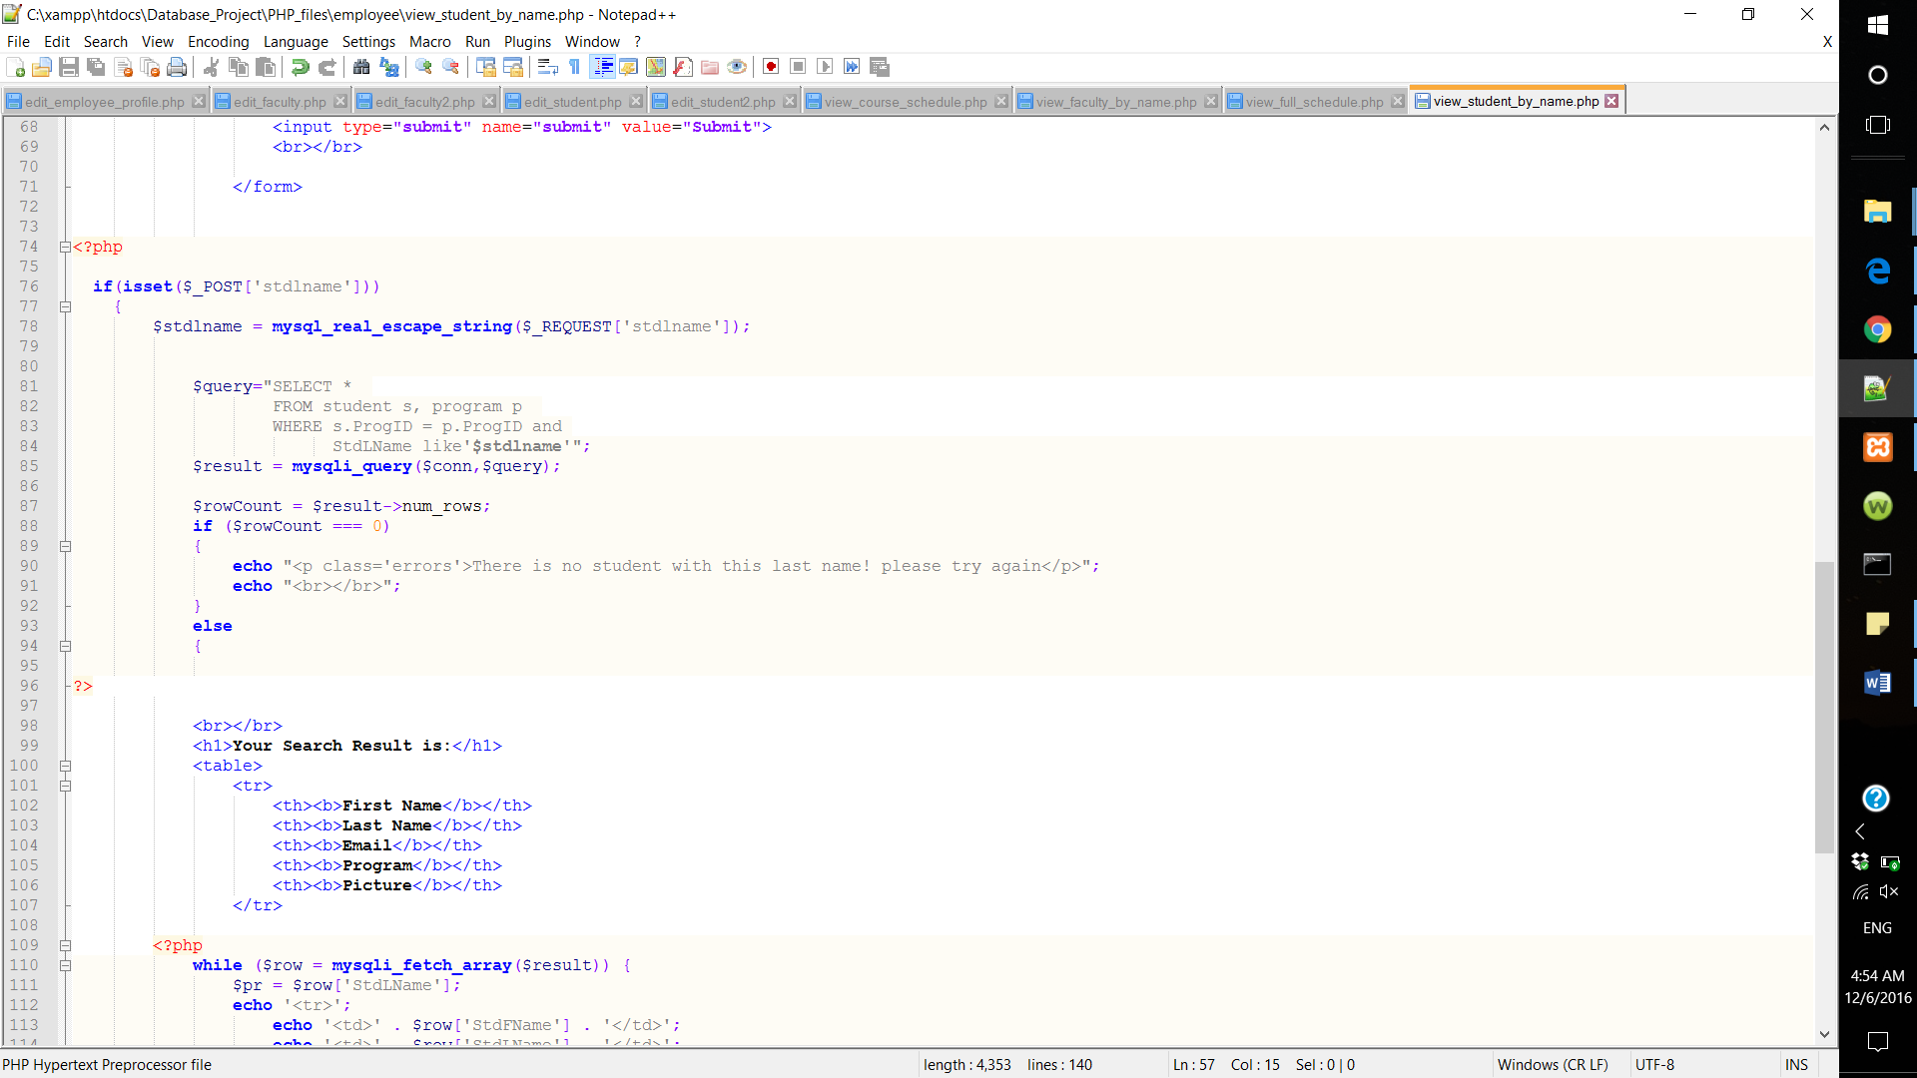

* Search for faculty information: Employee can view faculty information by searching for that faculty by their last name.

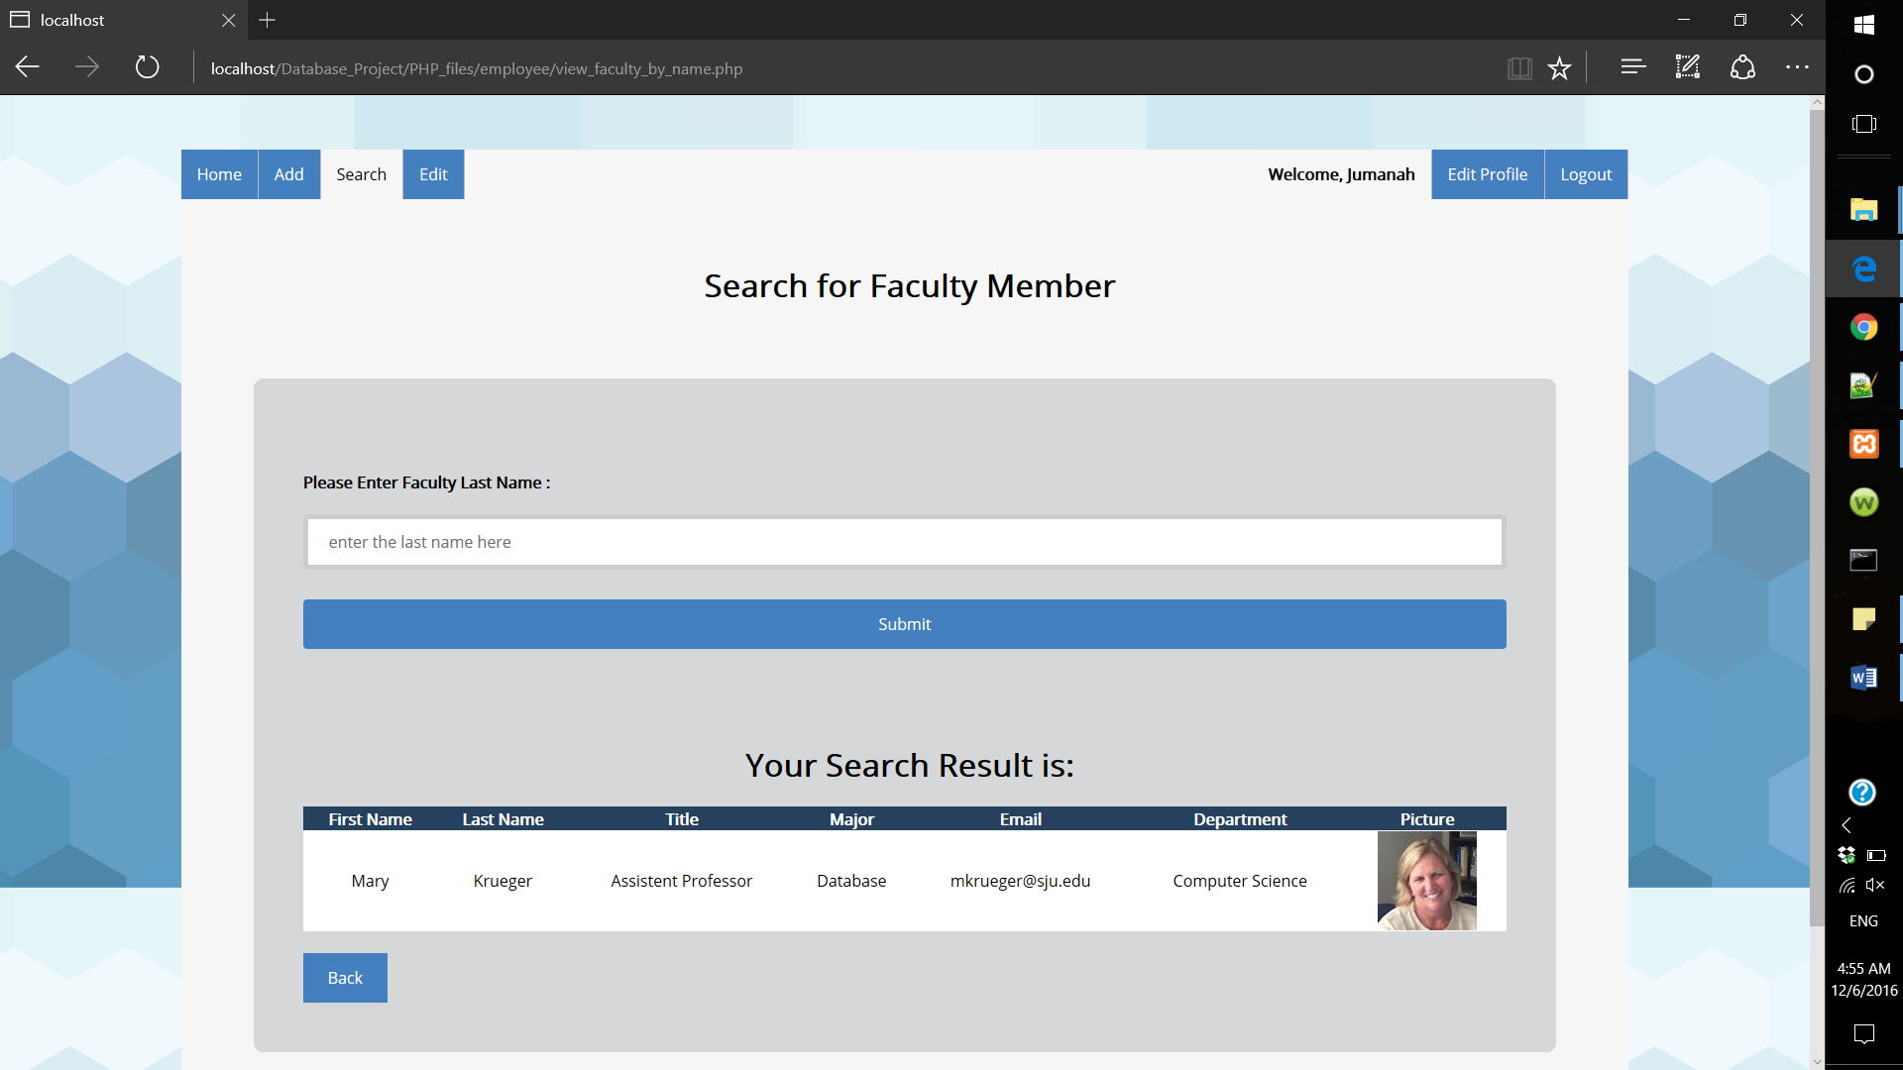

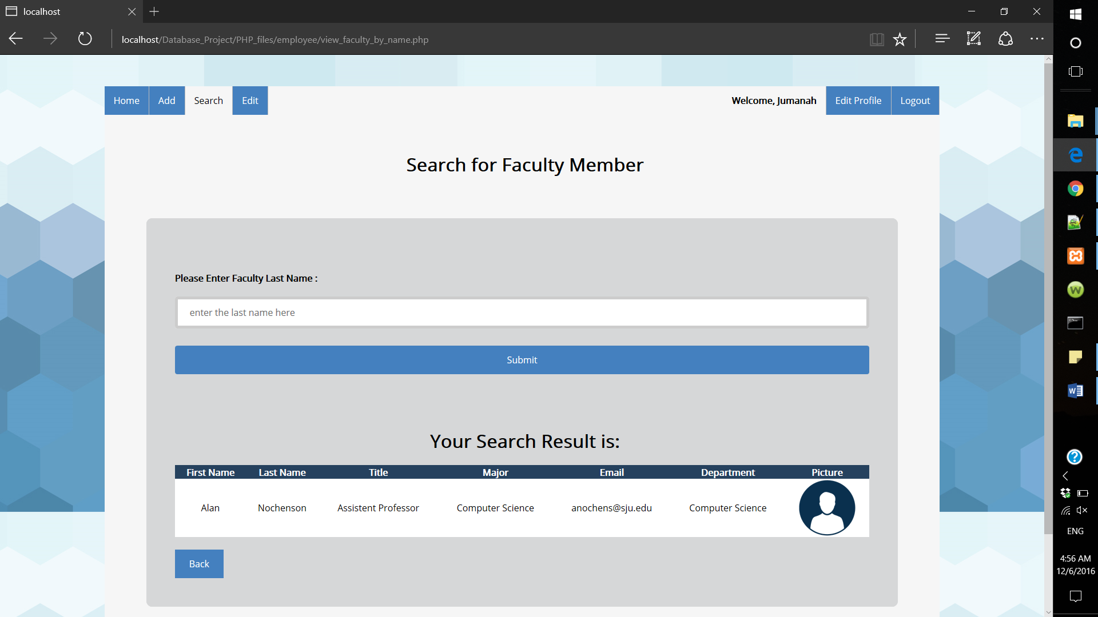

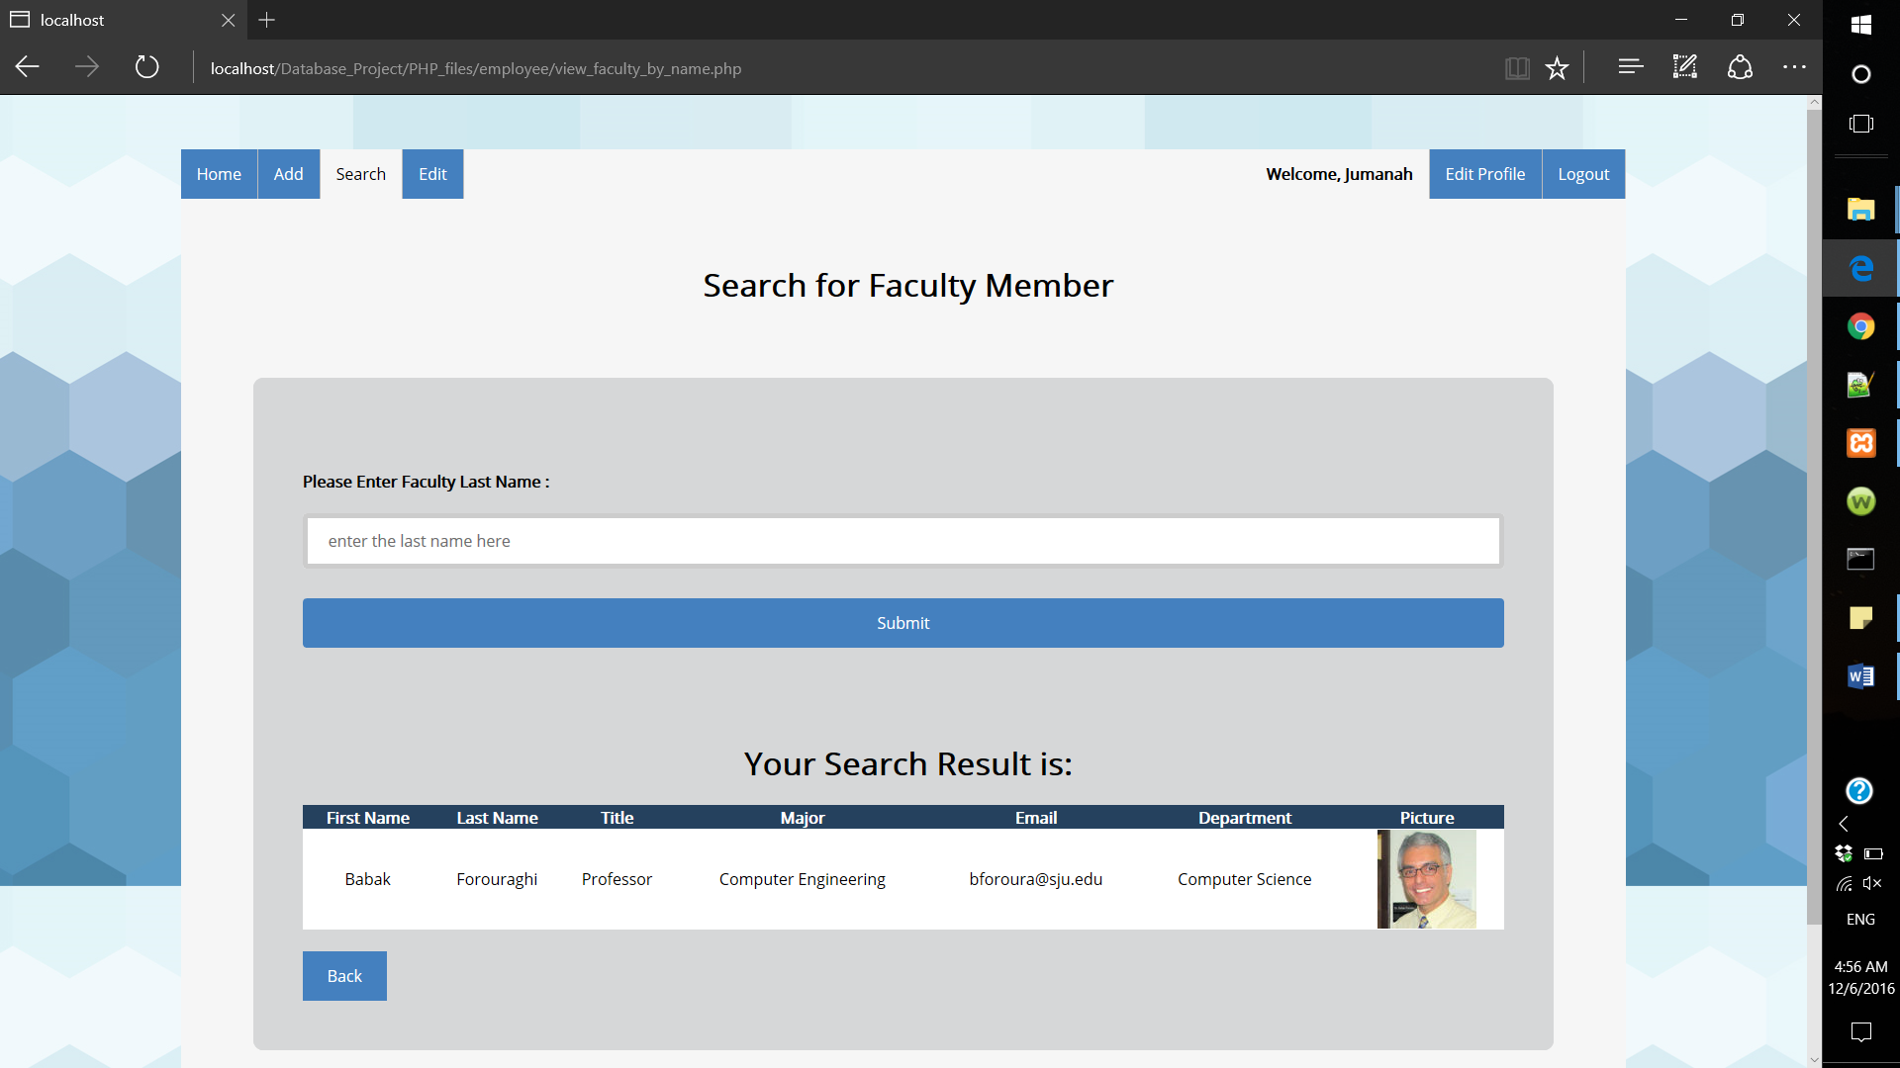

Query used in this form:

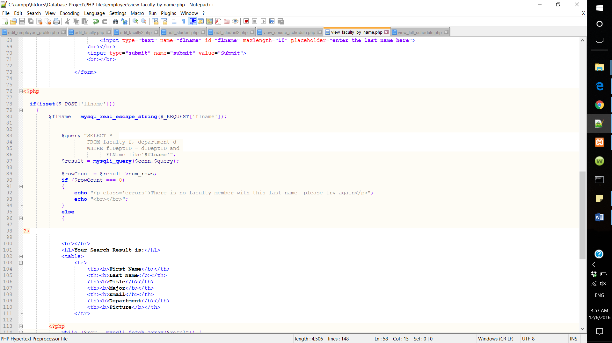

* 1. Edit:

Employee can edit and delete a faculty member, a student, and in the future he/she will be able to delete edit or delete offered course or course schedule.

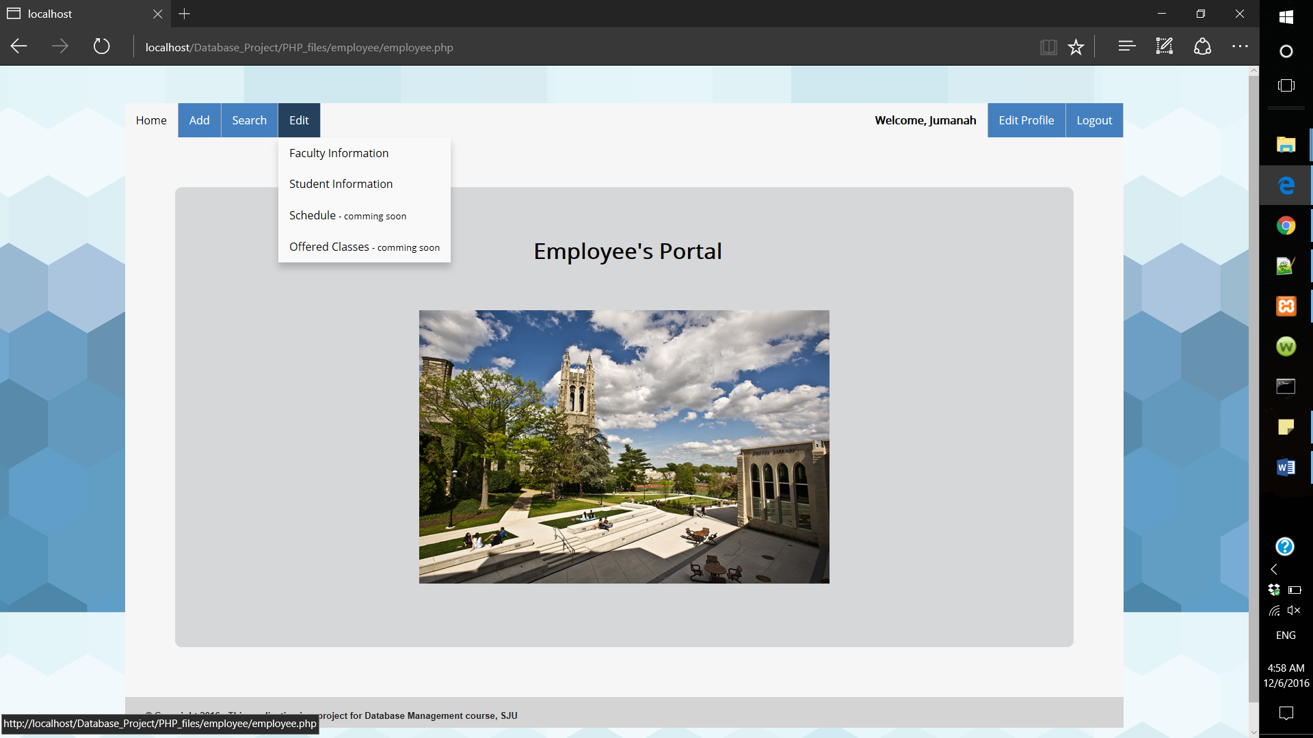

* Edit/delete faculty: First the employee must search for that faculty and then choose the edit or delete action.

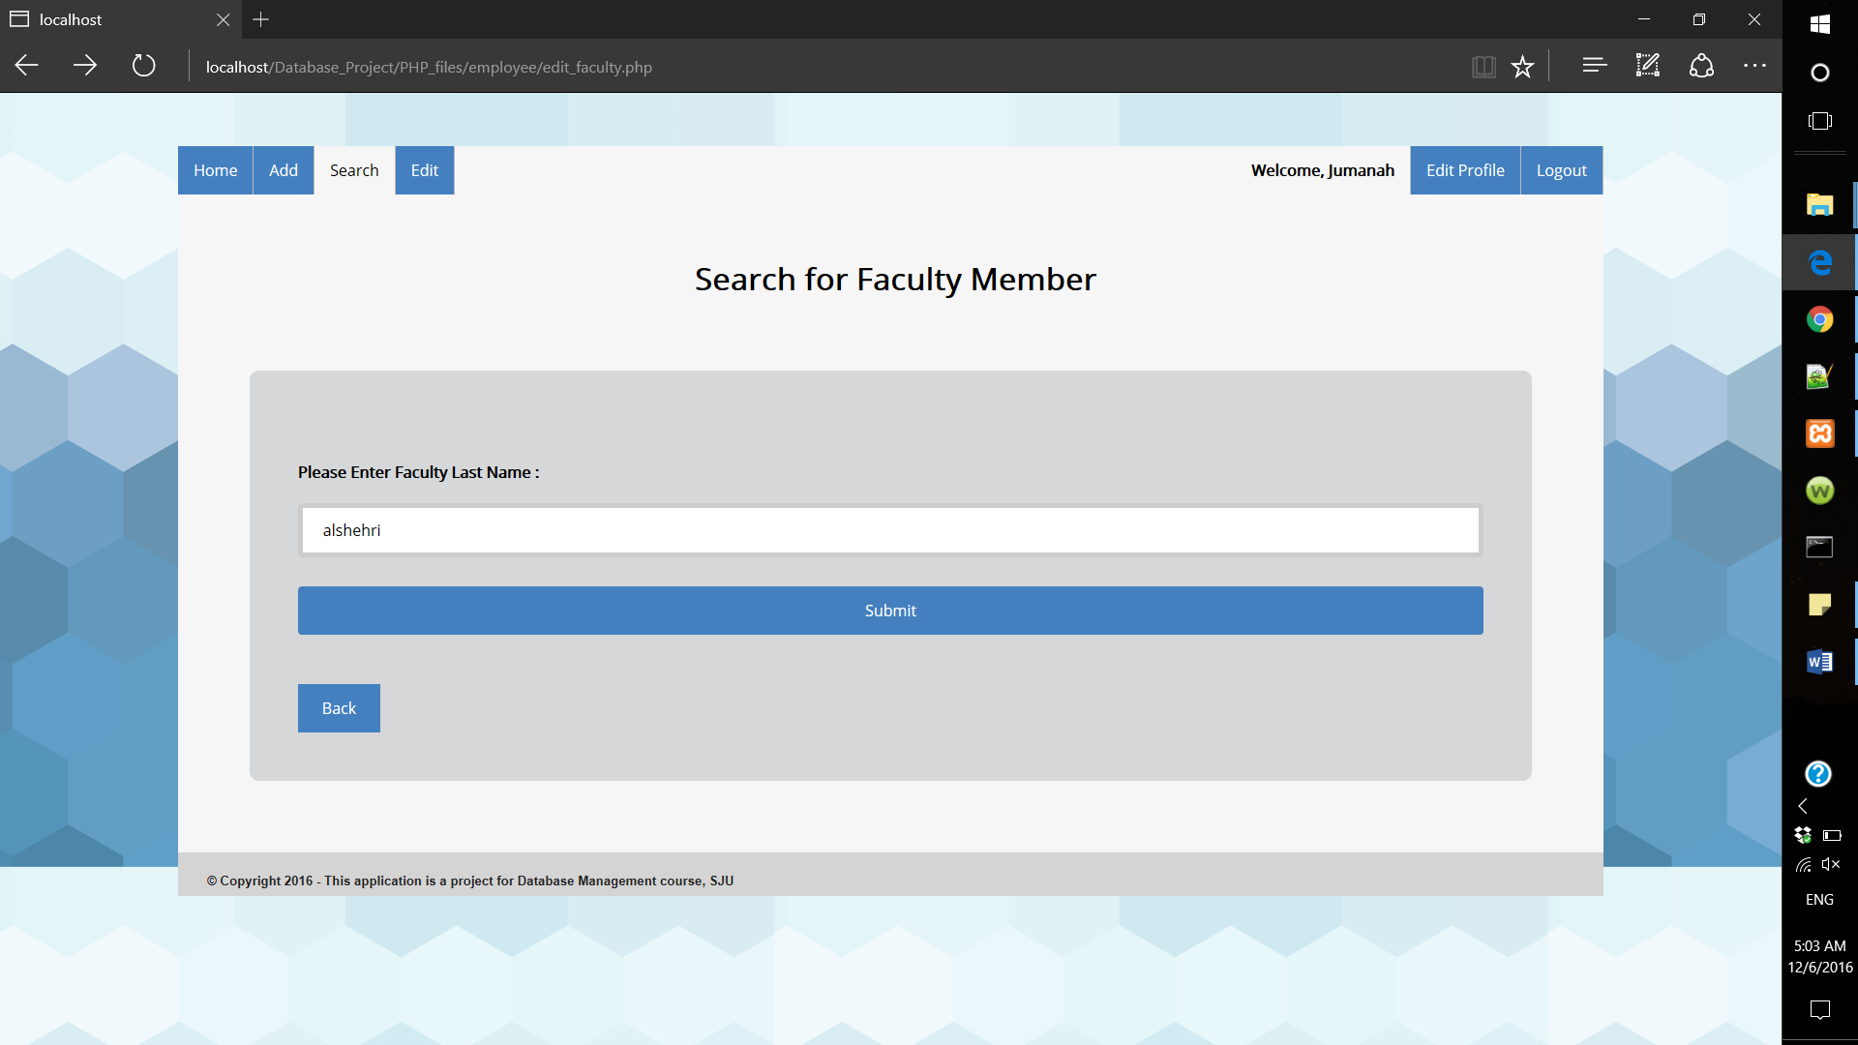

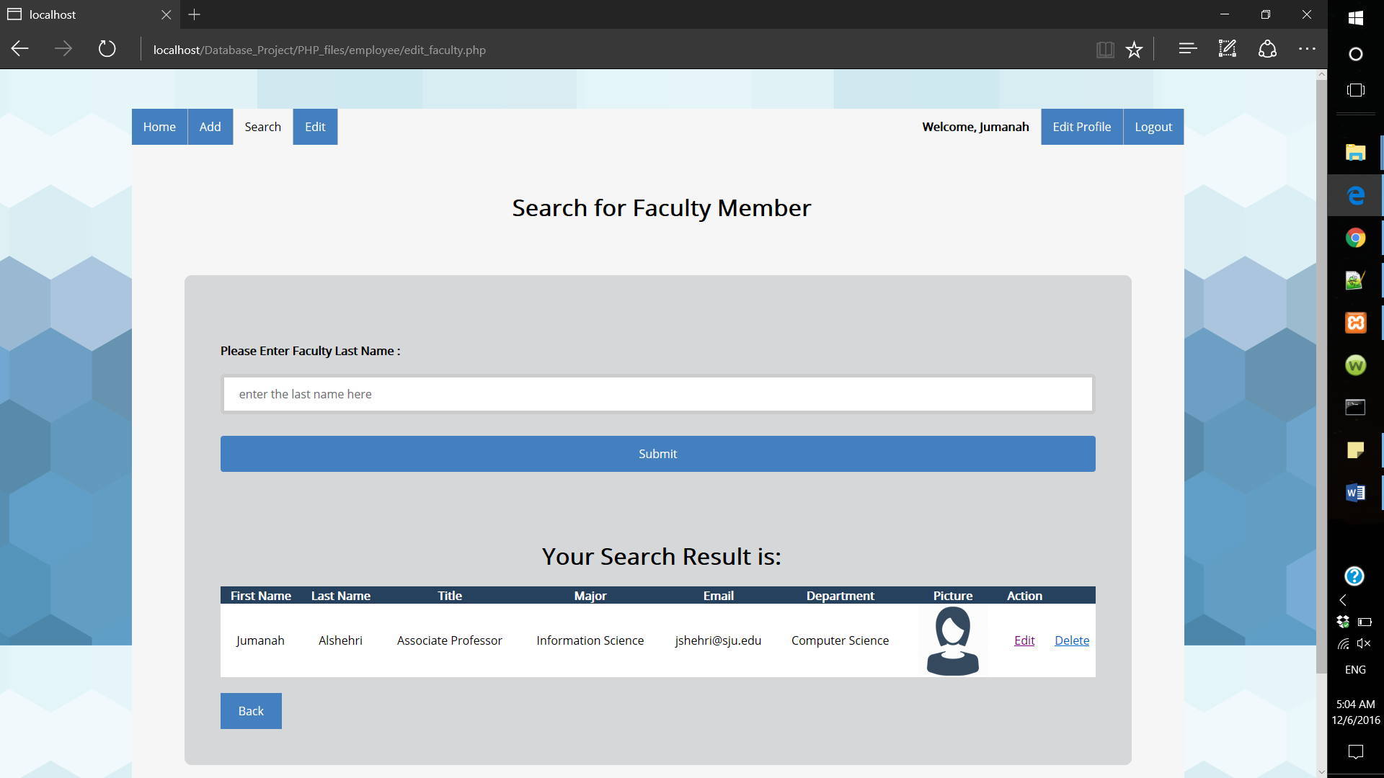

If the employee chose the edit action, the form will retrieve this faculty information and allow the employee to edit the information. Note that the employee can edit some of the information, but not everything, for example the employee cannot edit the faculty password.

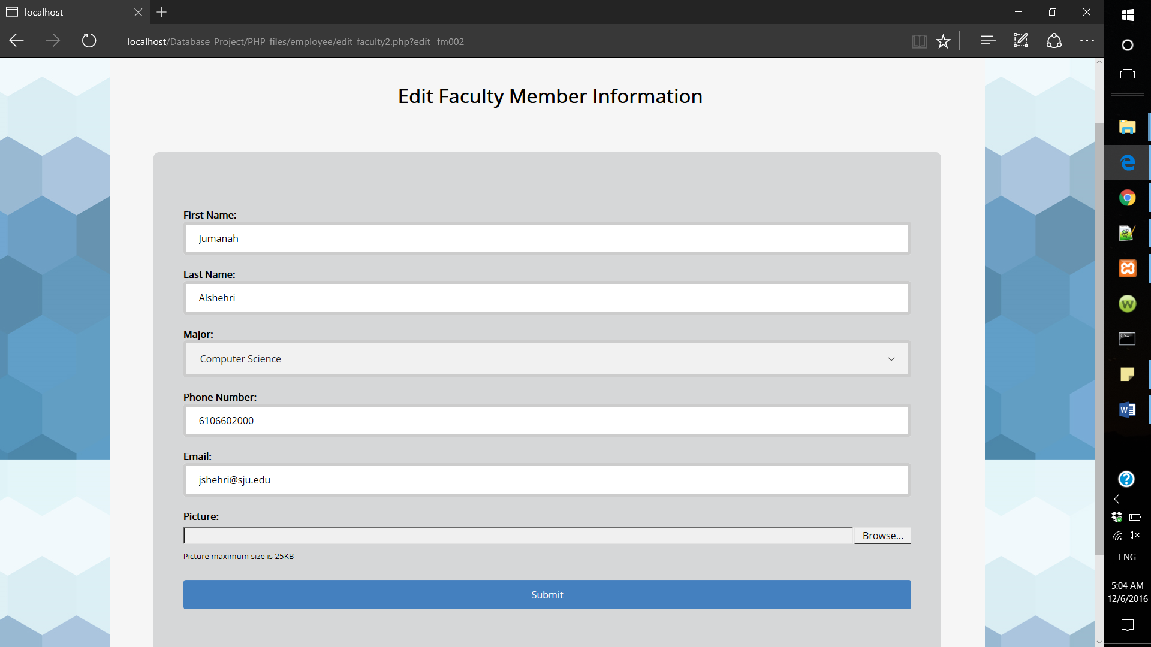

If the update was completed successfully the following message will appear. Otherwise, an error message will appear.

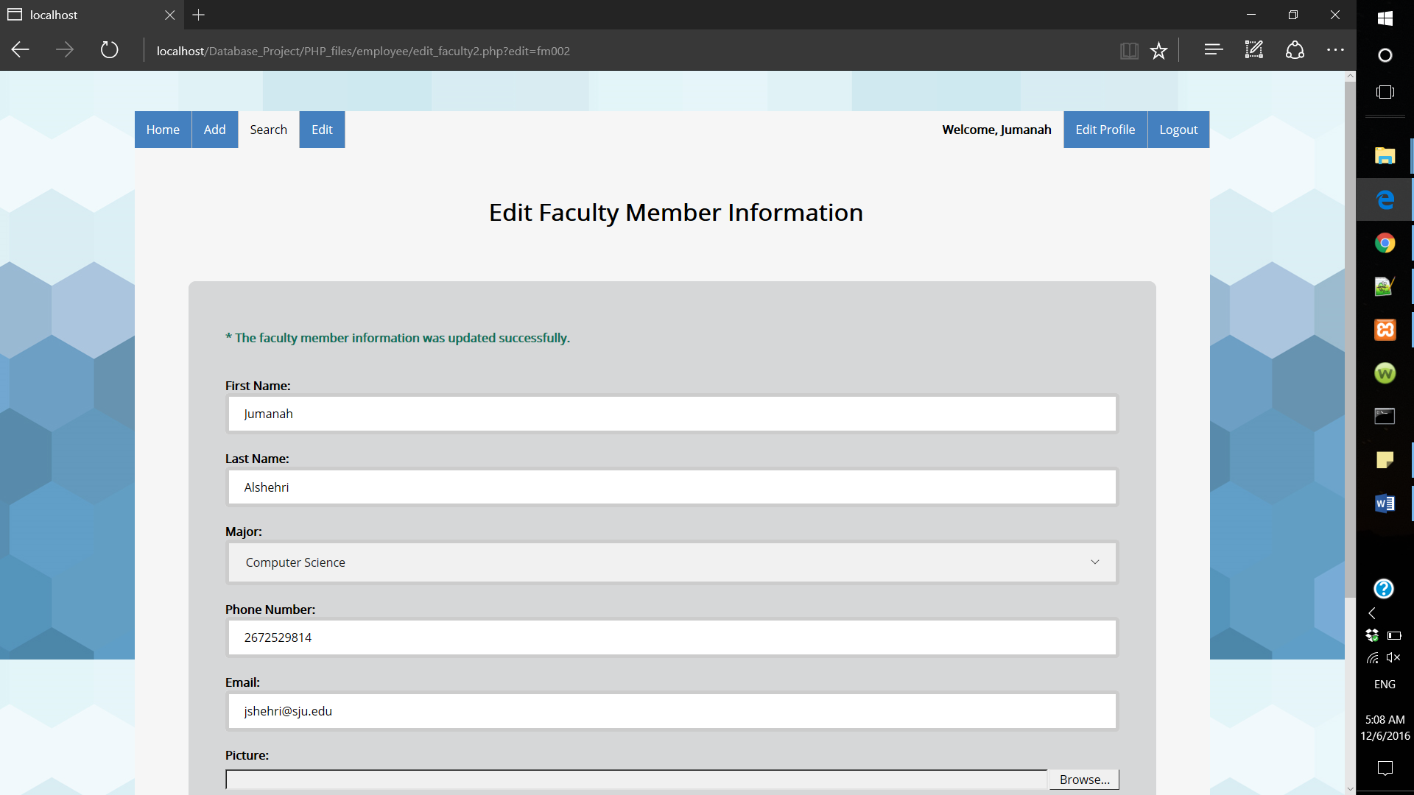

To delete this faculty, the employee must choose the delete action and then the faculty will be deleted from the database. And a message will appear in the delete action occurred or not.

Query used in this form:

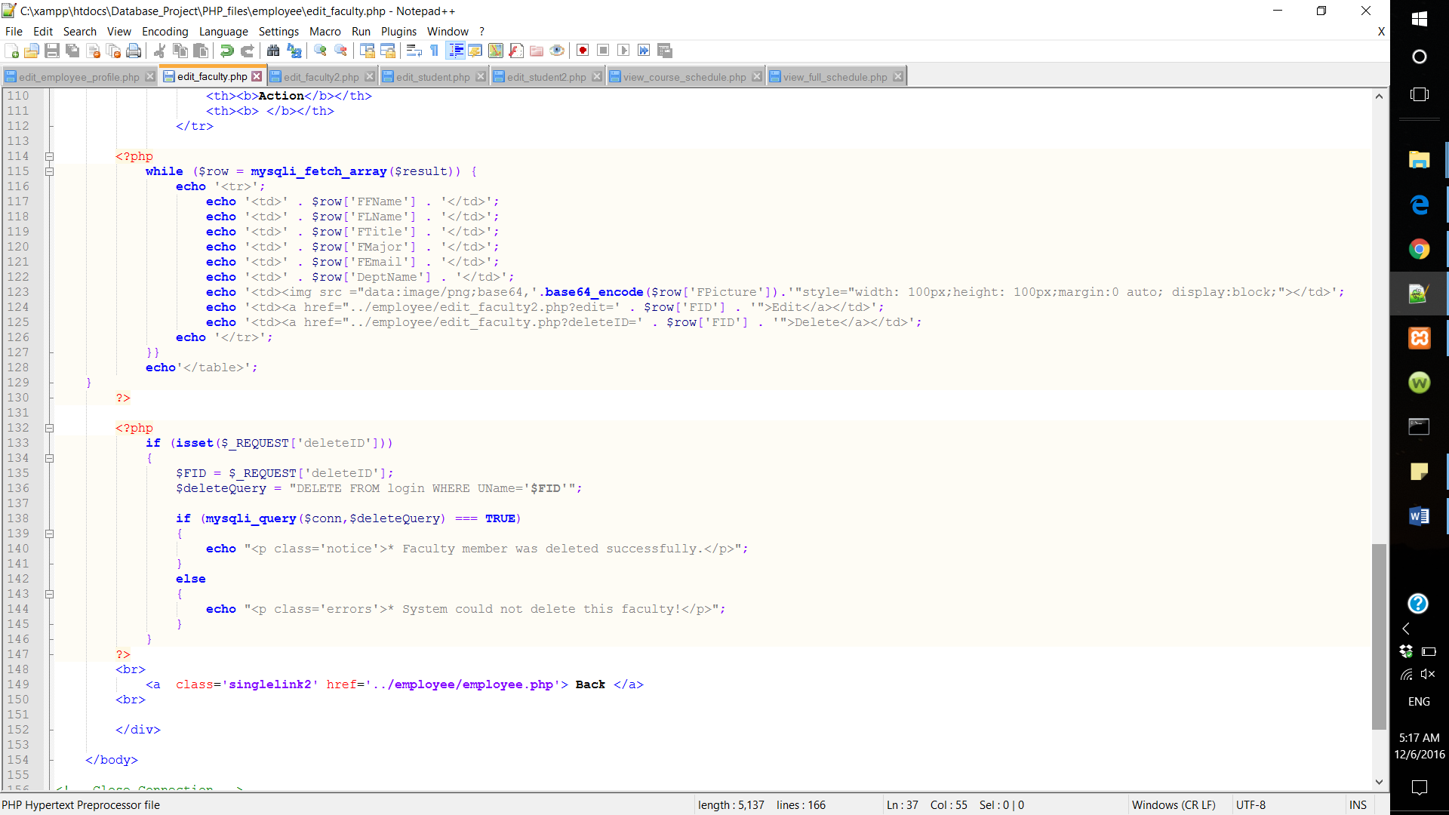

Since we used the constraint (Delete CASCADE) we only need to delete the faculty from the login table. And then it will be deleted automatically from the faculty table.

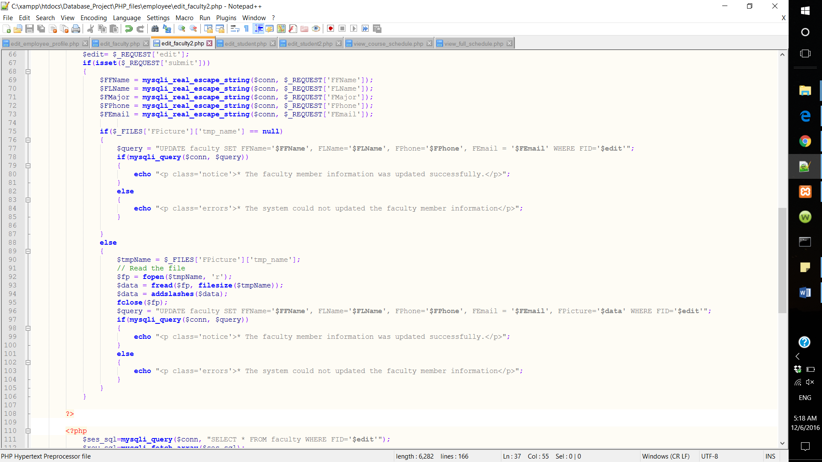

If the faculty was not found in the database, the following message will appear:

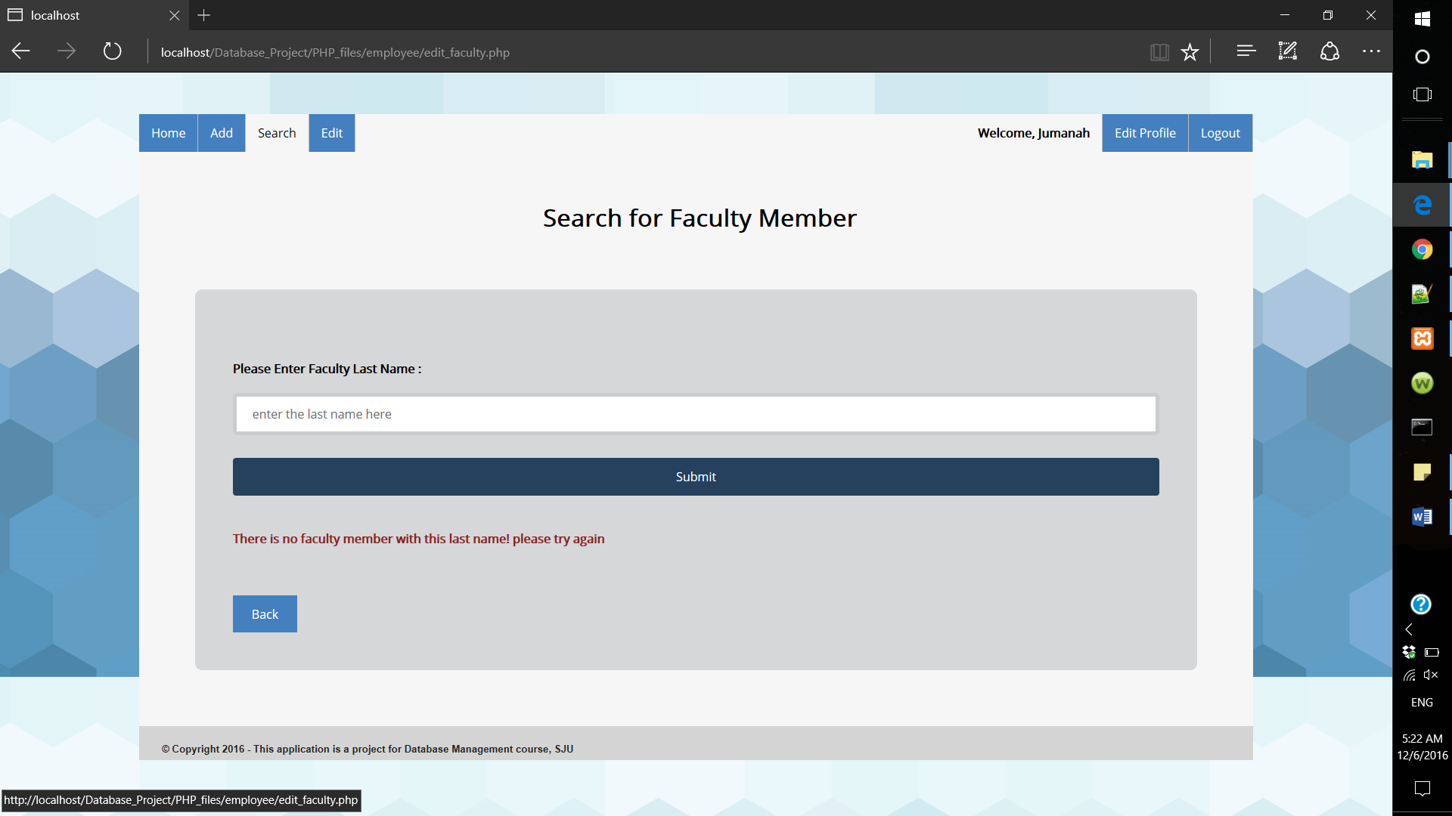

* Edit/delete student: the steps are same as editing and deleting a faculty member.

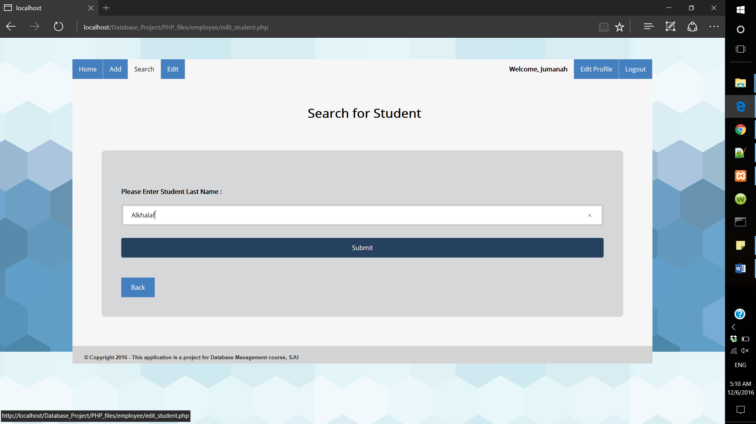

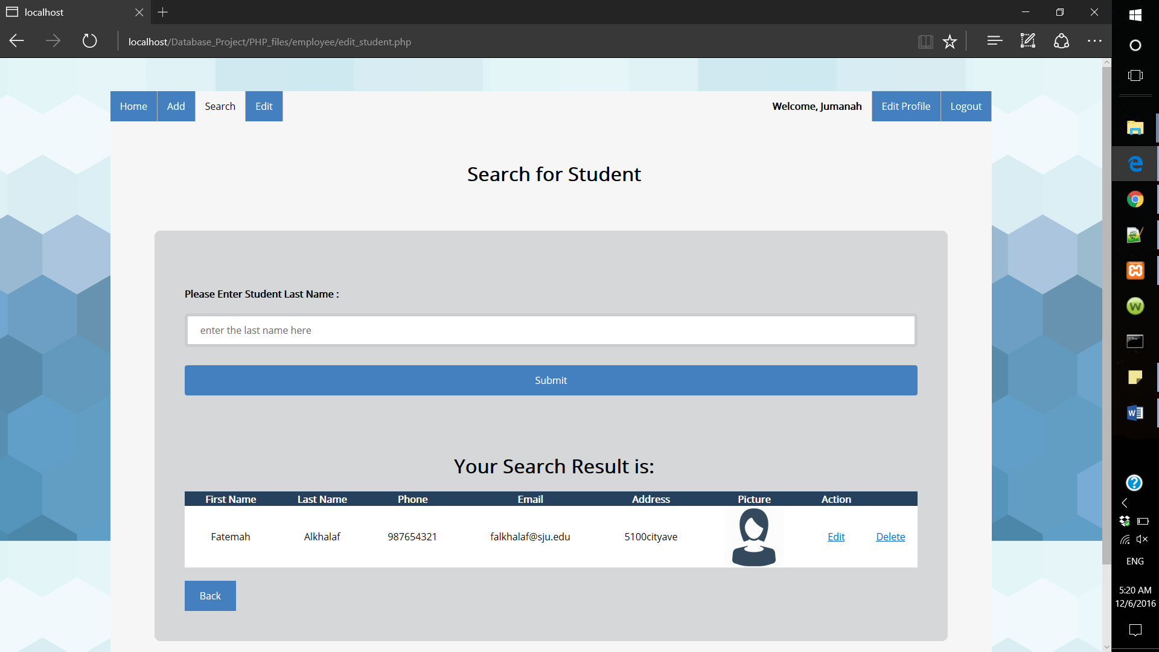

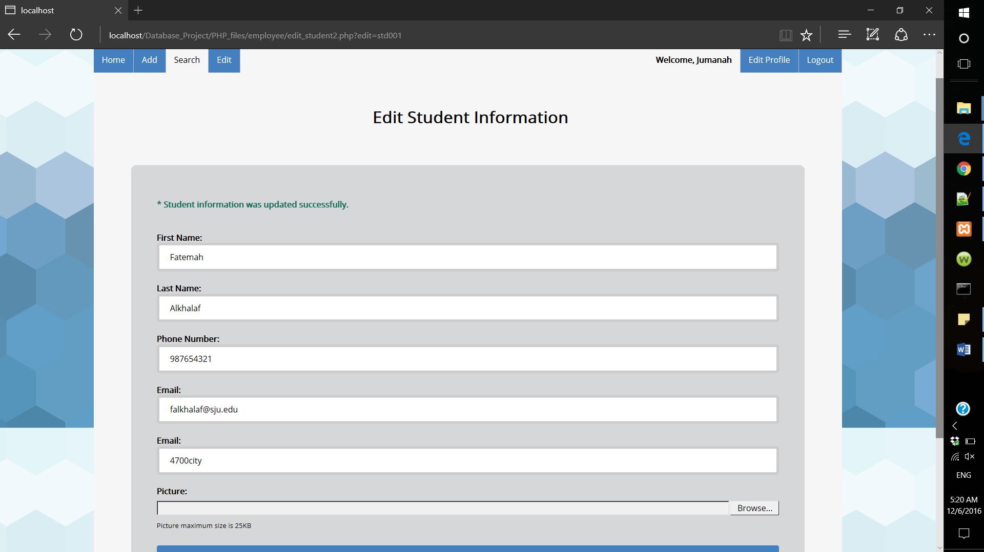

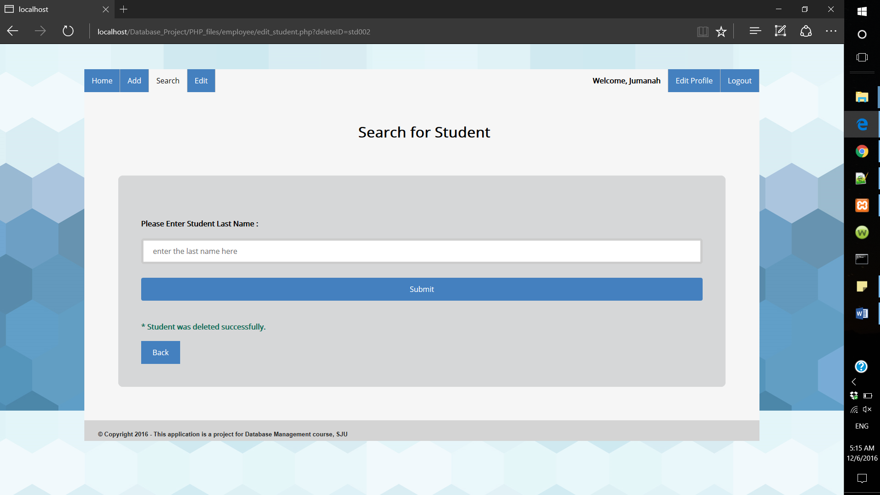

* 1. Edit profile:

Employees can also edit their own profile. However, they cannot edit all their profile because some fields such as job title has to be edited by the dean. When the employee clicks on edit profile, the form will automatically retrieve his/her information according to the session.

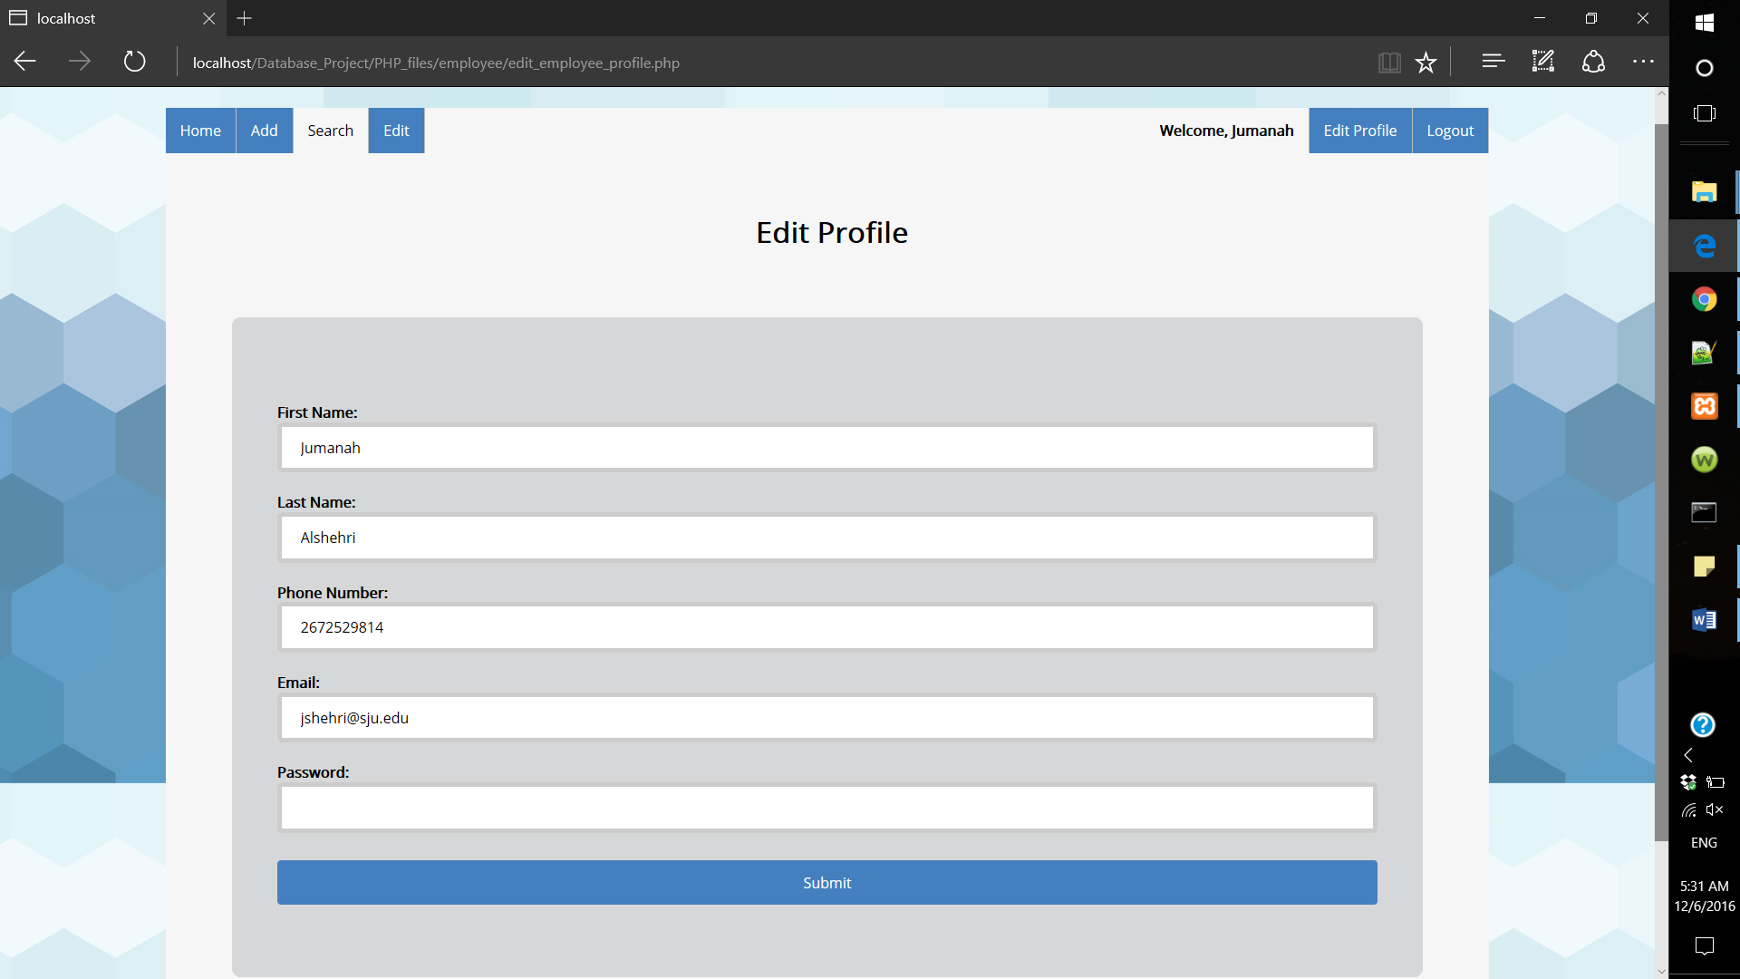

After that, a notify message will appear if the information was updated successfully. Otherwise an error message will appear.

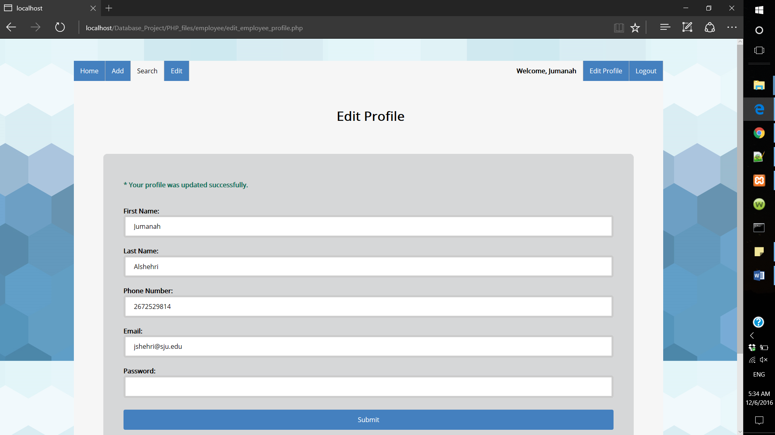

Query used in this form:

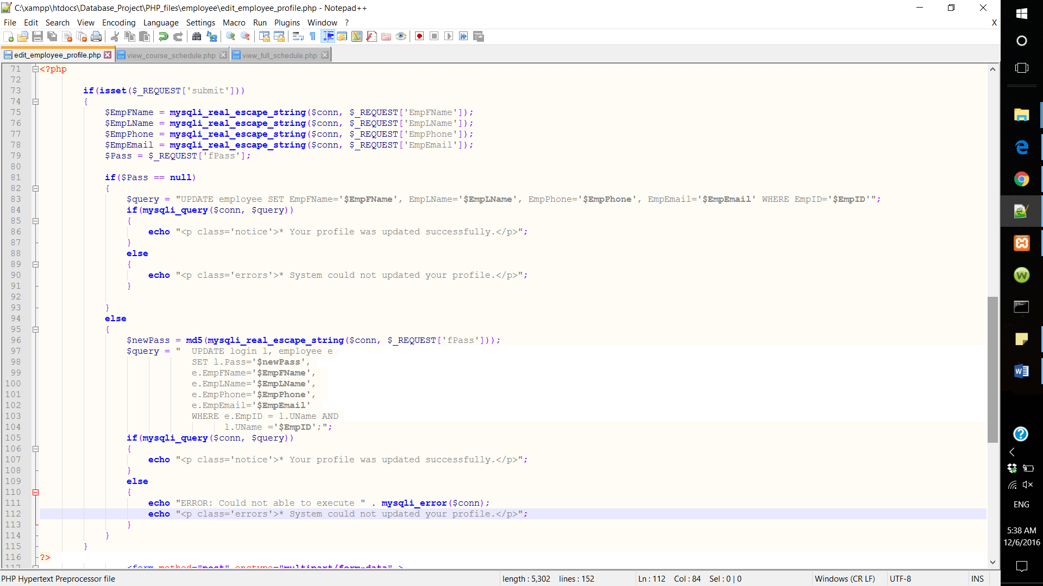

1. Faculty and Student Interfaces

Faculty members and students do not have the permission to add, edit or delete anything in our system, except for editing their own profile. However, they can search for college information, program information, course description, offered classes, view full schedule, view course schedule, view student information and view faculty information.

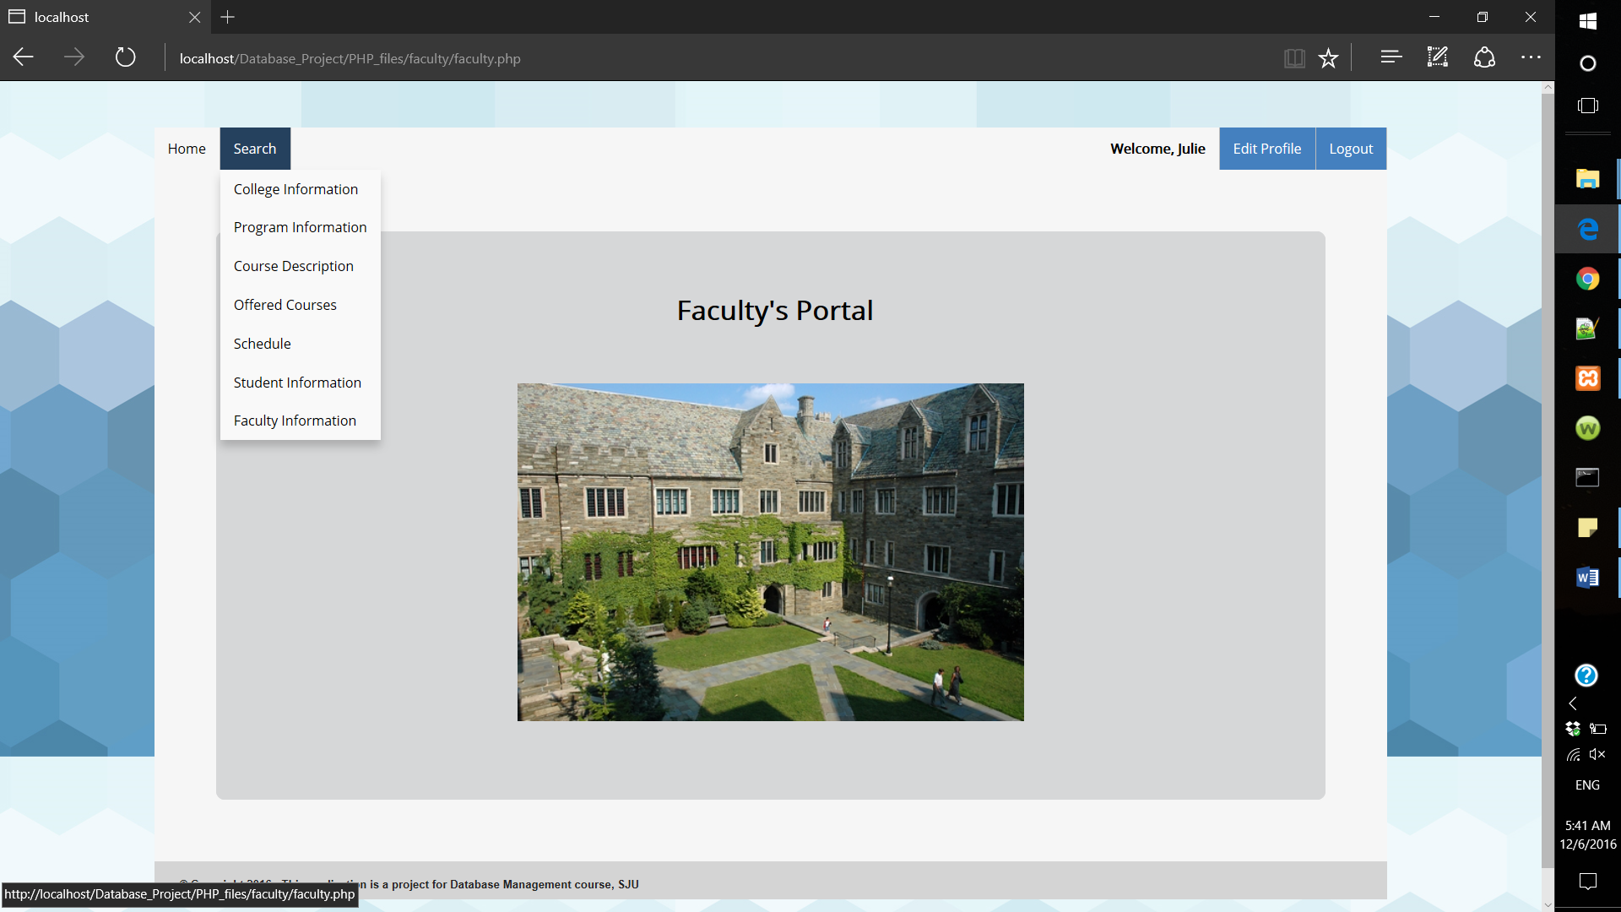

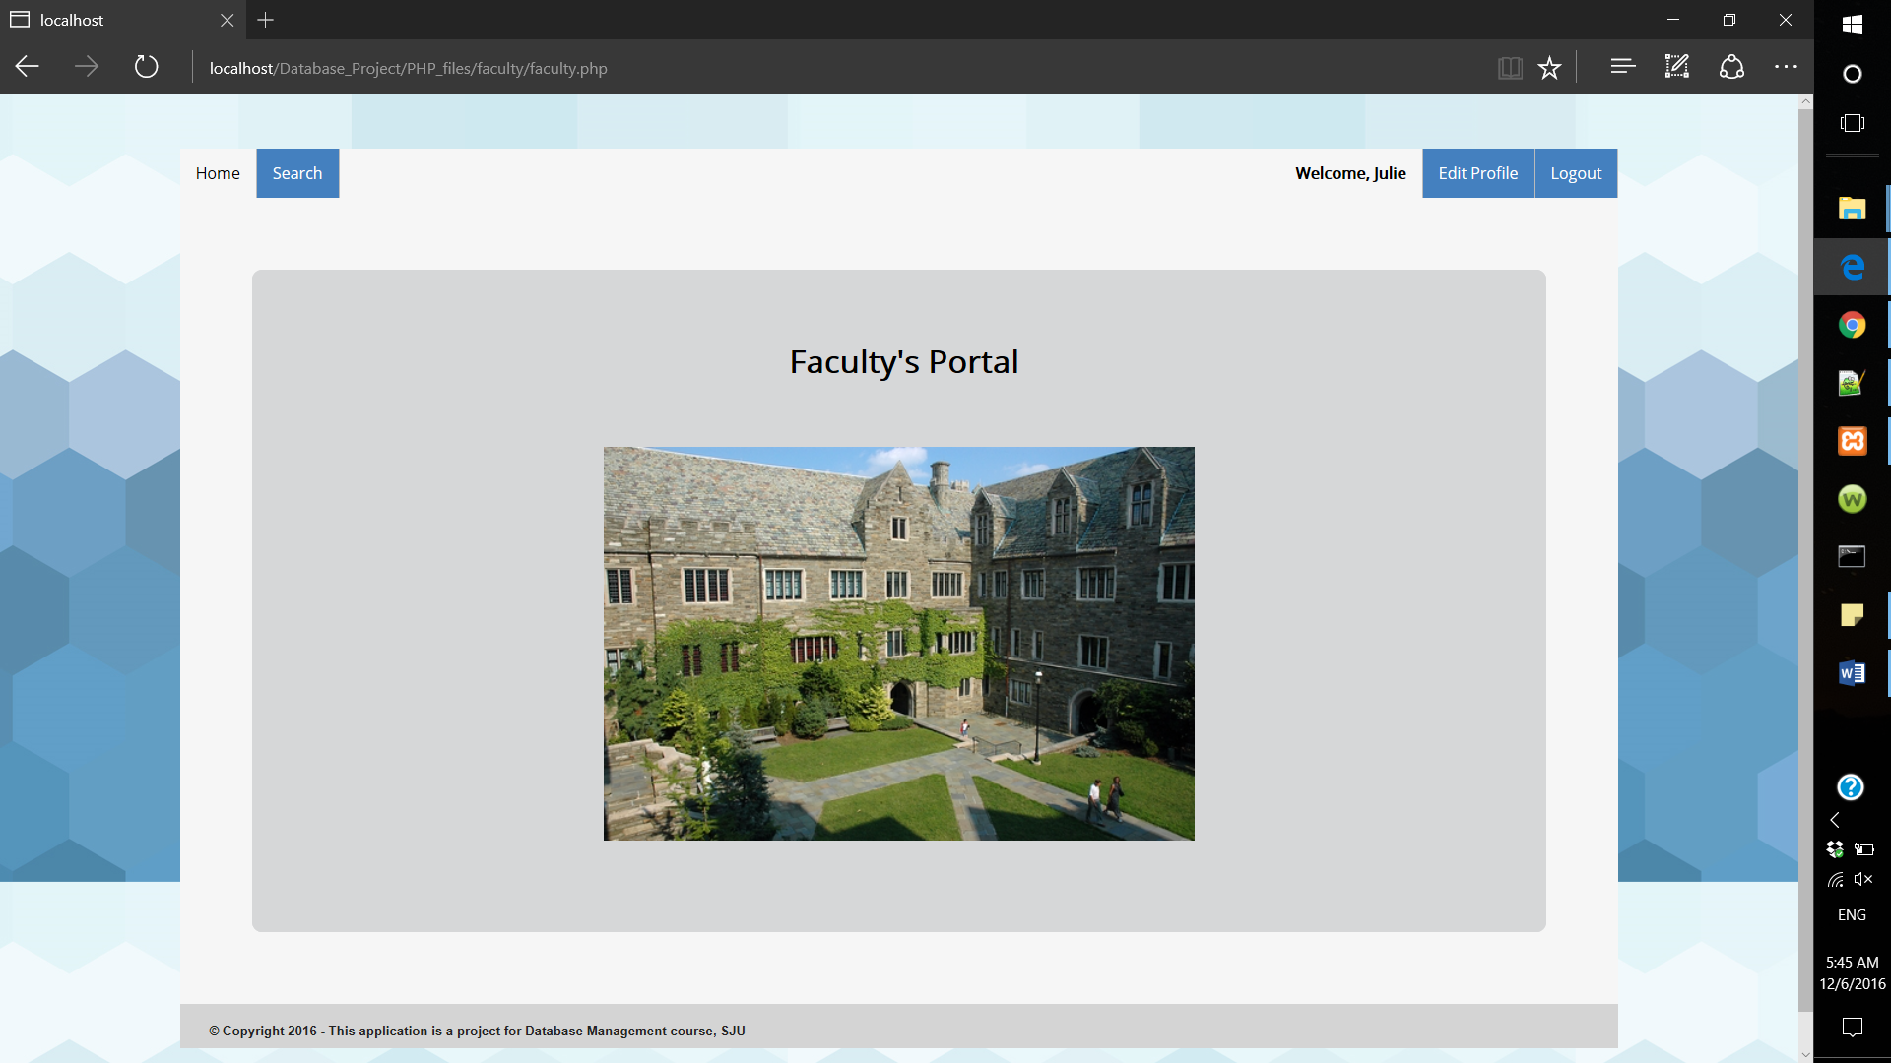

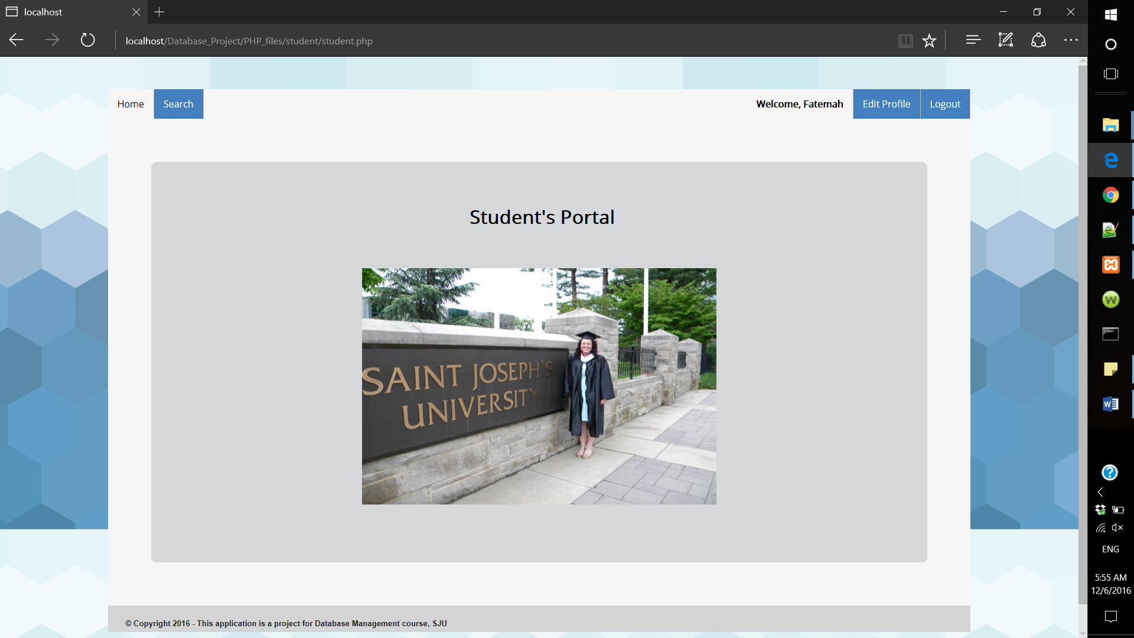

* Search for college information

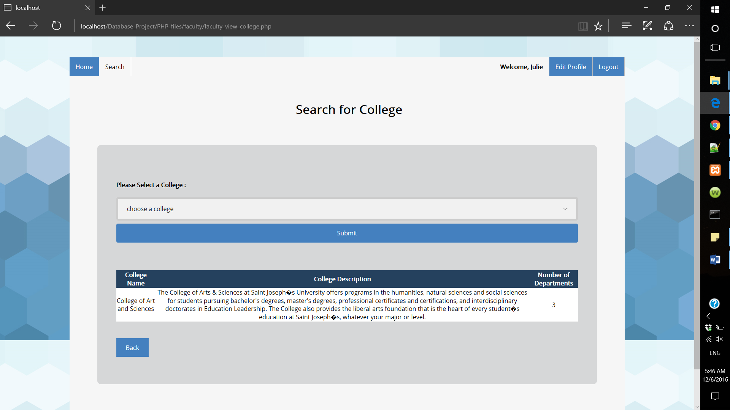

* Search for program requirements

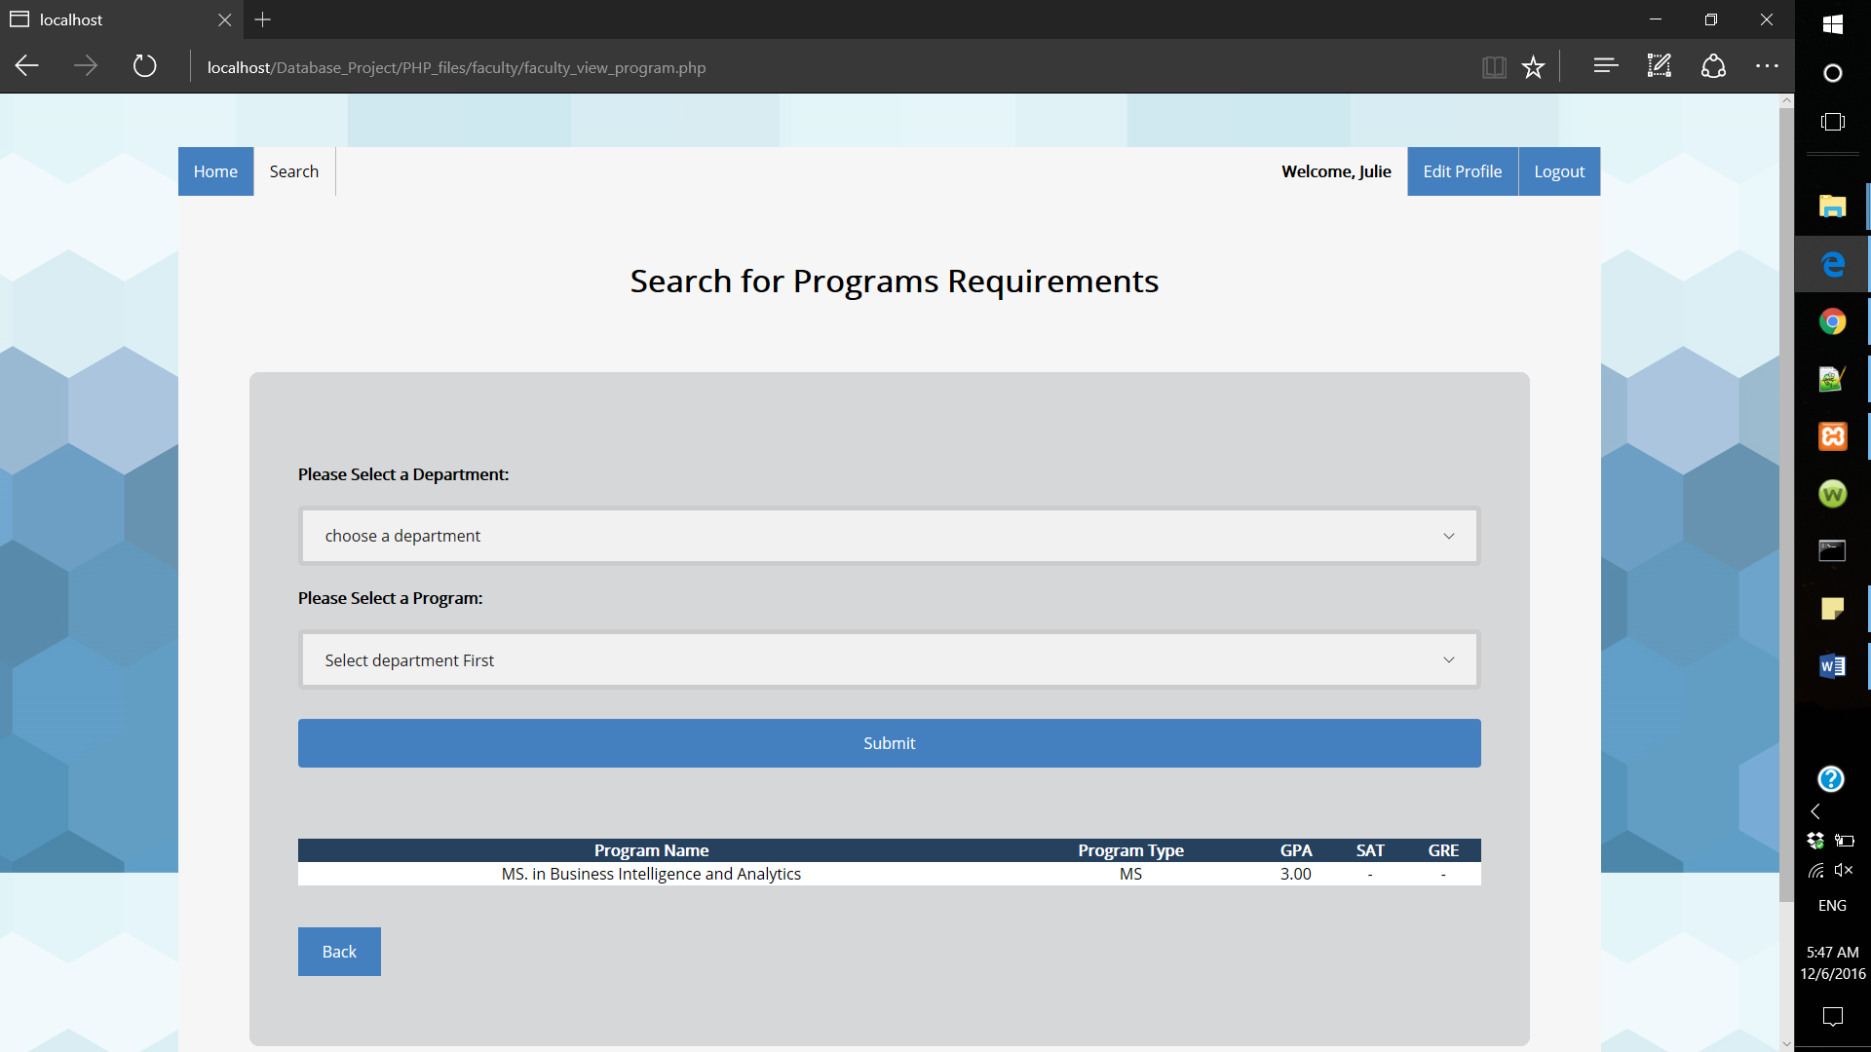

* Search for course description

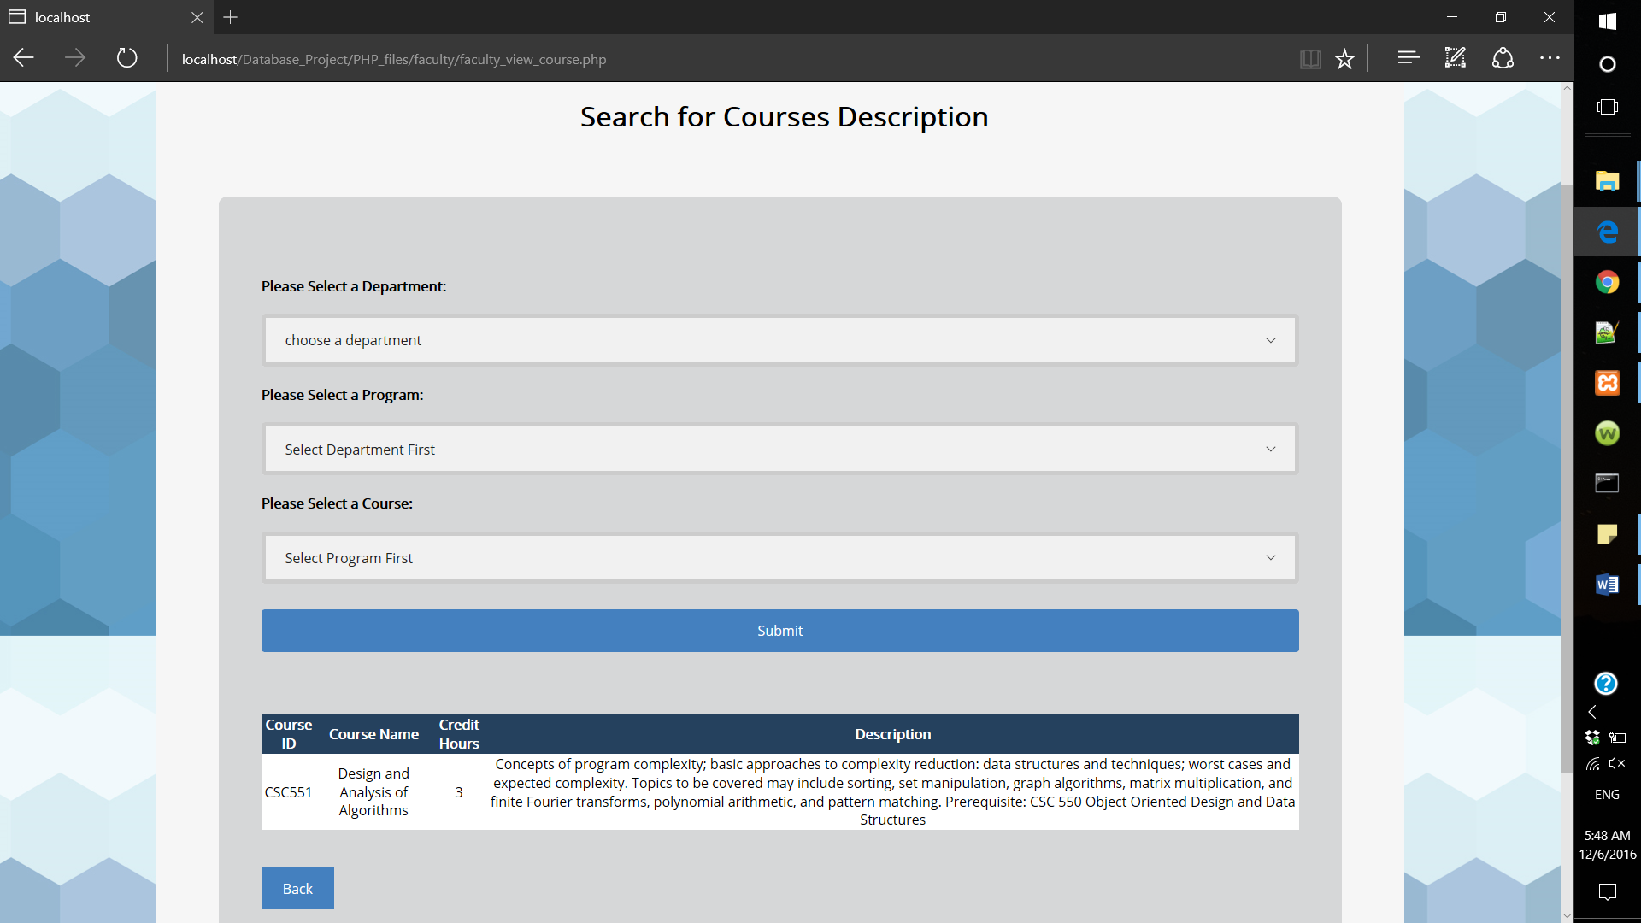

* Search for offered courses

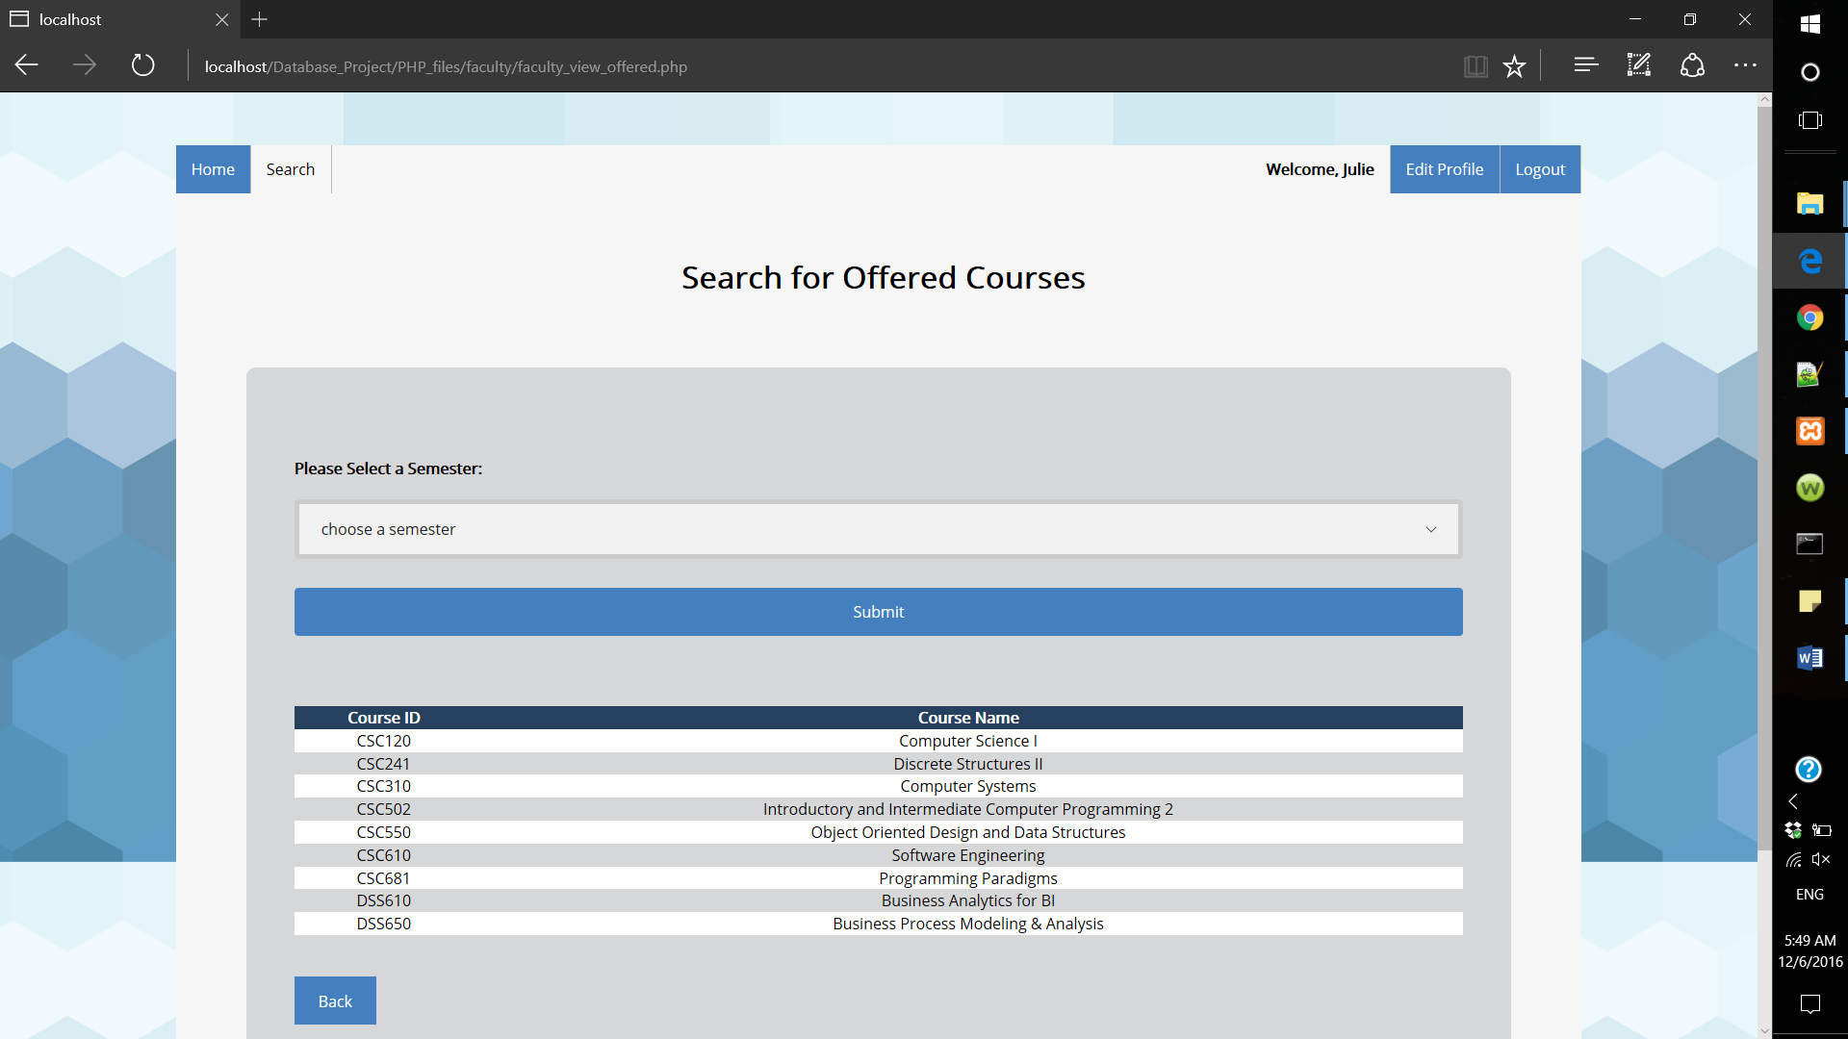

* View schedule

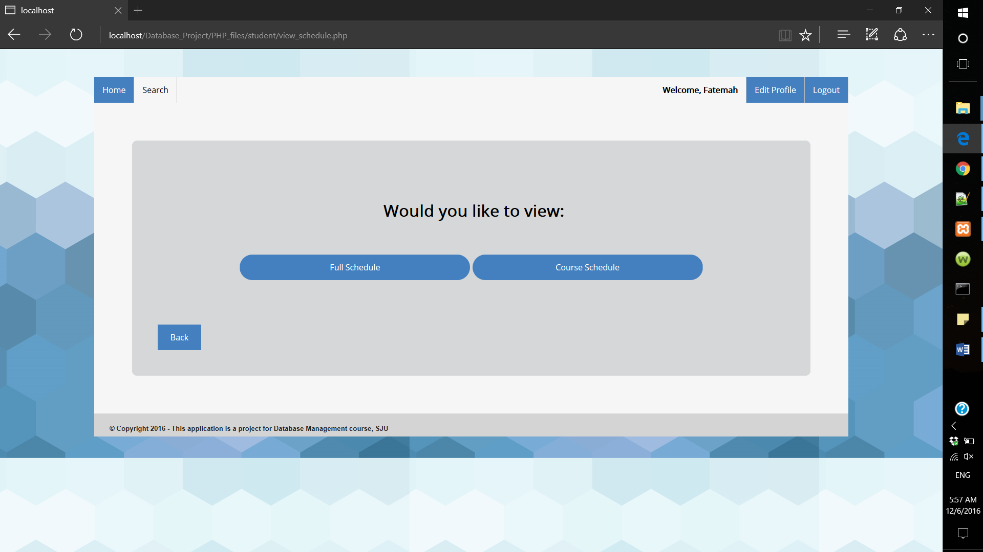

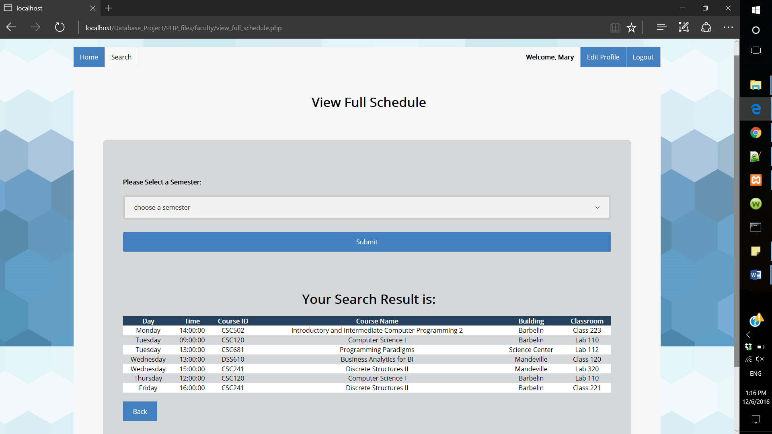

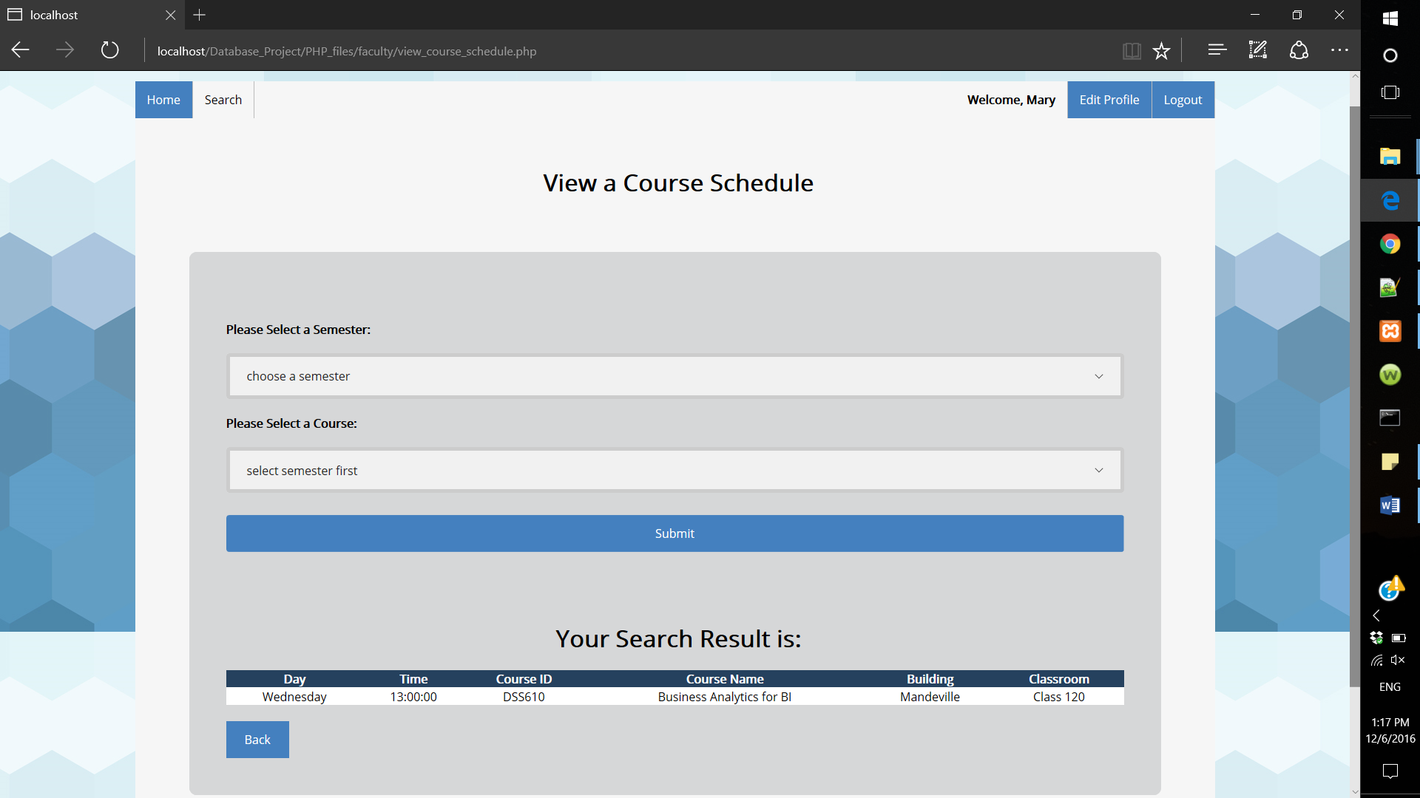

* Search for student information

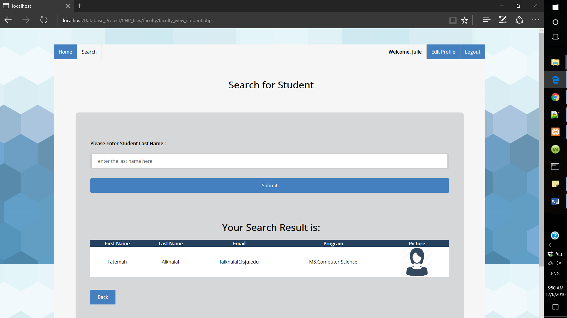

* Search for faculty information

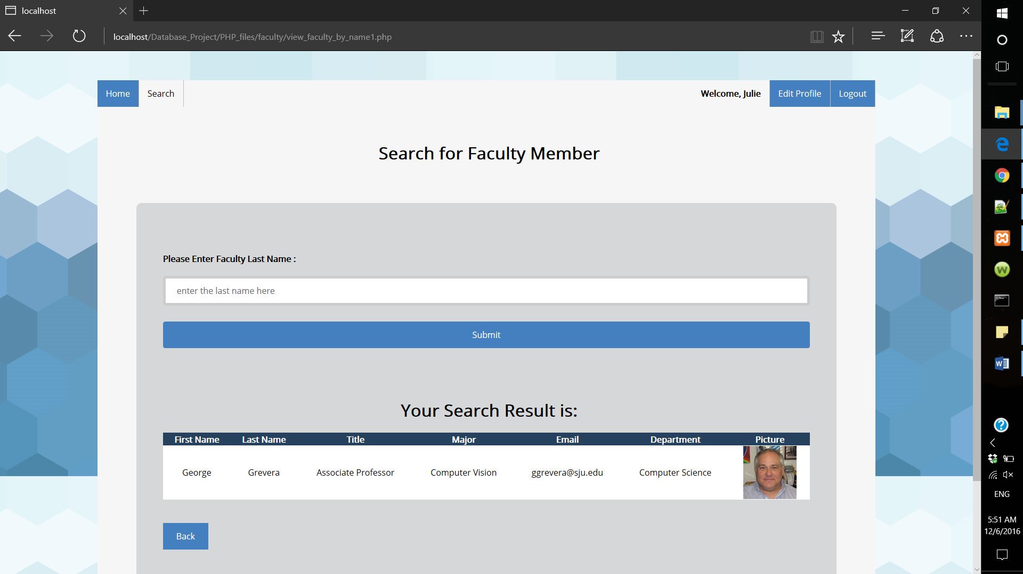

* Edit profile:

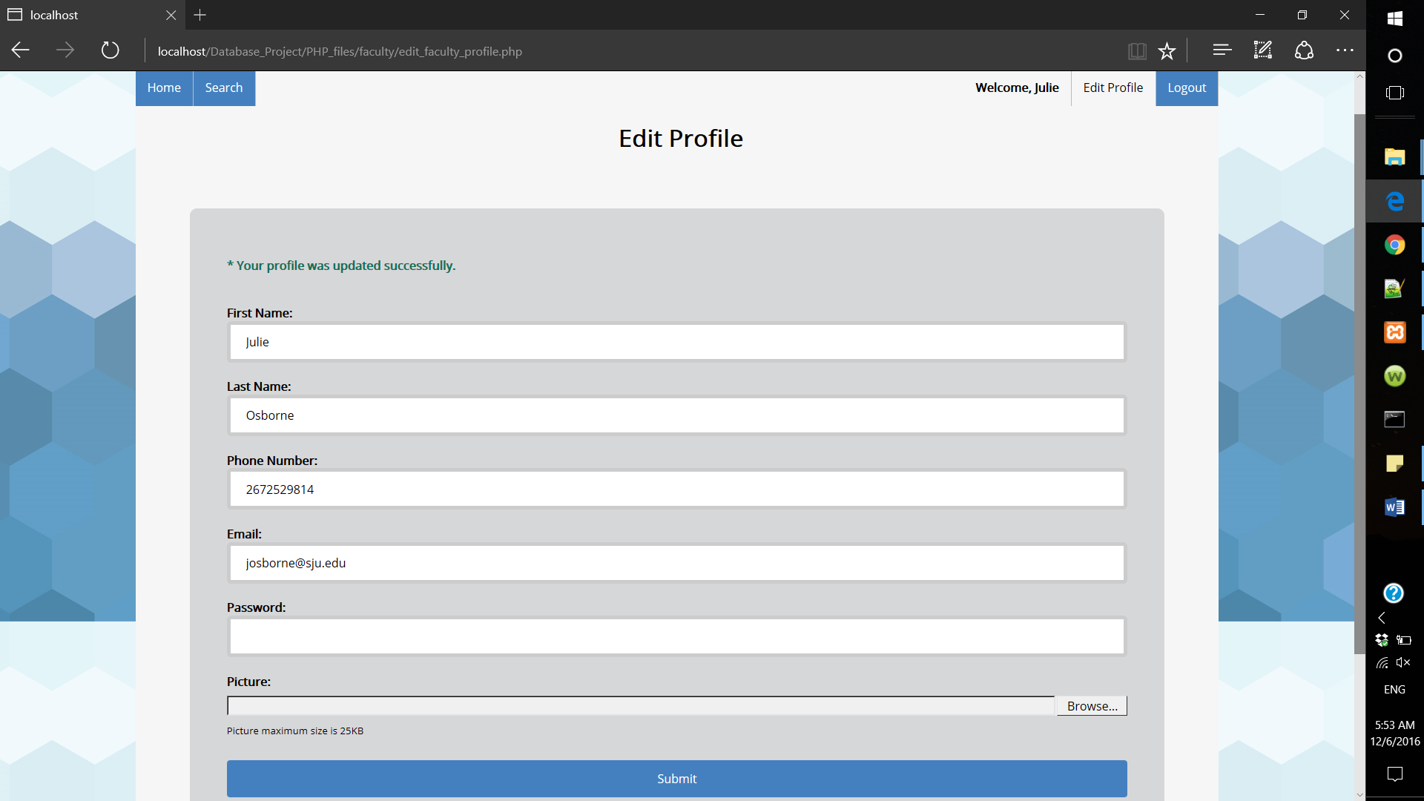

1. Guest Interfaces

Guests can browse our system by clicking on the “continue as a guest” link. Guests can only learn more about SJU colleges, view program requirements and view courses description a program.

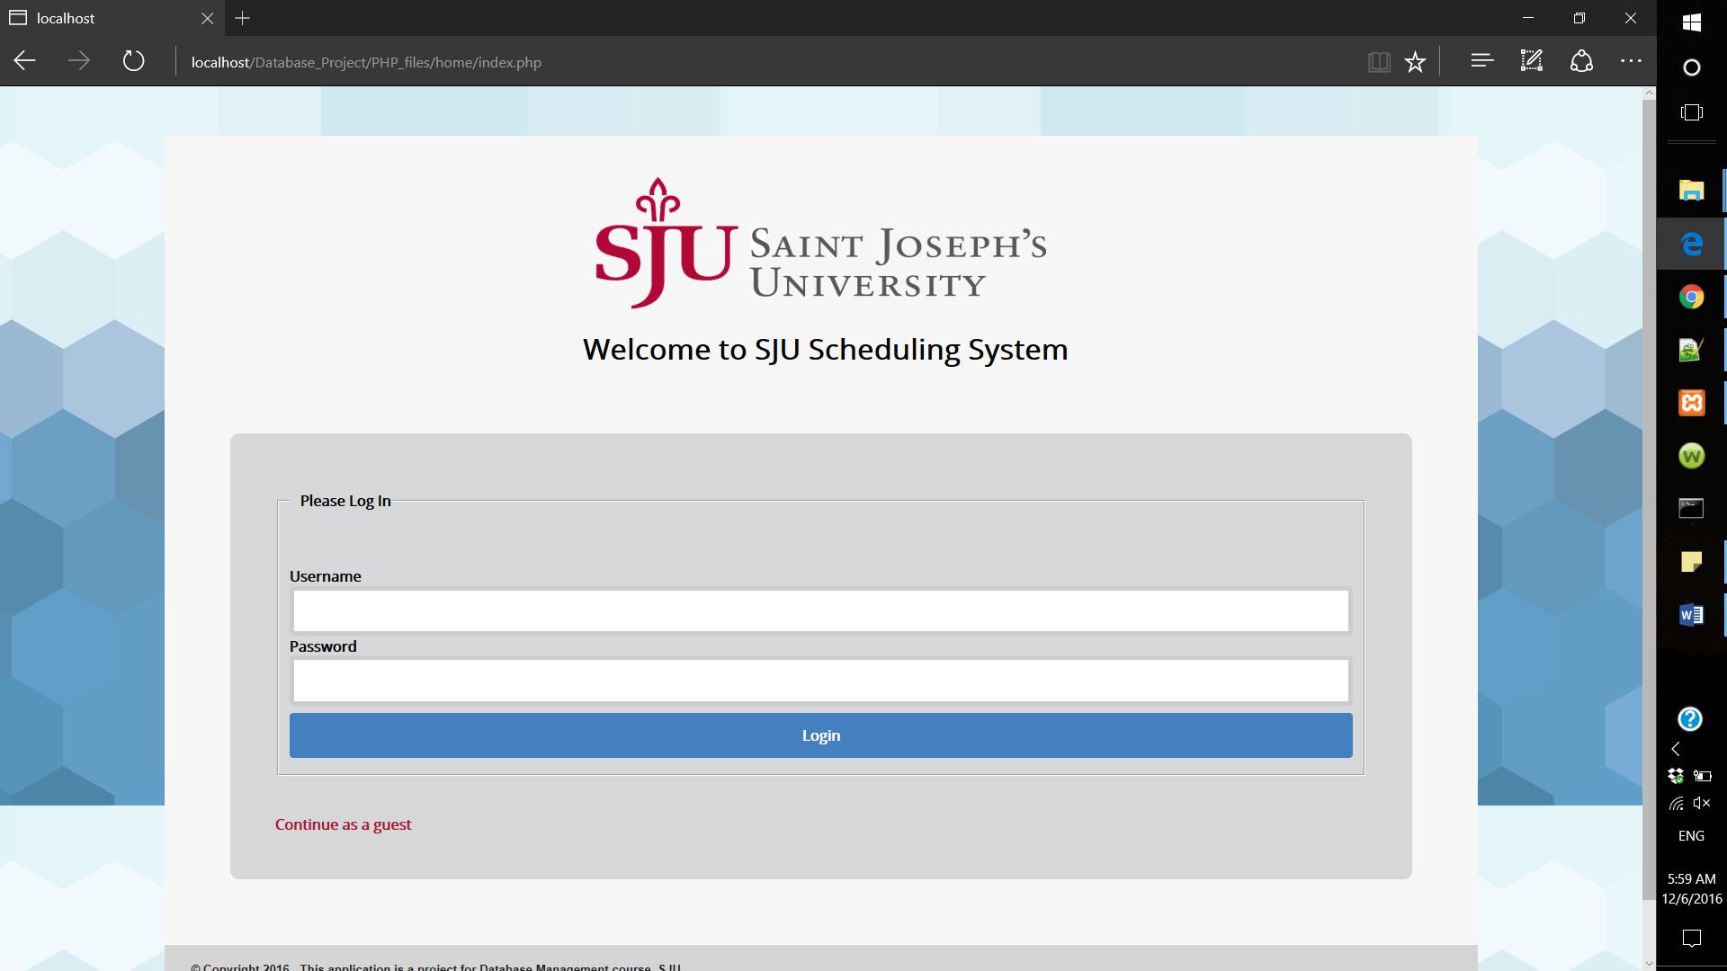

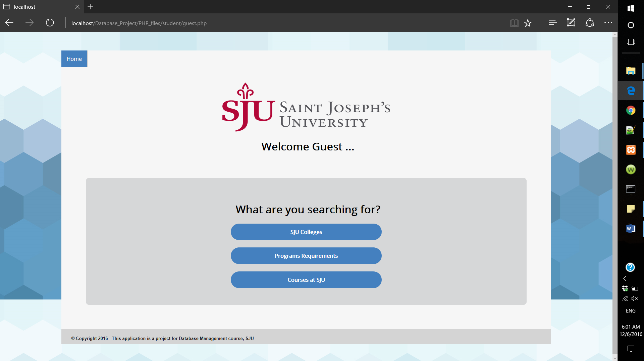

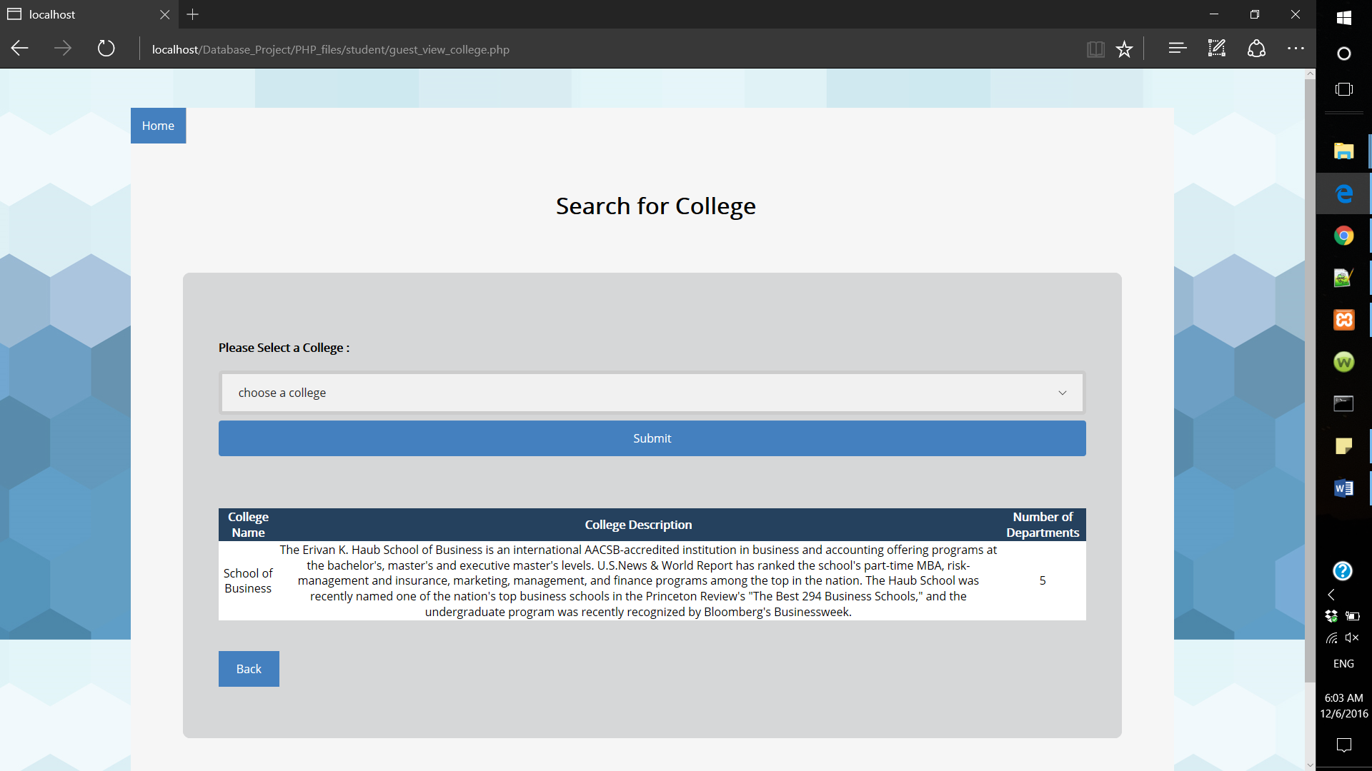

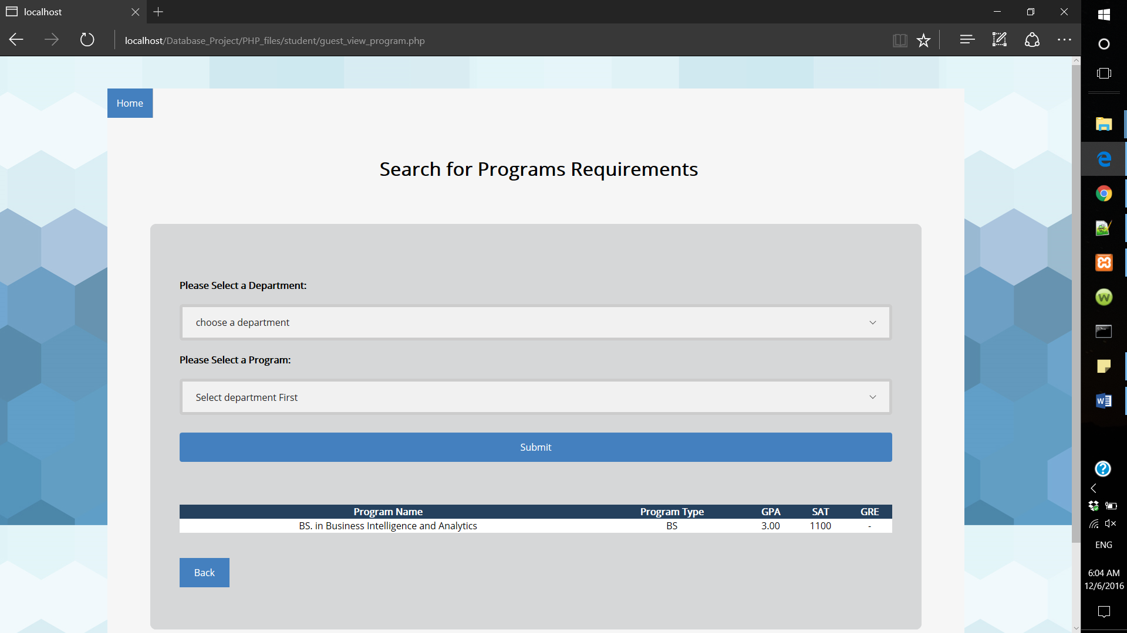

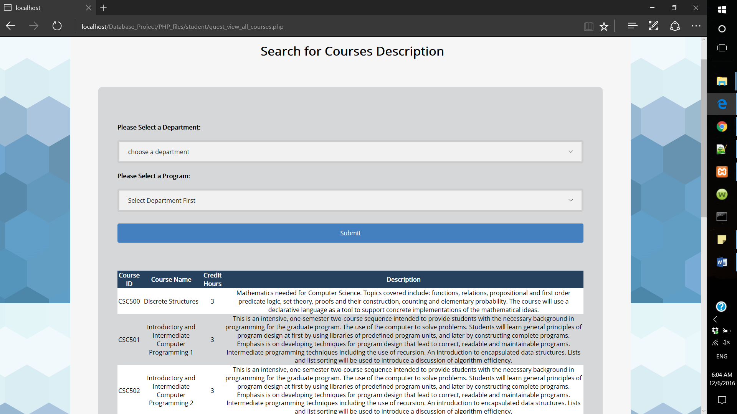

Since the course description will not be updated that often, we created a view for this form to retrieve the data faster. Query for this form:

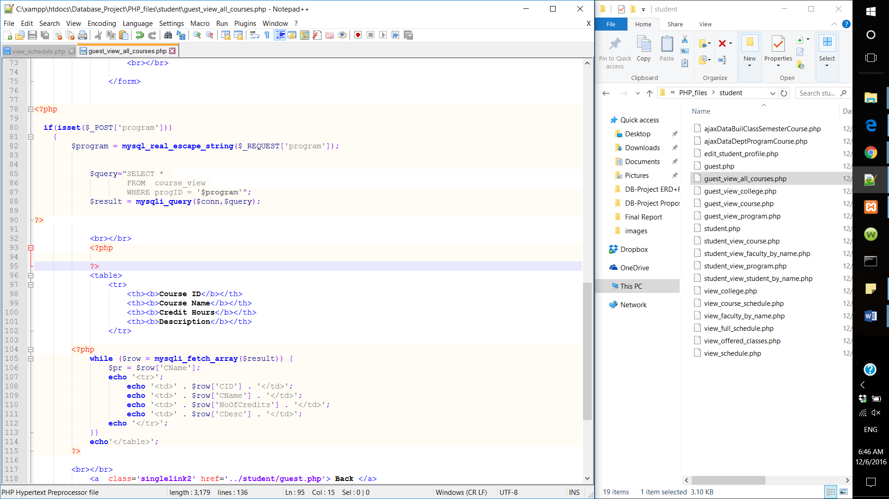

References

Dev, D. (n.d.). *Microsoft Access Query Types*. Retrieved from Database Dev: http://www.databasedev.co.uk/microsoft-access-query-types.html

Jukic , N., Vrbsky , S., & Nestorov, S. (2016). *Database Systems: Introduction to Databases and Data Warehouses.* Danvers: Prospect Press.

tutorial, W. 2. (n.d.). *Oracle SQL Introduction*. Retrieved from Way 2 tutorial: http://www.way2tutorial.com/sql/oracle_sql_introduction_type_of_sql_statement.php

Wales, M. (2014, December 8). *3 Web Dev Careers Decoded: Front-End vs Back-End vs Full Stack*. Retrieved from Udacity: http://blog.udacity.com/2014/12/front-end-vs-back-end-vs-full-stack-web-developers.html

W3Schools. (n.d.). *THE WORLD'S LARGEST WEB DEVELOPER SITE* http://www.w3schools.com/